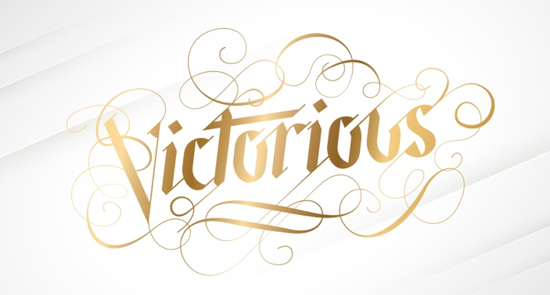

T

Celebrate Victory With Us This Easter

