First Sunday in End Time / Reformation
November 3, 2019

Church Name
CHURCH
LOGO
HERE
EVANGELICAL LUTHERAN CHURCH
Church tagline, i.e. a very brief summary of your mission statement

W
elcome! Thank you for joining us for worship this morning. In our service we gather before our almighty God to offer him our worship and praise. We also gather to strengthen ourselves through the study of God’s holy and powerful Word.
- Restrooms are located in the hallway directly opposite the entrance to the sanctuary.

- Staffed nursery. We offer a staffed nursery for ages 2 to 6 and special needs children. It is located to the left of the entry foyer near the kitchen.

- Connection Cards are inside the worship folder. We ask that before worship or during the offering, you fill those out, front and back. Then place them in the offering plate after the sermon.

- Additional info: church contact info, etc.

- Prayer before worship

The Season of End Time
The Church Year comes a close in November with the season of End Time. In this season, we are reminded that we are living in the “last days” between Christ’s first coming at Christmas and his second coming on Judgment Day. The world could be ended at any time. For a believer, the end of his life or the end of the world is a wonderful thing! It means the beginning of a new and better existence in a much more glorious world than this one.

The Reformation
On October 31, 1517 Martin Luther nailed 95 Theses—statements for debate—on the door of the Castle Church in Wittenberg, beginning a spiritual and historical movement known as the Reformation. The Reformation did not just change the face of Europe; it restored the gospel to the church. It gave God’s Word to the people. As we celebrate the Reformation, we are not honoring the man for whom our church body is named. We are thanking God for his grace which he has demonstrated through the generations—preserving the church and setting us free.

Our Theme for Today: You Are Free to Be Yourself
We continue our Welcome Home sermon series. One of the joys of being home is you need not put on airs. Out in the world, we do all we can to hide our faults and failings. You might be afraid if your boss knew your secrets, he’d give you your walking papers. You might be afraid that if neighbors knew your personal issues, they might consider moving. But we know that in a healthy family, people will love us in spite of our faults.
As a young man, Martin Luther thought of himself as God’s slave. Thus, he was terrified of God. Luther believed God was a terrifying taskmaster, looking for every possible reason to punish him. But as Martin Luther studied God’s Word, he realized that was not the case at all. God is a loving Father. He does not pretend we have no brokenness or sin, but he paid for it all by the death and resurrection of Christ. Scripture says that through faith in Christ, we are completely forgiven. We are part of God’s own family—a family where we are loved in spite of our faults.
God’s grace not only frees us from the fear of condemnation and punishment, it frees us to live a better, more grace-filled life. We want to live as God’s children. We want to love and bear with one another—our brothers and sisters—just as our Father loves and bears with us.
This service offers the congregation a form of worship that focuses on the proclamation of God’s Word which God himself preserved through the Reformation of the Church.
THE FESTIVAL OF THE REFORMATION

 Gathering 

INVOCATION & OPENING DIALOGUE

M: In the name of the Father,
and of the  Son,
and of the Holy Spirit.
C: Amen.

After a brief musical introduction, the congregation sings the following.
Please note that with subsequent verses there will be NO musical introduction.
ALL (sung): All hail the pow’r of Jesus’ name! Let angels prostrate fall;
Bring forth the royal diadem And crown him Lord of all.
Bring forth the royal diadem And crown him Lord of all.
Hail him, ye heirs of David’s line, Whom David Lord did call,
The God incarnate, Man divine, And crown him Lord of all.
The God incarnate, Man divine, And crown him Lord of all.
M: Blessing and honor and glory and power be unto the One who sits on the throne,
C: And to the Lamb, forever and ever.
M: His blood sets us free to be the people of God.
ALL (sung): Sinners whose love can ne’er forget The wormwood and the gall,
Go, spread your trophies at his feet And crown him Lord of all.
Go, spread your trophies at his feet And crown him Lord of all.

CONFESSION & ABSOLUTION
M: Let us confess our sins to the Lord.
C: Almighty God, merciful Father, I, a troubled and repentant sinner,
confess that I have sinned against you in my thoughts, my words, and my actions.
I have not loved you with my whole heart; I have not loved others as I should.
I am distressed by the sins that trouble me and am deeply sorry for them.
M: Jesus’ death paid for the guilt of your sins and the sins of the whole world.
He said to his people, “If you forgive the sins of any, they are forgiven.”
Because of the promise of our Savior Jesus, I forgive you all your sins.
Be assured that you are a dear child of God and an heir of eternal life!
ALL (sung): Let ev’ry kindred, ev’ry tribe On this terrestrial ball
To him all majesty ascribe And crown him Lord of all.
To him all majesty ascribe And crown him Lord of all.
M: Fight the good fight of faith!
C: For the Lord, the righteous Judge, has laid up for us a crown of life.
M: For us, and for all who await his appearing.
ALL (sung): Oh, that with yonder sacred throng We at his feet may fall!
We’ll join the everlasting song And crown him Lord of all.
We’ll join the everlasting song And crown him Lord of all.

PRAYER OF THE DAY
M: Gracious Lord, our refuge and strength,
pour out your Holy Spirit on your faithful people.
Keep them steadfast in your Word,
protect and comfort them in all temptations,
defend them against all their enemies,
and bestow on the Church your saving peace;
through your Son, Jesus Christ, our Lord,
who lives and reigns with you and the Holy Spirit,
one God now and forever.
C: Amen.
 The Word 

FIRST LESSON Jeremiah 31:31-34

Through Jeremiah, the Lord describes the new covenant established by the promised Messiah. He will
forgive sins and write the promise of grace on the hearts of his people, setting them free.

³¹ “The days are coming,” declares the Lord,
“when I will make a new covenant with the people of Israel and with the people of Judah.
³² It will not be like the covenant I made with their ancestors
when I took them by the hand to lead them out of Egypt,
because they broke my covenant, though I was a husband to them,” declares the Lord.
³³ “This is the covenant I will make with the people of Israel after that time,” declares the Lord.
“I will put my law in their minds and write it on their hearts.
I will be their God, and they will be my people.
³⁴ No longer will they teach their neighbor, or say to one another, ‘Know the Lord,’
because they will all know me, from the least of them to the greatest,” declares the Lord.
“For I will forgive their wickedness and will remember their sins no more.”

PSALM OF THE DAY Psalm 46

Cantor(s): Refrain
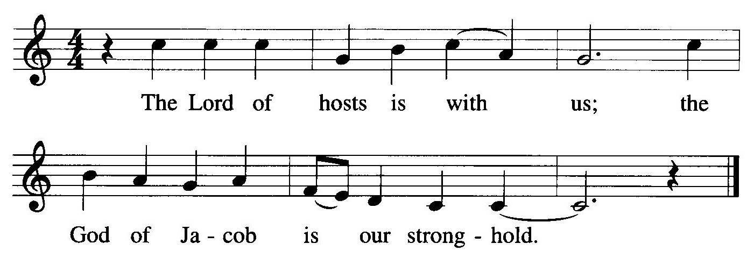
ALL: Refrain
CLICK HERE TO ORDER THIS PSALM.
THEN YOU CAN DELETE THE TEXT BOX.
Cantor(s): God is our refuge and strength,
a very present help in trouble.
Therefore we will not fear, though the earth be moved,
and though the mountains be toppled into the depths of the sea.
ALL: Refrain
Cantor(s): There is a river whose streams make glad the city of God,
the holy habitation of the Most High.
God is in the midst of her; she shall not be overthrown.
God shall help her at the break of day.
ALL: Refrain
Cantor(s): The nations make much ado, and the kingdoms are shaken;
God has spoken, and the earth shall melt away.
Come now and look upon the works of the Lord,
What awesome things he has done on earth.
ALL: Refrain
Cantor(s): It is he who makes war to cease in all the world;
He breaks the bow, and shatters the spear, and burns the shields with fire.
“Be still, then, and know that I am God;
I will be exalted among the nations; I will be exalted in the earth.”
ALL: Refrain (During the final refrain, the children may come forward.)

CHILDREN’S MESSAGE

SECOND LESSON Romans 3:19-28

We are justified by God’s grace, set free from sin’s curse and condemnation

¹⁹ Now we know that whatever the law says, it says to those who are under the law, so that every mouth may be silenced and the whole world held accountable to God. ²⁰ Therefore no one will be declared righteous in God’s sight by the works of the law; rather, through the law we become conscious of our sin.
²¹ But now apart from the law the righteousness of God has been made known, to which the Law and the Prophets testify. ²² This righteousness is given through faith in Jesus Christ to all who believe. There is no difference between Jew and Gentile, ²³ for all have sinned and fall short of the glory of God, ²⁴ and all are justified freely by his grace through the redemption that came by Christ Jesus. ²⁵ God presented Christ as a sacrifice of atonement, through the shedding of his blood—to be received by faith. He did this to demonstrate his righteousness, because in his forbearance he had left the sins committed beforehand unpunished— ²⁶ he did it to demonstrate his righteousness at the present time, so as to be just and the one who justifies those who have faith in Jesus.
²⁷ Where, then, is boasting? It is excluded. Because of what law? The law that requires works? No, because of the law that requires faith. ²⁸ For we maintain that a person is justified by faith apart from the works of the law.
VERSE OF THE DAY John 8:31,32

M: Alleluia. If you continue in my Word, then you are truly my disciples, and you will know the truth, and the truth will set you free. Alleluia.
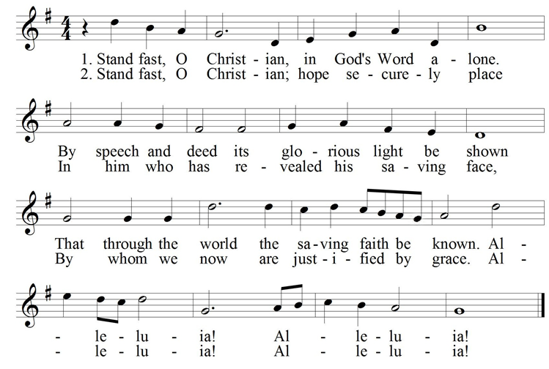
After a musical introduction, the congregation sings…

GOSPEL John 8:31-36

Within true discipleship comes the understanding and knowledge of the
true mystery of Christ. With this knowledge comes freedom.

³¹ To the Jews who had believed him, Jesus said, “If you hold to my teaching, you are really my disciples. ³² Then you will know the truth, and the truth will set you free.”
³³ They answered him, “We are Abraham’s descendants and have never been slaves of anyone. How can you say that we shall be set free?”
³⁴ Jesus replied, “Very truly I tell you, everyone who sins is a slave to sin. ³⁵ Now a slave has no permanent place in the family, but a son belongs to it forever. ³⁶ So if the Son sets you free, you will be free indeed.

M: This is the Gospel of our Lord.
C: Praise be to you, O Christ!

HYMN OF THE DAY — 200 A Mighty Fortress Is Our God

SERMON

CONFESSION OF FAITH Apostles’ Creed
I believe in God, the Father almighty,
maker of heaven and earth.
I believe in Jesus Christ, his only Son, our Lord,
who was conceived by the Holy Spirit,
born of the virgin Mary,
suffered under Pontius Pilate,
was crucified, died, and was buried.
He descended into hell.
The third day he rose again from the dead.
He ascended into heaven,
and is seated at the right hand of God the Father almighty. From there he will come to judge the living and the dead.
I believe in the Holy Spirit,
the holy Christian Church,
the communion of saints,
the forgiveness of sins,
the resurrection of the body,
and the life everlasting. Amen.

THANK OFFERING

Members of this congregation have joined together in love and faith to do the Lord’s work in this community and around the world. Visitors need not feel obligated to participate in this offering which supports our ministry.

 Prayers 

PRAYER OF THE CHURCH
Based on Luther’s prayer at the Diet of Worms (1521) as he faced the papal and imperial authorities

M: Almighty, eternal God, out of the depths we call to you. The world opens its mouth to swallow your church, and our faith in you is too small to confront its lures and attractions!
C: We confess the weakness of our sinful flesh. Satan deceives us daily. If we are to depend upon any strength from ourselves, all is lost. Help us, we beg, to withstand the ungodly way of life that the world has to offer.
M: The work is not ours, O God, but yours. O Sovereign Lord and Creator, we have no way to satisfy your righteousness, nothing to contest the Deceiver’s earthly power, nothing to mute its false attractions, nothing to uproot the rule of our sinful flesh.
C: We would gladly pass our days in happiness and peace in an age awash with iniquity. Hear us, heavenly Father, for the cause is yours. Yes, Creator of all that is, your cause is righteous and everlasting. Vindicate your name among the nations!
M: O all-seeing Lord, have mercy on your church. You understand our plight. We thank you for sending a messenger of peace to correct the times between life and death. This One is your Son, Jesus the Christ, the incarnate Savior, who saves us from calamities that plague your church.
C: You have chosen us to do your work. Therefore, O God, accomplish it by your will. Stand by your church each day in the name of Jesus, who is our shelter and shield, our mighty fortress. Through the strength of the Holy Spirit, such faith works joy and peace and willingness to serve a world in need.
M: We are even ready to lay down our life for this cause, as were your servants Martin Luther and his fellow Reformers and Confessors, who forcefully stormed the kingdom of heaven to restore the gospel of your righteousness to its central place in Christian life.
C: For the cause is holy. Though this world is filled with devils and though our bodies perish in persecution, your Word and your Spirit still remain. The church always needs reform as its message encounters the false and frivolous. But the Word of God stands firm forever.
M: In the confidence of this faith, gracious Lord, bless our efforts to spread the gospel of the glory and grace of God throughout the world to the joy and edifying of all who hear and believe and for your glory and our good.
C: Amen.
Special prayers and intercessions may follow
M: Hear us, Lord, as we bring you our private petitions.
Silent prayer
LORD’S PRAYER
M: Lord, remember us in your kingdom, and teach us to pray:
C: Our Father in heaven,
hallowed be your name,
your kingdom come,
your will be done on earth as in heaven.
Give us today our daily bread.
Forgive us our sins, as we forgive those who sin against us.
Lead us not into temptation,
but deliver us from evil.
For the kingdom, the power, and the glory are yours now and forever.
Amen.

BLESSING
M: Brothers and sisters, go in peace.
Live in harmony with one another.
Serve the Lord with gladness.

The Lord bless you and keep you.
The Lord make his face shine on you and be gracious to you.
The Lord look on you with favor and give  you peace.
C: Amen.

CLOSING HYMN — 203 Lord, Keep Us Steadfast In Your Word

Hymn Appreciation: Lord, Keep Us Steadfast In Your Word was written by Dr. Martin Luther in 1541 because of a grave and growing threat. Militant Islam was on the move. Seeking to conquer the West and force conversion, the armies of Islam conquered much of the Mediterranean world. They conquered right up to Vienna, the gateway to Europe. A service of prayer for the safety of Christendom was held in 1541, and Luther wrote this hymn for the boys’ choir. It is a prayer that God preserve his people regardless of the evil aims of this world.

COPYRIGHT INFORMATION
The following items are reprinted under OneLicense.net #A-000000
Psalm 46 © 2004 by GIA Publications. Music: J. William Greene (based on EIN FESTE BURG)

