Second Sunday in End Time / Last Judgment
November 10, 2019

Church Name
CHURCH
LOGO
HERE
EVANGELICAL LUTHERAN CHURCH
Church tagline, i.e. a very brief summary of your mission statement

W
elcome! Thank you for joining us for worship this morning. In our service we gather before our almighty God to offer him our worship and praise. We also gather to strengthen ourselves through the study of God’s holy and powerful Word.
- Restrooms are located in the hallway directly opposite the entrance to the sanctuary.

- Staffed nursery. We offer a staffed nursery for ages 2 to 6 and special needs children. It is located to the left of the entry foyer near the kitchen.

- Connection Cards are inside the worship folder. We ask that before worship or during the offering, you fill those out, front and back. Then place them in the offering plate after the sermon.

- Additional info: church contact info, etc.

- Prayer before worship

The Season of End Time
The Church Year comes a close in November with the season of End Time. In this season, we are reminded that we are living in the “last days” between Christ’s first coming at Christmas and his second coming on Judgment Day. The world could be ended at any time. For a believer, the end of his life or the end of the world is a wonderful thing! It means the beginning of a new and better existence in a much more glorious world than this one.
Our Worship Series: Welcome Home
The Holy Spirit wants believers to think of each other as family. Having a spiritual family is essential to our well-being. In this worship series, we look at how our Father knits us together in love and unity. We see the benefits of being part of this family. In the Church, Christ has given us a better home.
Welcome Home!
Our Need for Christian Community
The Lost Are Now Found
You Are Free to Be Yourself
You Are Perfectly Safe Here
You Have an Everlasting Family
You are Part of Christ’s Glorious Kingdom

Our Theme for Today: Home, Where You Are Perfectly Safe
Twenty-one billion dollars. That is how much Americans spend annually on home security. We want our homes to be a place that our family can feel safe, where they can be apart from everything that can hurt them.
However, the reality is that no matter how many locks and alarms and cameras you might use to guard your house, you and your family are not perfectly safe. There is a greater danger than thieves … a greater threat than bullies. There is even something worse than physical death. Judgment Day is coming, and with it, the destruction of all creation. If that day comes and you are not prepared, you begin an eternal nightmare.
In the Church, our brother Jesus has given us a home that is indeed perfectly safe. Not even Judgment Day can touch it. Christians can look forward to Judgment Day with great anticipation. Even as “the mountains fall into the heart of the sea” (Psalm 46:2), we have Christ’s promise that we will be perfectly safe.
Order of Service for
THE LAST JUDGMENT

 Gathering 

OPENING HYMN — 220, vs. 1 & 2 O’er the Distant Mountains Breaking

INVOCATION
M: The grace of our Lord  Jesus Christ, the love of God, and the fellowship of the Holy Spirit
be with you all.
C: And also with you.

CONFESSION OF SINS
M: Beloved in the LORD, the day is surely coming, and it will burn like a furnace.
Therefore, let us draw near with a true heart and confess our sins to God our Father,
asking him in the name of our Lord Jesus Christ to grant us forgiveness.
C: Holy and merciful Father, I confess that I am sinful by nature,
and that I have disobeyed you in my thoughts, words, and actions.
I have done what is evil and failed to do what is good.
For this I deserve your punishment both now and in eternity.
But I am truly sorry for my sins,
and trusting in my Savior Jesus Christ, I pray:
Lord, have mercy on me, a sinner.
M: God, our heavenly Father, has been merciful to us
and has given his only Son to be the atoning sacrifice for our sins.
Therefore, as a called servant of Christ and by his authority,
I forgive all your sins in the name of the Father and of the Son  and of the Holy Spirit.
C: Amen!
The Rite of Holy Baptism may take place here.

M: In the peace of forgiveness, let us praise the Lord.
After a brief musical introduction, the congregation sings.
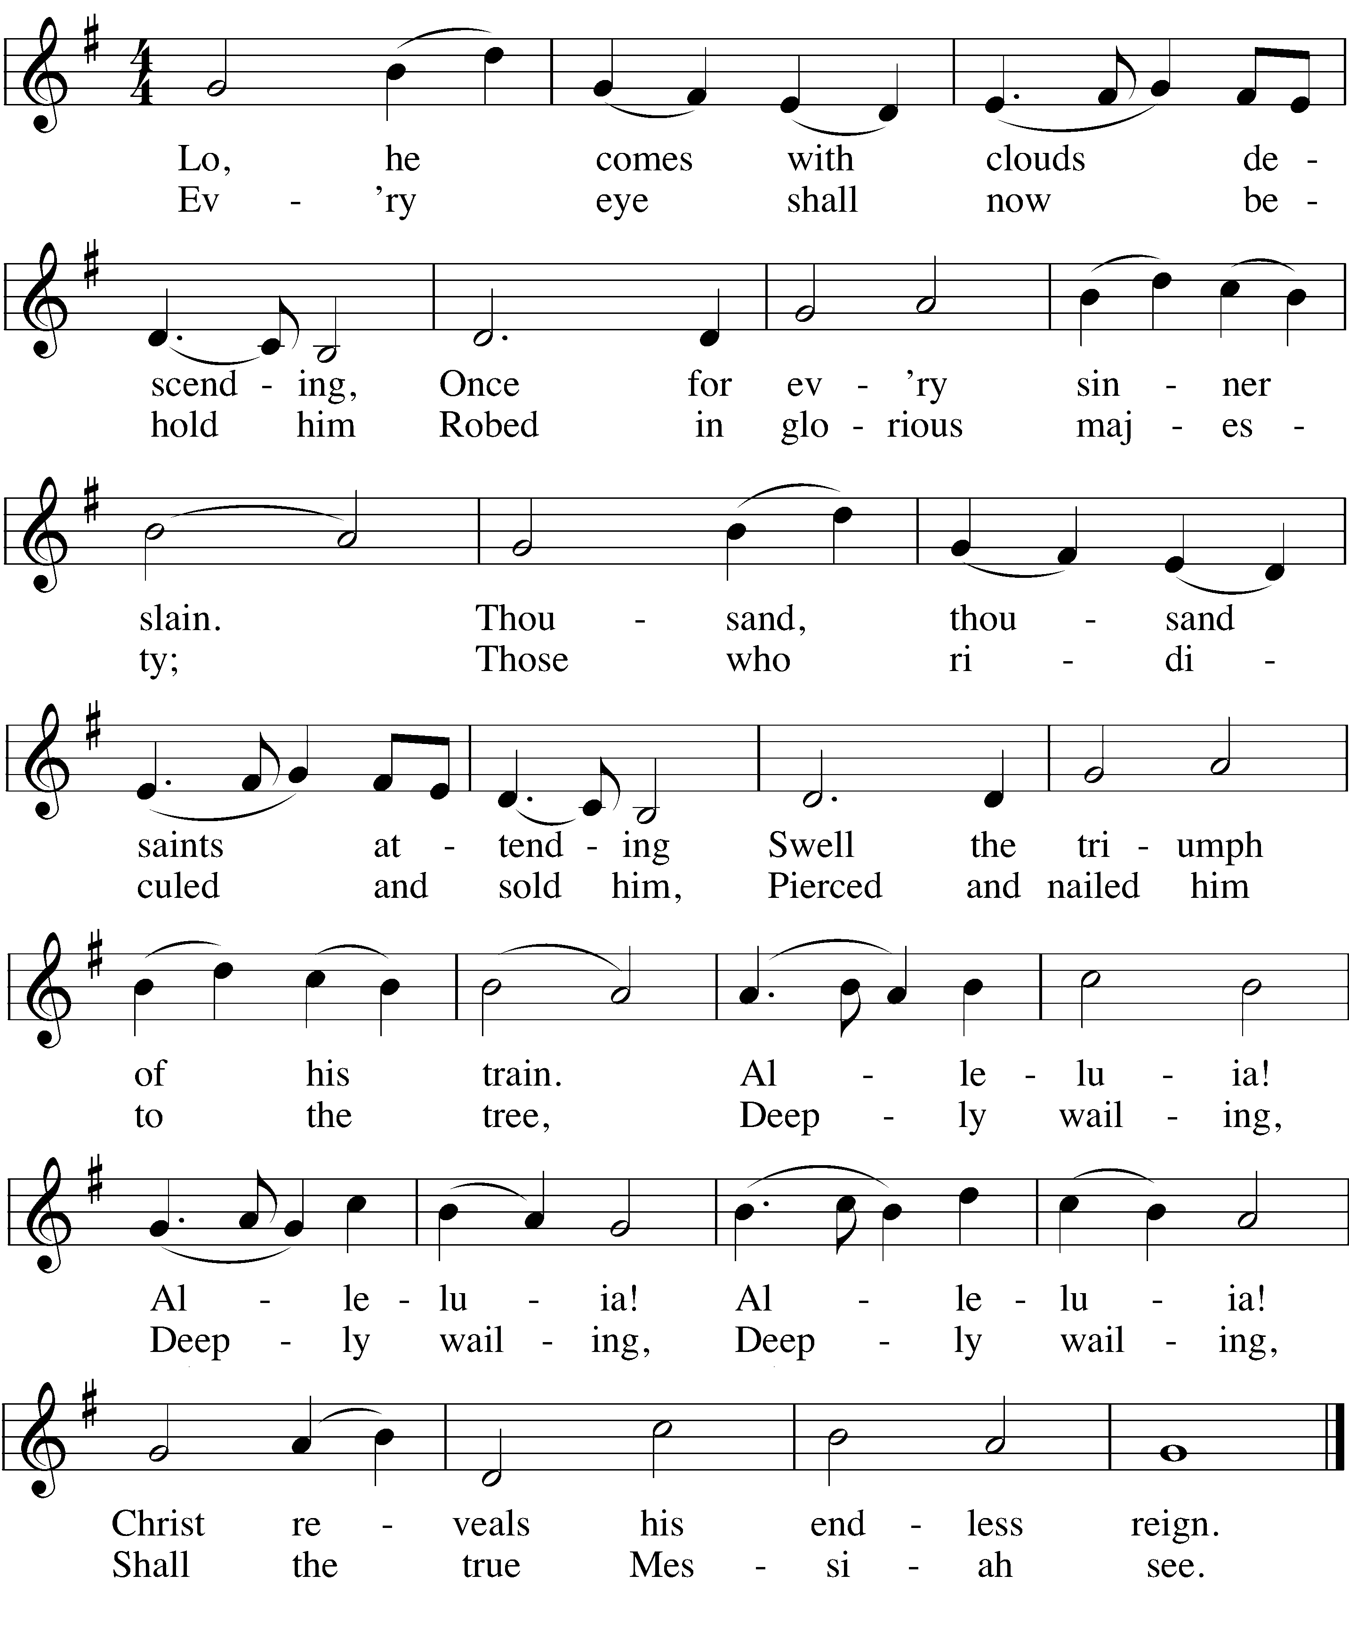

PRAYER OF THE DAY

M: Lord God Almighty, so rule and govern our hearts and minds by your Holy Spirit that we may always look forward to the end of this present evil age and to the day of your righteous judgment. Keep us steadfast in true and living faith and present us at last holy and blameless before you; through your Son, Jesus Christ our Lord, who lives and reigns with you and the Holy Spirit, one God, now and forever.
C: Amen.
 The Word 

FIRST LESSON Jeremiah 26:1-6

The Lord’s judgment is coming to bring destruction on those who refuse to listen to his Word.
We rejoice that in Christ, we are considered the family of God and so will be safe on the Last Day.

¹Early in the reign of Jehoiakim son of Josiah king of Judah, this word came from the Lord: ² “This is what the Lord says: Stand in the courtyard of the Lord’s house and speak to all the people of the towns of Judah who come to worship in the house of the Lord. Tell them everything I command you; do not omit a word. ³ Perhaps they will listen and each will turn from their evil ways. Then I will relent and not inflict on them the disaster I was planning because of the evil they have done.⁴ Say to them, ‘This is what the Lord says: If you do not listen to me and follow my law, which I have set before you, ⁵ and if you do not listen to the words of my servants the prophets, whom I have sent to you again and again (though you have not listened), ⁶ then I will make this house like Shiloh and this city a curse among all the nations of the earth.’”

PSALM OF THE DAY Psalm 90

M: Lord, you have been our dwelling place throughout all generations.
C: From everlasting to everlasting you are God.
M: You turn men back to dust, saying, “Return to dust, O sons of men.”
C: For a thousand years in your sight are like a day that has just gone by.
M: You sweep men away in the sleep of death.
C: We are consumed by your anger and terrified by your indignation.
M: You have set our iniquities before you,
C: our secret sins in the light of your presence.
O: The length of our days is seventy years—or eighty, if we have the strength;
C: yet their span is but trouble and sorrow, for they quickly pass, and we fly away.
M: Teach us to number our days aright, that we may gain a heart of wisdom.
C: Satisfy us in the morning with your unfailing love,
that we may sing for joy and be glad all our days.
M: May the favor of the Lord our God rest upon us.
C: Establish the work of our hands for us. Yes, establish the work of our hands.
After a brief musical introduction, the congregation sings the following.
The children may come forward for the Children’s Message.
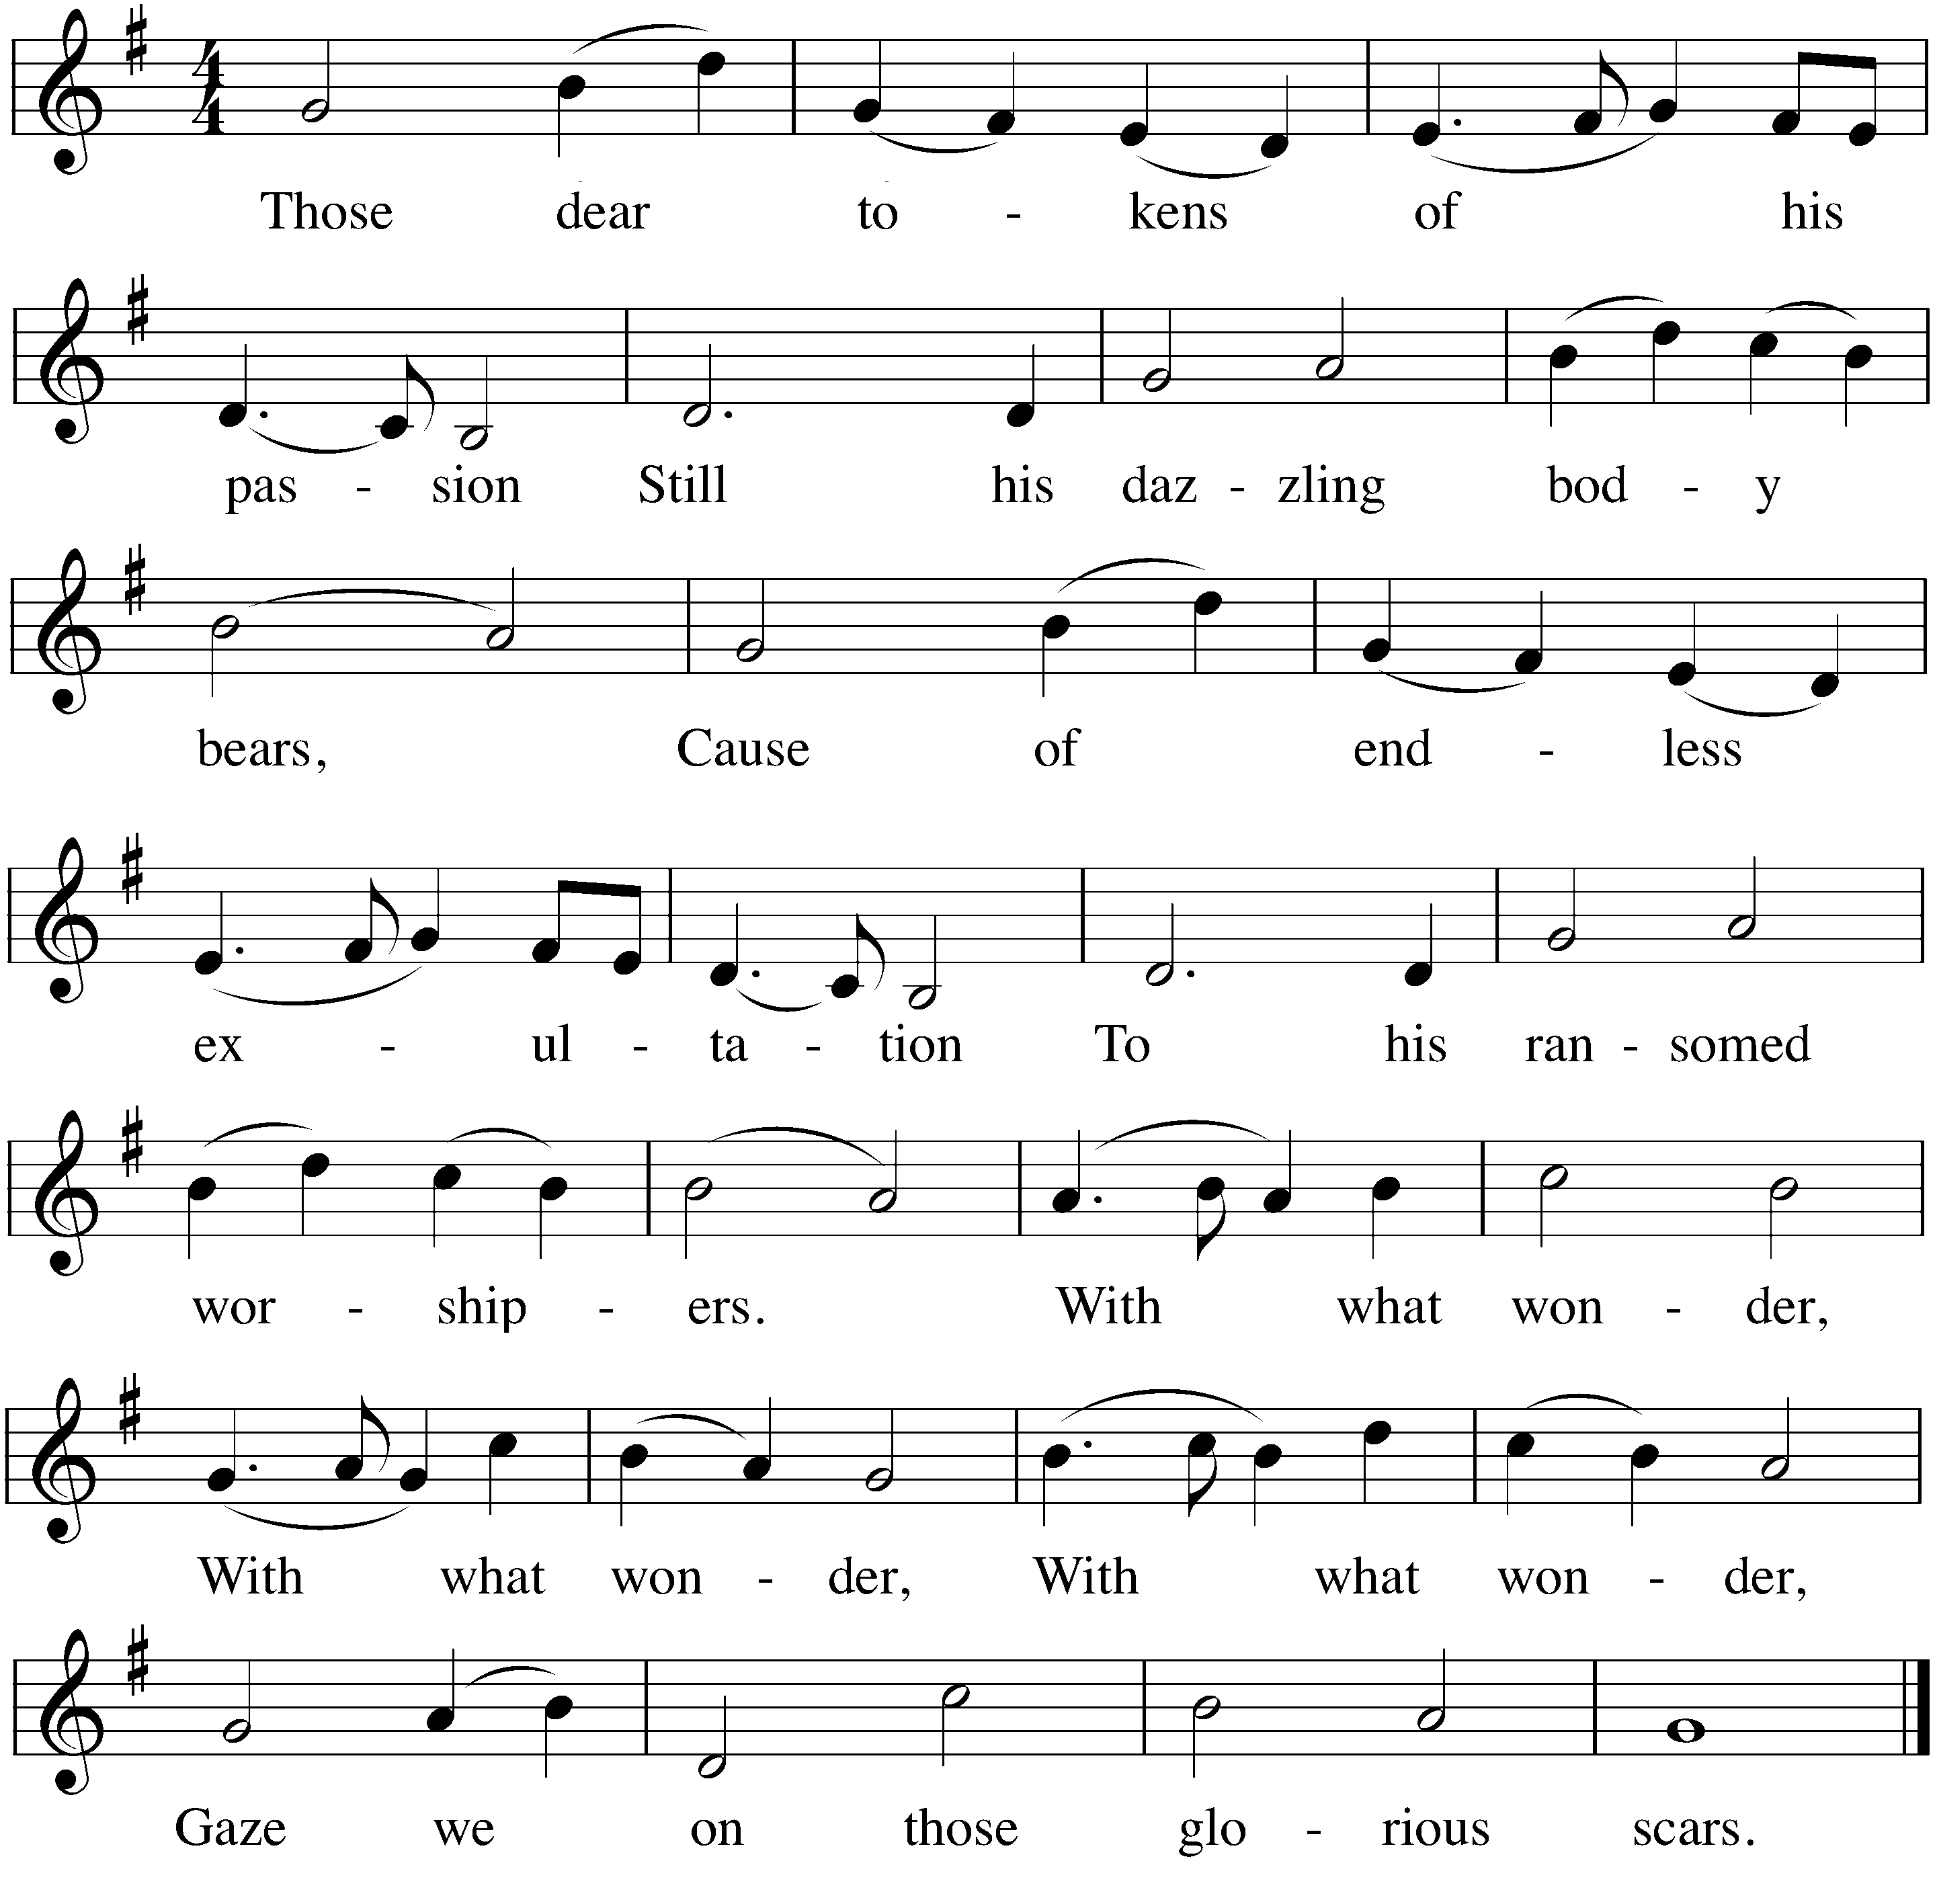

CHILDREN’S MESSAGE

SECOND LESSON 2 Thessalonians 1:5-10

The Lord Jesus is revealed as a judge. His ruling will be just. Those who do not acknowledge him
will be punished. But those who have faith in him will be brought to everlasting glory.

⁵ All this is evidence that God’s judgment is right, and as a result you will be counted worthy of the kingdom of God, for which you are suffering.⁶ God is just: He will pay back trouble to those who trouble you ⁷ and give relief to you who are troubled, and to us as well. This will happen when the Lord Jesus is revealed from heaven in blazing fire with his powerful angels. ⁸ He will punish those who do not know God and do not obey the gospel of our Lord Jesus. ⁹ They will be punished with everlasting destruction and shut out from the presence of the Lord and from the glory of his might ¹⁰ on the day he comes to be glorified in his holy people and to be marveled at among all those who have believed. This includes you, because you believed our testimony to you.

VERSE OF THE DAY Matthew 24:42

M: Alleluia. Watch, therefore, for you do not know on what day your Lord is coming. Alleluia.
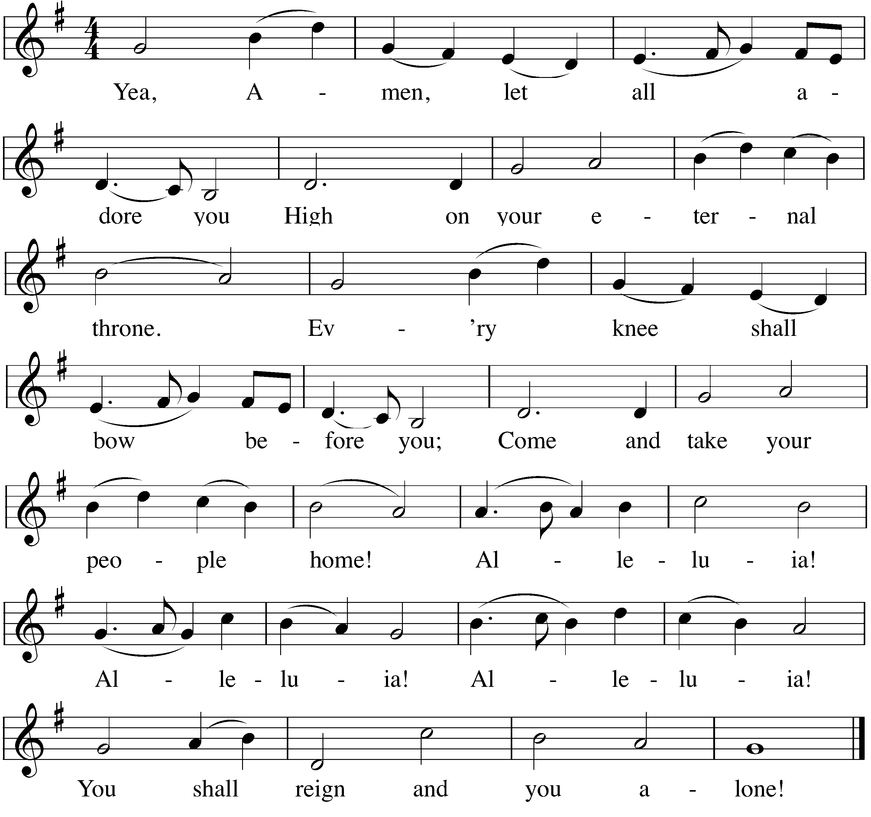
After a musical introduction, the congregation sings…

GOSPEL Luke 19:11-27

Through a parable Jesus teaches that on Judgment Day those who wasted their God-given gifts will have to
give an account. Fortunately, when judging us, the Master will look at what Christ has done as our Savior.

¹¹ While they were listening to this, he went on to tell them a parable, because he was near Jerusalem and the people thought that the kingdom of God was going to appear at once. ¹² He said: “A man of noble birth went to a distant country to have himself appointed king and then to return. ¹³ So he called ten of his servants and gave them ten minas. ‘Put this money to work,’ he said, ‘until I come back.’
¹⁴ “But his subjects hated him and sent a delegation after him to say, ‘We don’t want this man to be our king.’
¹⁵ “He was made king, however, and returned home. Then he sent for the servants to whom he had given the money, in order to find out what they had gained with it.
¹⁶ “The first one came and said, ‘Sir, your mina has earned ten more.’
¹⁷ “‘Well done, my good servant!’ his master replied. ‘Because you have been trustworthy in a very small matter, take charge of ten cities.’
¹⁸ “The second came and said, ‘Sir, your mina has earned five more.’
¹⁹ “His master answered, ‘You take charge of five cities.’
²⁰ “Then another servant came and said, ‘Sir, here is your mina; I have kept it laid away in a piece of cloth. ²¹ I was afraid of you, because you are a hard man. You take out what you did not put in and reap what you did not sow.’
²² “His master replied, ‘I will judge you by your own words, you wicked servant! You knew, did you, that I am a hard man, taking out what I did not put in, and reaping what I did not sow? ²³ Why then didn’t you put my money on deposit, so that when I came back, I could have collected it with interest?’
²⁴ “Then he said to those standing by, ‘Take his mina away from him and give it to the one who has ten minas.’
²⁵ “‘Sir,’ they said, ‘he already has ten!’
²⁶ “He replied, ‘I tell you that to everyone who has, more will be given, but as for the one who has nothing, even what they have will be taken away. ²⁷ But those enemies of mine who did not want me to be king over them—bring them here and kill them in front of me.’”

M: This is the Gospel of our Lord.
C: Praise be to you, O Christ!
HYMN OF THE DAY — 337, vs. 1, 2, 3, & 4 Delay Not! Delay Not

SERMON

CONFESSION OF FAITH Apostles’ Creed
I believe in God, the Father almighty, maker of heaven and earth.
I believe in Jesus Christ, his only Son, our Lord, who was conceived by the Holy Spirit, born of the virgin Mary, suffered under Pontius Pilate, was crucified, died, and was buried. He descended into hell. The third day he rose again from the dead. He ascended into heaven, and is seated at the right hand of God the Father almighty. From there he will come to judge the living and the dead.
I believe in the Holy Spirit, the holy Christian Church, the communion of saints, the forgiveness of sins, the resurrection of the body, and the life everlasting.
Amen.

THANK OFFERING

Members of this congregation have joined together in love and faith to do the Lord’s work in this community and around the world. Visitors need not feel obligated to participate in this offering which supports our ministry.

 Prayers 

PRAYER OF THE CHURCH

M: Out of the depths we cry to you, O Lord; O Lord, hear our voices.
C: Let your ears be attentive to our cries for mercy.
M: Heavenly Father, we confess with sorrow that we have sinned
and deserve only your anger and punishment.
C: If you kept a record of sins, we would surely be lost.
M: We confess with joy that your unfailing love has redeemed us.
C: Our hope is in you and in your full redemption.
M: Around us we see the birth pangs of the last days:
war, famine, earthquakes, false prophets, spiritual apathy.
C: Use these signs to remind us that we do not know
the day or the hour when Christ will come again.
M: Keep us faithful to your Word; send your Spirit to strengthen our faith
so that we are always prepared for your Son’s return as judge.
C: Make us faithful in sharing your Word,
and cause many more to put their hope in you before the end comes.
M: Build our fellowship of love as brothers and sisters in faith.
C: Help us support one another when trials and troubles come our way.
Special prayers and intercessions may follow
M: Hear us, Lord, as we bring you our private petitions.
Silent prayer
M: Heavenly Father, we eagerly await for Jesus to come again and make all things new.
May he find us, whose names are written in the Lamb’s book of life,
faithfully enduring until the end, through the power of your Holy Spirit.
C: Come, Lord Jesus. May your grace be with us. Amen.
LORD’S PRAYER
M: Lord, remember us in your kingdom, and teach us to pray:
C: Our Father in heaven, hallowed be your name, your kingdom come, your will be done on earth as in heaven. Give us today our daily bread. Forgive us our sins, as we forgive those who sin against us. Lead us not into temptation, but deliver us from evil. For the kingdom, the power, and the glory are yours now and forever. Amen.
BLESSING
M: Brothers and sisters, go in peace. Live in harmony with one another. Serve the Lord with gladness.

The Lord bless you and keep you.
The Lord make his face shine on you and be gracious to you.
The Lord look on you with favor and give  you peace.
C: Amen.

CLOSING HYMN — 382 My Hope Is Built on Nothing Less

COPYRIGHT INFORMATION
The following items are reprinted under OneLicense.net #A-000000

