 Holy Communion 

OPENING SENTENCES
M: The Lord be with you.
C: And also with you.
M: Lift up your hearts.
C: We lift them up to the Lord.
M: Let us give thanks to the Lord our God.
C: It is good and right so to do.
M: It is truly good and right that we should at all times and in all places give you thanks, O Lord, holy Father, almighty and everlasting God, through Jesus Christ, our Lord, who promised that wherever two or three come together in his name, there he is with them to shepherd his flock till he comes again in glory. Therefore, with all the saints on earth and hosts of heaven, we praise your holy name and join their glorious song:

HOLY, HOLY, HOLY Sanctus

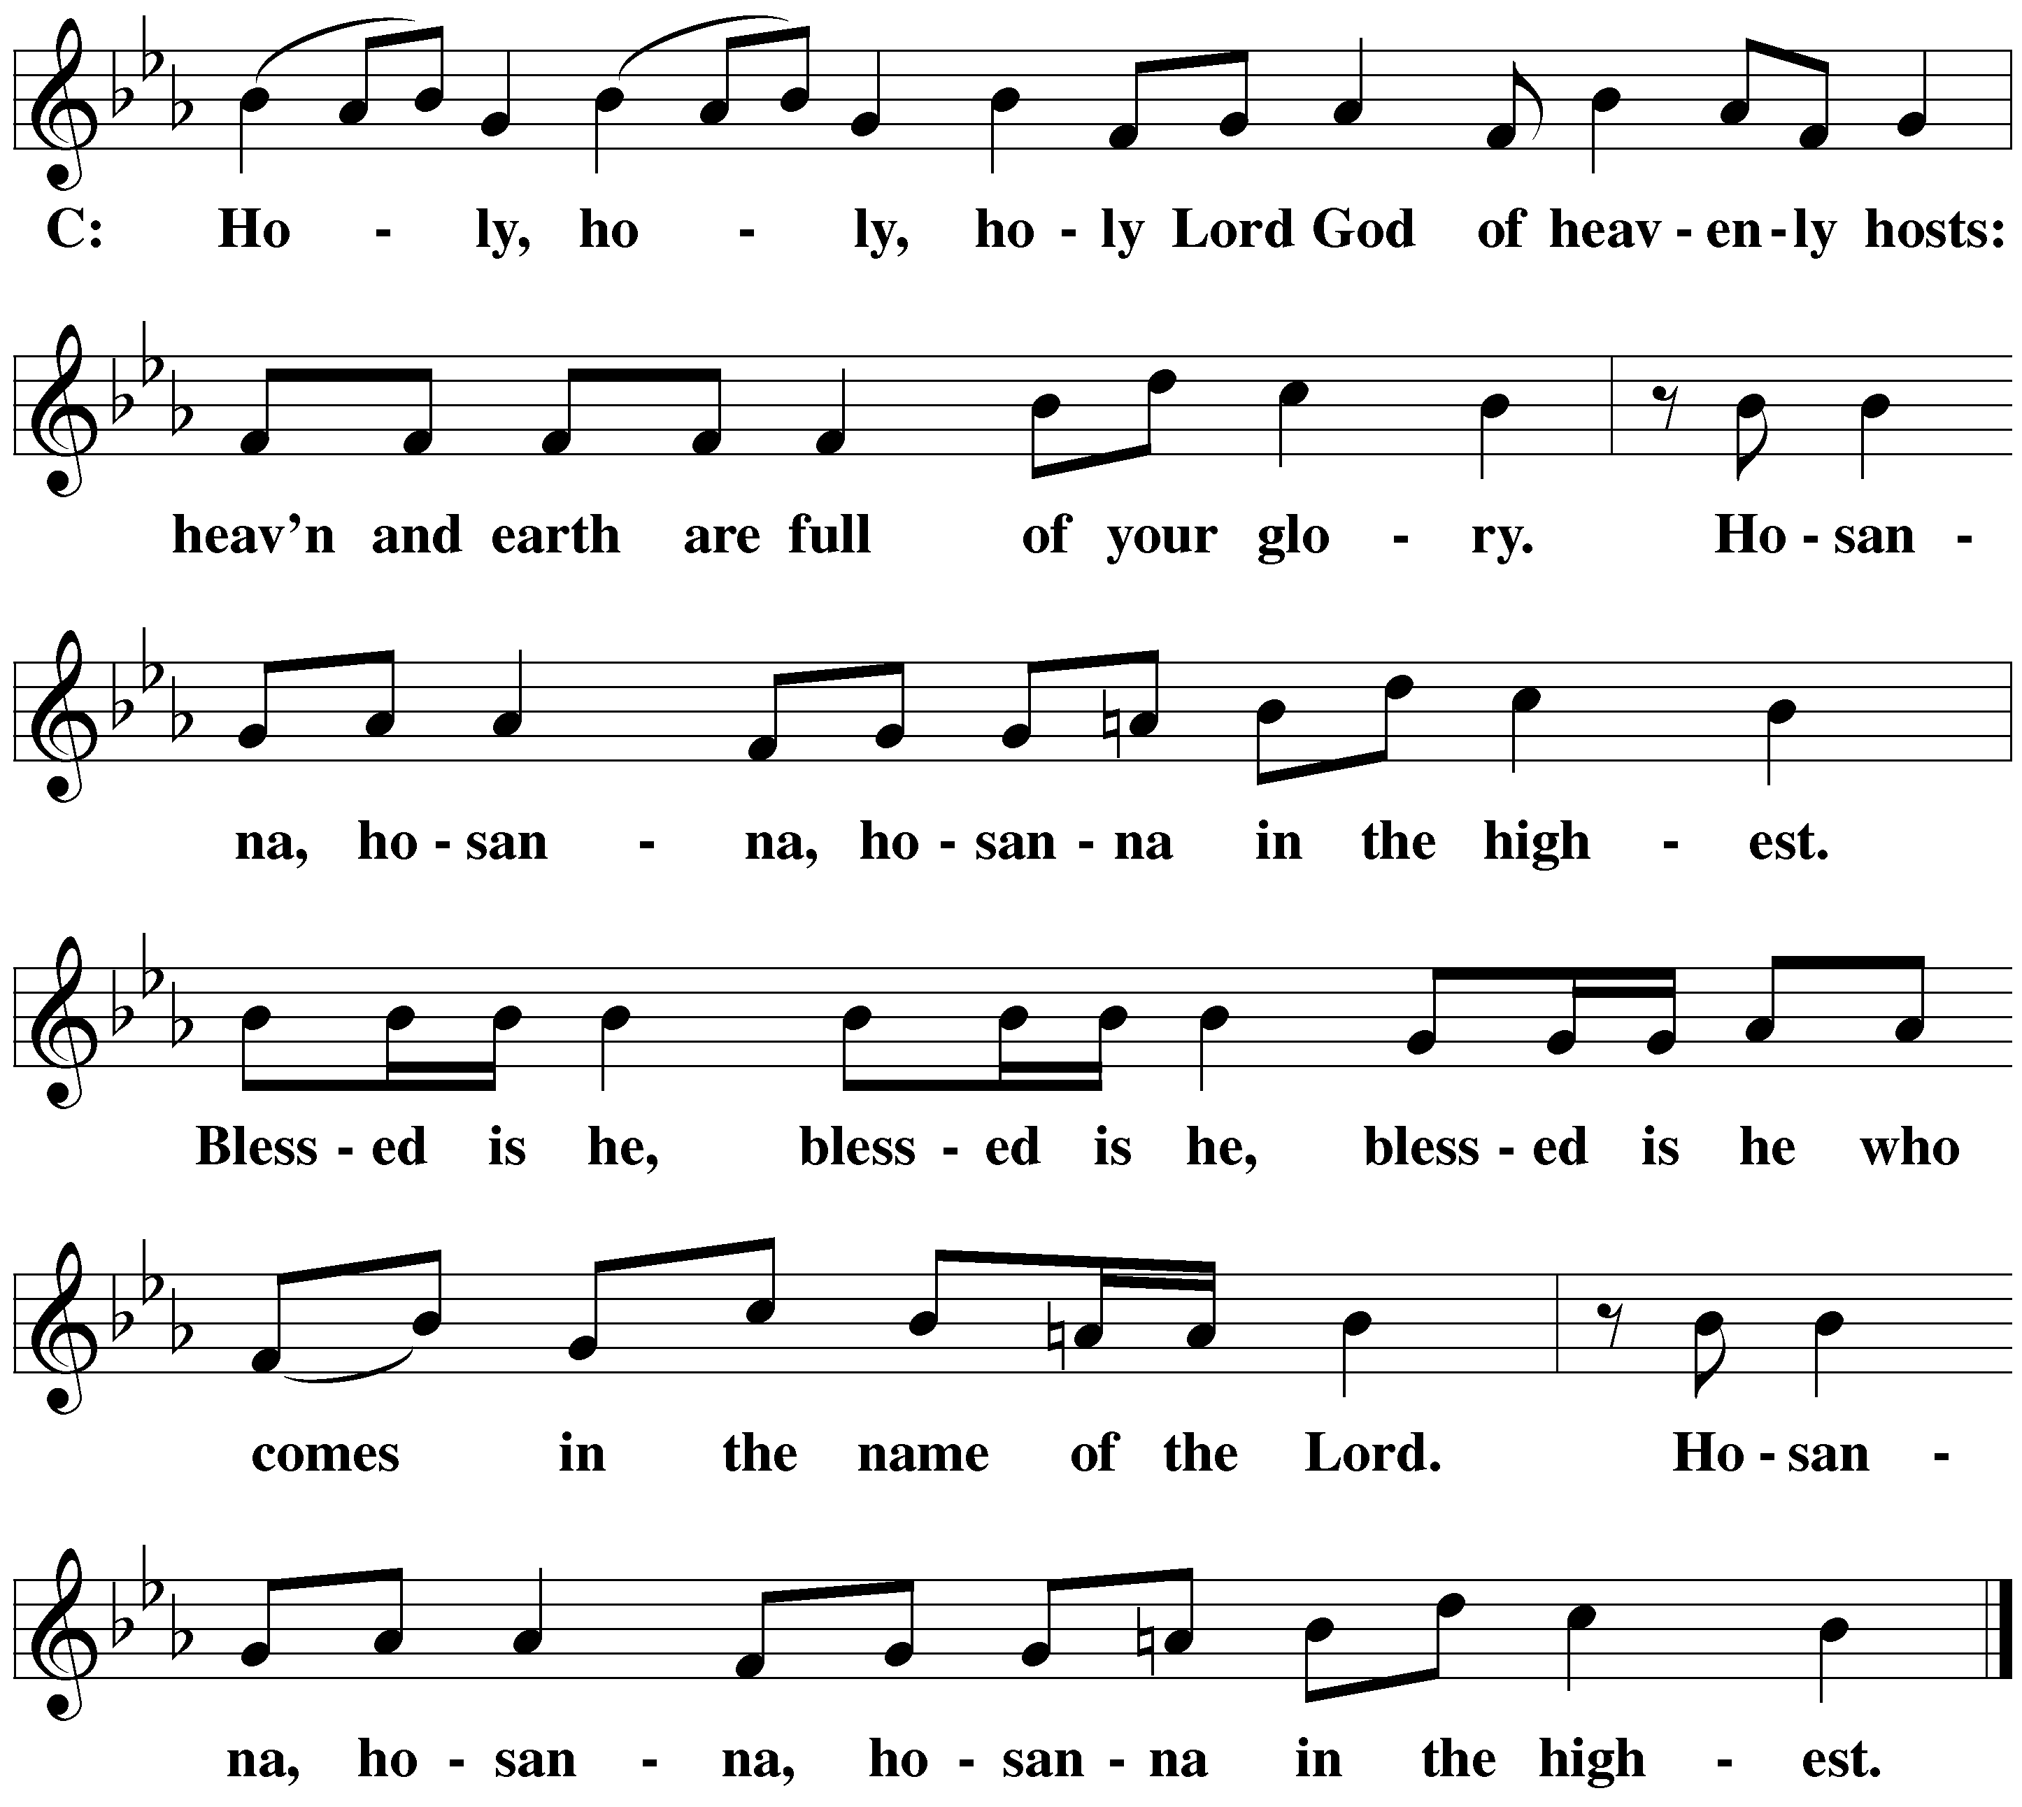

WORDS OF INSTITUTION
M: Our Lord Jesus Christ, on the night he was betrayed, took bread; and when he had given thanks, he broke it and gave it to his disciples, saying, “Take and eat; this is my  body, which is given for you. Do this in remembrance of me.”
Then he took the cup, gave thanks, and gave it to them, saying, “Drink from it, all of you; this is my  blood of the new covenant, which is poured out for you for the forgiveness of sins. Do this, whenever you drink it, in remembrance of me.”
The peace of the Lord be with you always.
C: Amen.

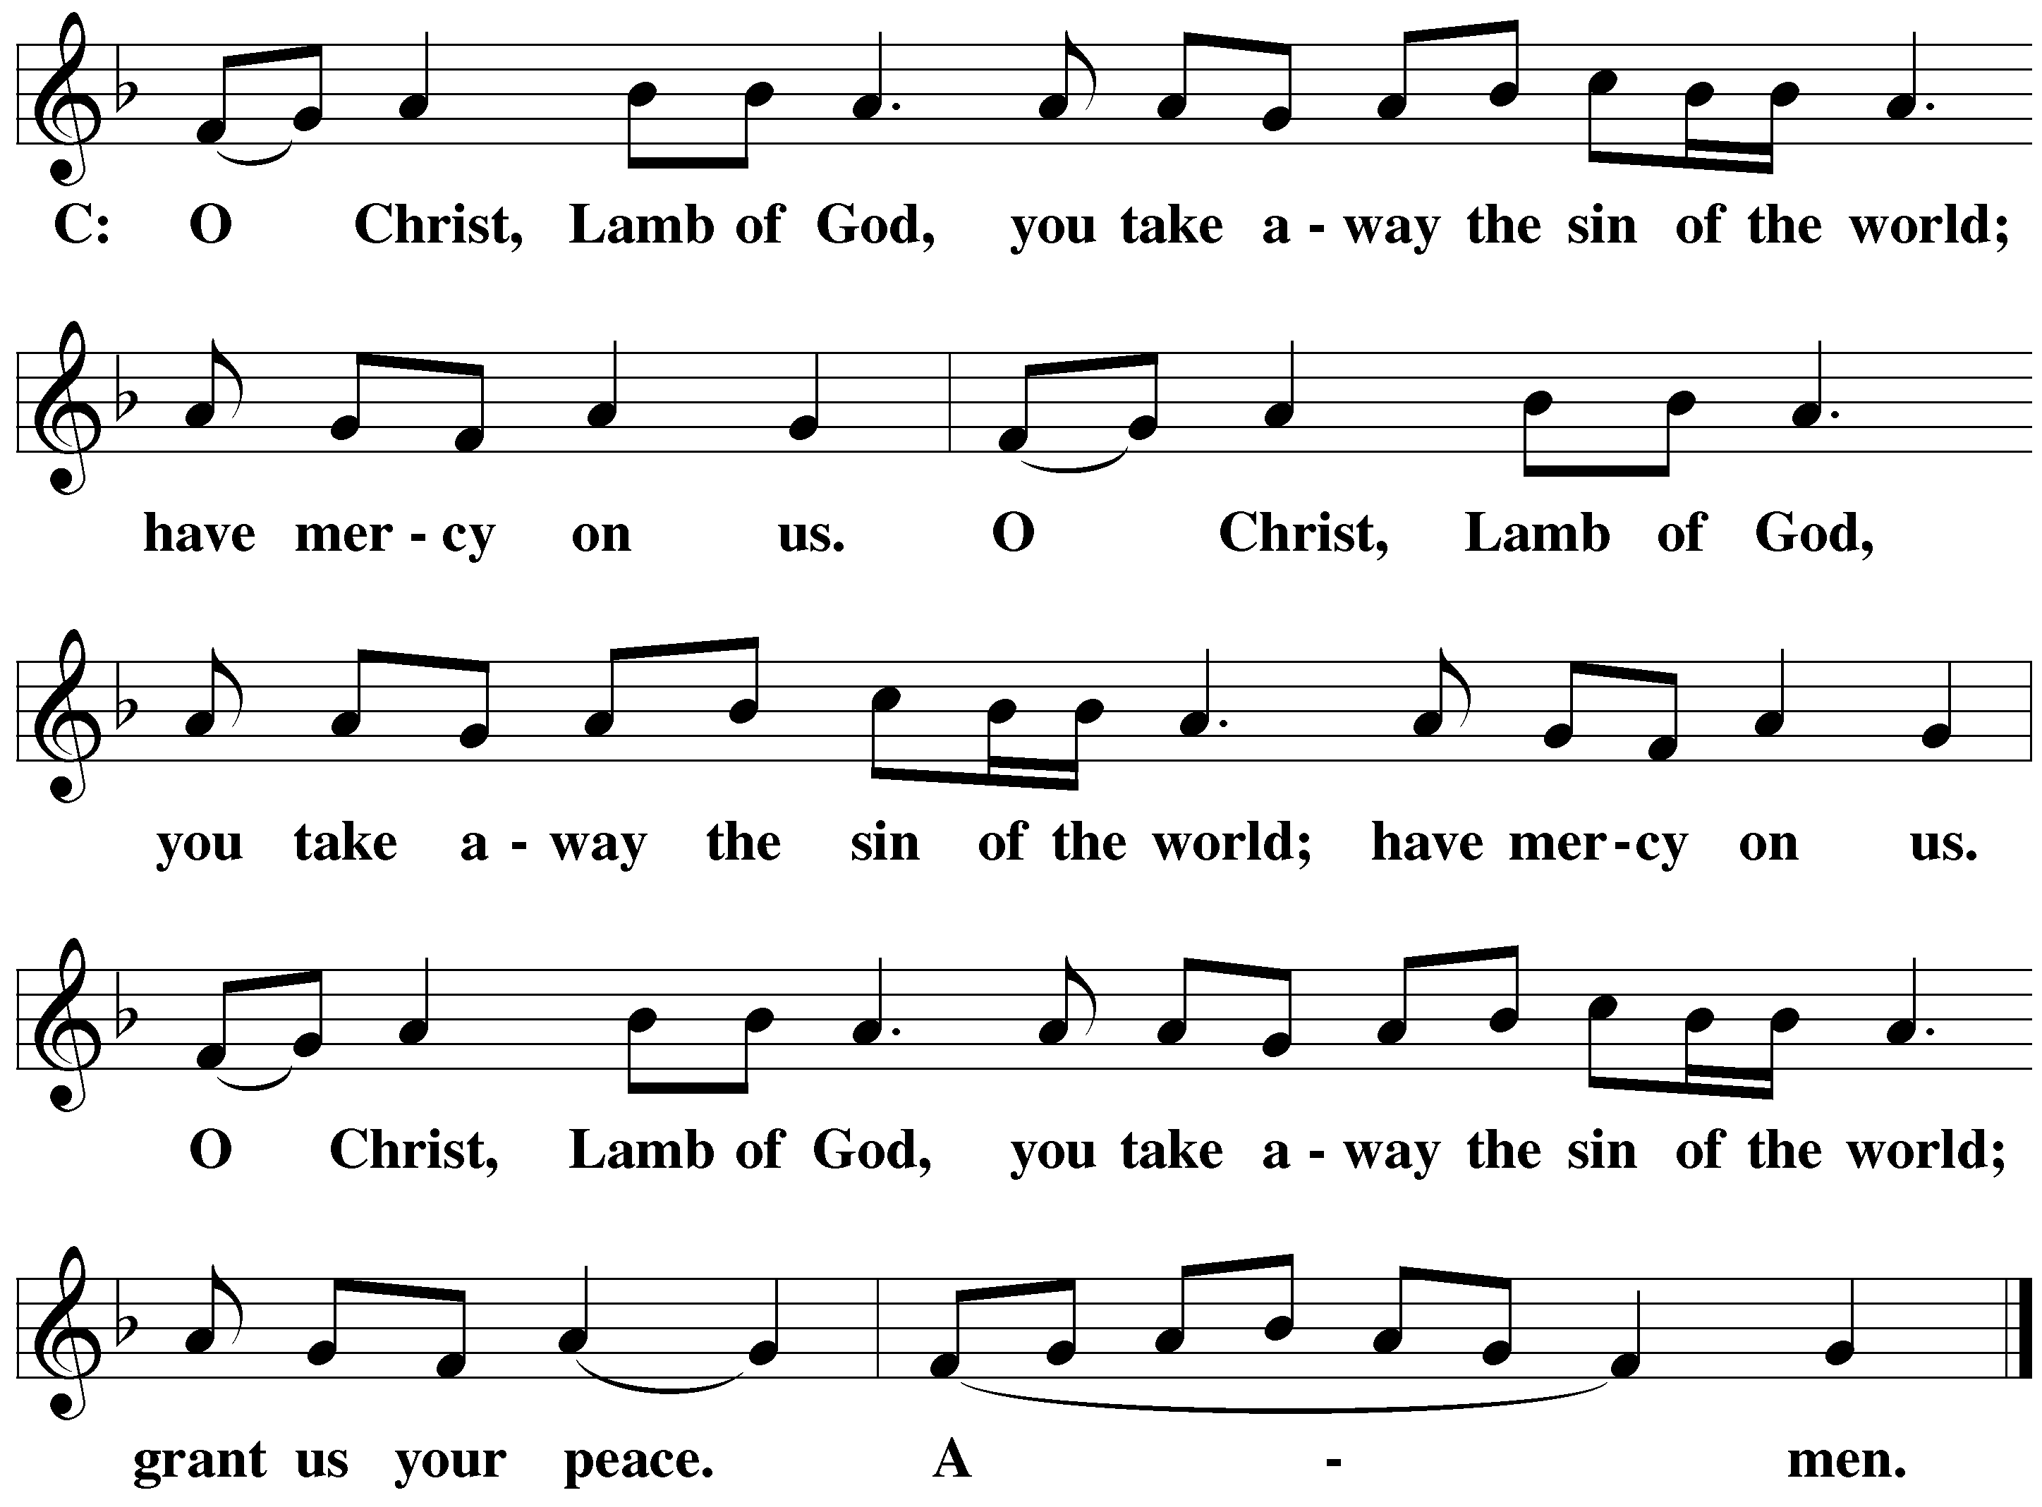
O CHRIST, LAMB OF GOD Agnus Dei

DISTRIBUTION HYMN — 492 Son of God, Eternal Savior

DISTRIBUTION HYMN — 309 Draw Near and Take the Body of the Lord

CLOSING PRAYER
M: We give you thanks, O Lord,
for the foretaste of the heavenly banquet
that you have given us to eat and to drink in this sacrament.
Through this gift you have fed our faith,
nourished our hope,
and strengthened our love.
By your Spirit help us to live as your holy people
until that day when you will receive us as your guests
at the wedding supper of the Lamb,
who lives and reigns with you and the Holy Spirit,
one God, now and forever.
C: Amen.

BLESSING
M: Brothers and sisters, go in peace.
Live in harmony with one another.
Serve the Lord with gladness.

The Lord bless you and keep you.
The Lord make his face shine on you and be gracious to you.
The Lord look on you with favor and give  you peace.
C: Amen.

