

**Third Sunday in End Time / Saints Triumphant**

**November 17, 2019**

Church Name

**CHURCH**

**LOGO**

**HERE**

EVANGELICAL LUTHERAN CHURCH

*Church tagline, i.e. a very brief summary of your mission statement*

W

**elcome!** Thank you for joining us for worship this morning. In our service we gather before our almighty God to offer him our worship and praise. We also gather to strengthen ourselves through the study of God’s holy and powerful Word.

* **Restrooms** are located in the hallway directly opposite the entrance to the sanctuary.
* **Staffed nursery.** We offer a staffed nursery for ages 2 to 6 and special needs children. It is located to the left of the entry foyer near the kitchen.
* **Connection Cards** are inside the worship folder. We ask that before worship or during the offering, you fill those out, front and back. Then place them in the offering plate after the sermon.
* Additional info: church contact info, etc.
* **Prayer before worship**

**The Season of End Time**

The Church Year comes a close in November with the season of End Time. In this season, we are reminded that we are living in the “last days” between Christ’s first coming at Christmas and his second coming on Judgment Day. The world could end at any time. For a believer, the end of his life or the end of the world is a wonderful thing! It means the beginning of a new and better existence in a much more glorious world than this one.

**Our Worship Series: Welcome Home**

|  |
| --- |
| **Welcome Home!** |
| *Our Need for Christian Community* |
| *The Lost Are Now Found* |
| *You Are Free to Be Yourself* |
| *You Are Perfectly Safe Here* |
| *You Have an Everlasting Family* |
| *You are Part of Christ’s Glorious Kingdom* |

The Holy Spirit wants believers to think of each other as family. Having a spiritual family is essential to our well-being. In this worship series, we look at how our Father knits us together in love and unity. We see the benefits of being part of this family. In the Church, Christ has given us a better home.

**Our Theme for Today: You Have an Everlasting Family**

Death is ugly. It does not matter if someone dies after a long, protracted fight with some illness or if they die peacefully in their sleep. Either way, the body goes into the ground and begins to decay. Either way, that person is gone, and their absence is constantly noticed.

Death would be overwhelming were it not for the fact that, for the believer, Christ has completely transformed death. Death is not the end. For those who are part of Christ’s family, death is the beginning of a new and better life, one where the deceased has triumphed over sin and all its consequences.

We thank God for this beautiful gospel truth—that Christians have an everlasting family. When Christian loved ones die, they are not “lost.” Something is lost when: a) you don’t know where it is, and therefore b) you will not see it again. We know exactly where our deceased Christian loved ones are. We look forward to being reunited with them soon.

Today, we celebrate the Saints Triumphant—those believers who have died and been welcomed into their true home with Jesus.



**Order of Service for**

**SAINTS TRIUMPHANT**

** Gathering **

**OPENING HYMN — 551: verses 1, 2, & 3 *For All the Saints***

**INVOCATION**

M: The grace of our Lord  Jesus Christ, the love of God,

and the fellowship of the Holy Spirit be with you all. *2 Corinthians 13:13*

**C:** **And also with you.**

M: I heard a voice from heaven say,

"Write: Blessed are the dead who die in the Lord."

**C:** **"Yes," says the Spirit, "they will rest from their labor,**

**for their deeds will follow them."** *Revelation 14:13*

M: For the saints of the Most High will receive the kingdom

and will possess it forever —

**C: yes, for ever and ever!** *Daniel 7:18*

**CONFESSION OF SINS**

M: Beloved in the Lord,

we desire to one day join the saints triumphant in heaven.

Yet we have disobeyed God, and deserve only his wrath and punishment.

Therefore, let us draw near with a true heart and confess our sins to God our Father,

asking him in the name of our Lord Jesus Christ to grant us forgiveness.

C: **Holy and merciful Father, I confess that I am by nature sinful,**

**and that I have disobeyed you in my thoughts, words, and actions.**

**I have done what is evil and failed to do what is good.**

**For this I deserve your punishment both now and in eternity.**

**But I am truly sorry for my sins, and trusting in my Savior Jesus Christ, I pray:**

**Lord, have mercy on me, a sinner.**

M: God, our heavenly Father, has been merciful to us

and has given his only Son to be the atoning sacrifice for our sins.

Therefore, as a called servant of Christ and by his authority,

I forgive you all your sins in the name of the Father and of the Son  and of the Holy Spirit.

**C:** **Amen!**

*The rite of Holy Baptism may take place here*

M: In the peace of forgiveness, let us praise the Lord.

*After a brief musical introduction, the congregation sings:*

**ALL (sung): Oh, blest communion, fellowship divine!**

**We feebly struggle; they in glory shine,**

**Yet all are one within your grand design. Alleluia! Alleluia!**

**And when the fight is fierce, the warfare long,**

**Steals on the ear the distant triumph-song,**

**And hearts are brave again and arms are strong. Alleluia! Alleluia!**

**The golden evening brightens in the west;**

**Soon, soon, to faithful warriors comes their rest.**

**Sweet is the calm of paradise the blest. Alleluia! Alleluia!**

**PRAYER OF THE DAY**

M: Almighty God and Savior,

you have set the final day and hour

when we shall be delivered from this world of sin and death.

Keep us ever watchful for the coming of your Son

that we may sit with him

and all your holy ones at the marriage feast in heaven;

through your Son, Jesus Christ, our Lord,

who lives and reigns with you and the Holy Spirit,

one God, now and forever.

**C: Amen.**

** The Word **

**FIRST LESSON Isaiah 65:17-25**

*In the New Jerusalem we will not experience the “former things” like death, crying,  
 and pain. We will enjoy the company of our Christian family for all eternity.*

17“See, I will create new heavens and a new earth.  
 The former things will not be remembered, nor will they come to mind.  
18But be glad and rejoice forever in what I will create,  
 for I will create Jerusalem to be a delight and its people a joy.  
19I will rejoice over Jerusalem and take delight in my people;  
 the sound of weeping and of crying will be heard in it no more.

20“Never again will there be in it an infant who lives but a few days,  
 or an old man who does not live out his years;  
 the one who dies at a hundred will be thought a mere child;  
 the one who fails to reach a hundred will be considered accursed.  
21They will build houses and dwell in them;  
 they will plant vineyards and eat their fruit.  
22No longer will they build houses and others live in them, or plant and others eat.  
 For as the days of a tree, so will be the days of my people;  
 my chosen ones will long enjoy the work of their hands.  
23They will not labor in vain,  
 nor will they bear children doomed to misfortune;  
 for they will be a people blessed by the Lord,

they and their descendants with them.  
24Before they call I will answer;  
 while they are still speaking I will hear.  
25The wolf and the lamb will feed together,  
 and the lion will eat straw like the ox,  
 and dust will be the serpent’s food.  
 They will neither harm nor destroy on all my holy mountain,”  
 says the Lord.

**PSALM OF THE DAY Psalm 150**

M: Praise the Lord. Praise God in his sanctuary;

**C:** **praise him in his mighty heavens.**

M: Praise him for his acts of power;

**C:** **praise him for his surpassing greatness.**

M: Praise him with the sounding of the trumpet,

**C:** **praise him with the harp and lyre,**

M: praise him with timbrel and dancing,

**C:** **praise him with the strings and pipe,**

M: praise him with the clash of cymbals,

**C:** **praise him with resounding cymbals.**

M: Let everything that has breath praise the Lord.

**C:** **Praise the Lord.**

*After a brief musical introduction, the congregation sings:*

**ALL (sung): But then there breaks a yet more glorious day:**

**The saints triumphant rise in bright array;**

**The King of glory passes on his way. Alleluia! Alleluia!**

**SECOND LESSON Revelation 22:1-5**

*The vastness of our heavenly home is beyond our comprehension.  
 We will live in our new home “for ever and ever.”*

1Then the angel showed me the river of the water of life, as clear as crystal, flowing from the throne of God and of the Lamb 2down the middle of the great street of the city. On each side of the river stood the tree of life, bearing twelve crops of fruit, yielding its fruit every month. And the leaves of the tree are for the healing of the nations. 3No longer will there be any curse. The throne of God and of the Lamb will be in the city, and his servants will serve him. 4They will see his face, and his name will be on their foreheads. 5There will be no more night. They will not need the light of a lamp or the light of the sun, for the Lord God will give them light. And they will reign for ever and ever.

**VERSE OF THE DAY Revelation 7:15**

M: Alleluia. They are before the throne of God and serve him day and night in his temple. Alleluia.

*After a brief musical introduction, the congregation sings:*

**ALL (sung): From earth’s wide bounds to ocean’s farthest coast**

**Through gates of pearl streams in the countless host,**

**Singing to Father, Son, and Holy Ghost. Alleluia! Alleluia!**

**GOSPEL Luke 20:27-38**

*Through a parable Jesus teaches that on Judgment Day those who wasted their God-given gifts will have to   
give an account. Fortunately, when judging us, the Master will look at what Christ has done as our Savior.*

27Some of the Sadducees, who say there is no resurrection, came to Jesus with a question. 28“Teacher,” they said, “Moses wrote for us that if a man’s brother dies and leaves a wife but no children, the man must marry the widow and raise up offspring for his brother. 29Now there were seven brothers. The first one married a woman and died childless.30The second 31and then the third married her, and in the same way the seven died, leaving no children. 32Finally, the woman died too. 33Now then, at the resurrection whose wife will she be, since the seven were married to her?”

34Jesus replied, “The people of this age marry and are given in marriage. 35But those who are considered worthy of taking part in the age to come and in the resurrection from the dead will neither marry nor be given in marriage, 36and they can no longer die; for they are like the angels. They are God’s children, since they are children of the resurrection. 37But in the account of the burning bush, even Moses showed that the dead rise, for he calls the Lord ‘the God of Abraham, and the God of Isaac, and the God of Jacob.’ 38He is not the God of the dead, but of the living, for to him all are alive.”

M: This is the Gospel of our Lord.

**C: Praise be to you, O Christ!**

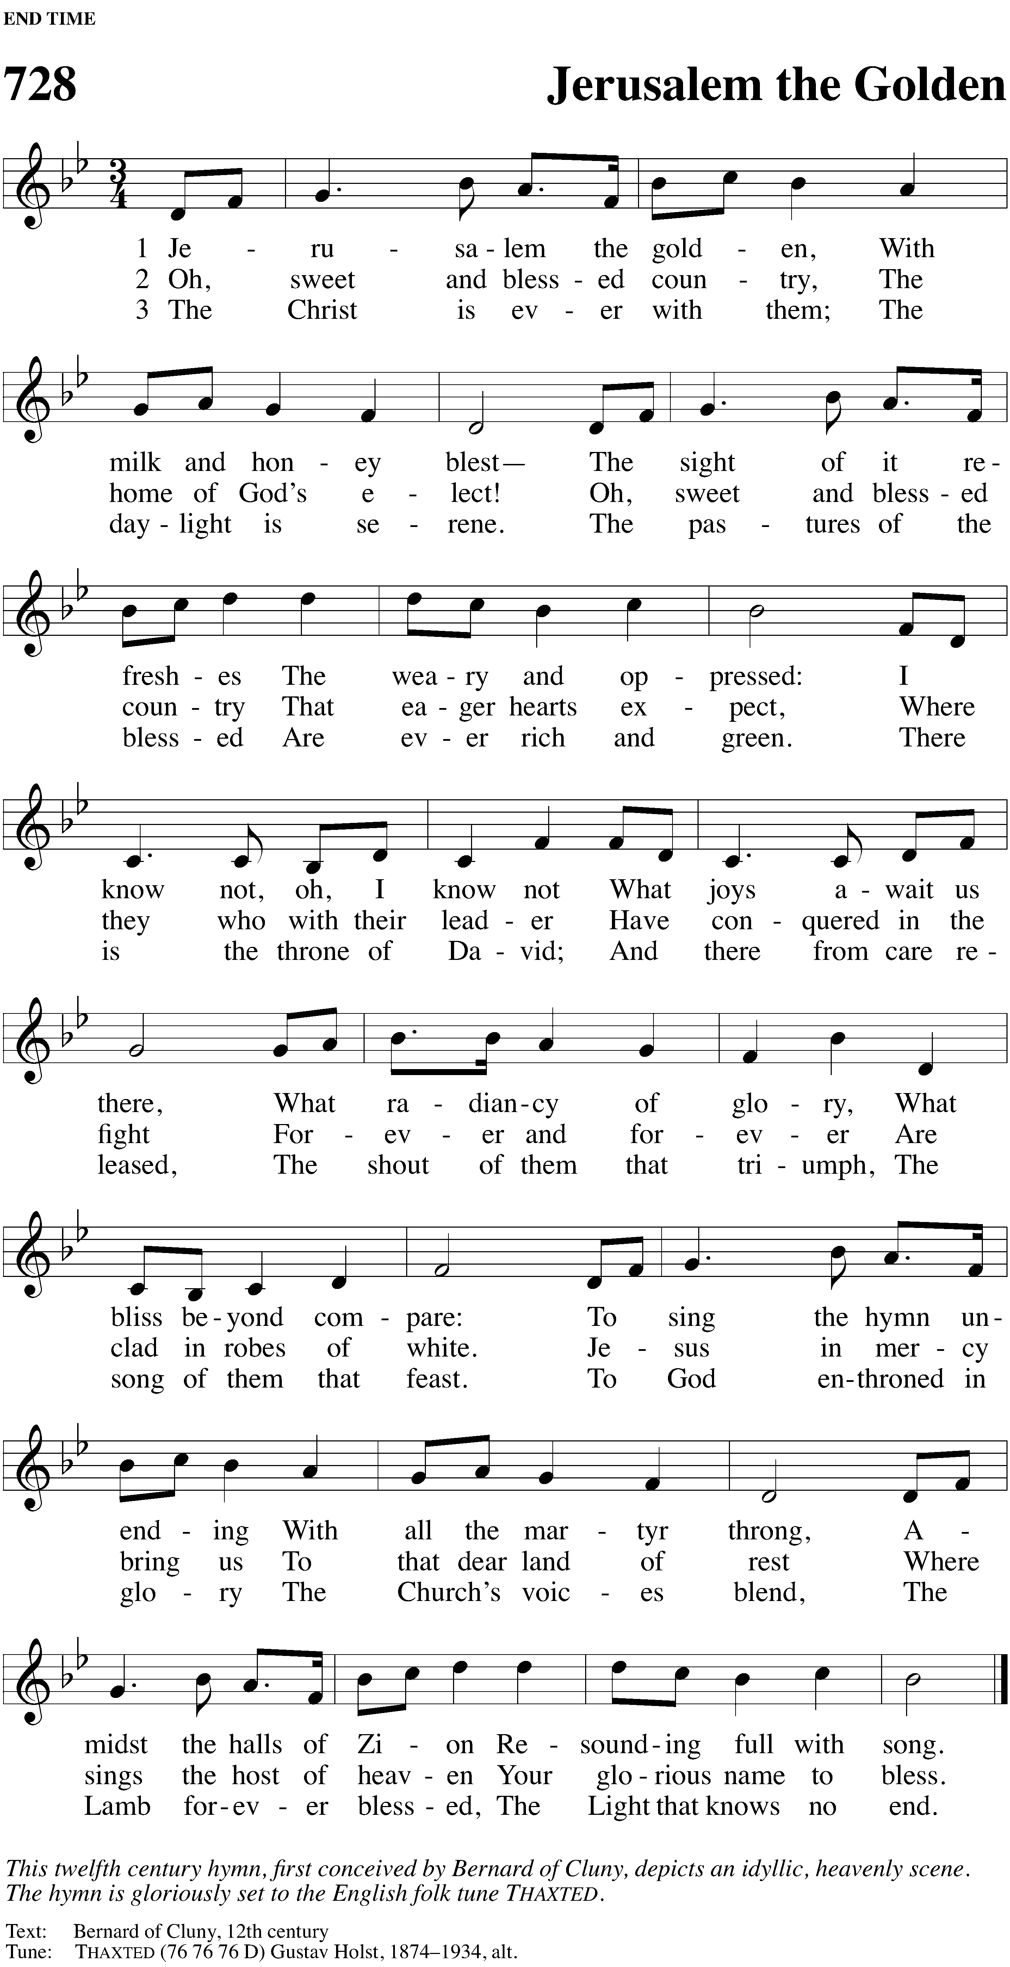**HYMN OF THE DAY — 728 *Jerusalem the Golden***



**SERMON**

**CONFESSION OF FAITH *Apostles’ Creed***

**I believe in God, the Father almighty, maker of heaven and earth.**

**I believe in Jesus Christ, his only Son, our Lord, who was conceived by the Holy Spirit, born of the virgin Mary, suffered under Pontius Pilate, was crucified, died, and was buried. He descended into hell. The third day he rose again from the dead. He ascended into heaven, and is seated at the right hand of God the Father almighty. From there he will come to judge the living and the dead.**

**I believe in the Holy Spirit, the holy Christian Church, the communion of saints, the forgiveness of sins, the resurrection of the body, and the life everlasting.**

**Amen.**

**THANK OFFERING**

** Prayers **

**PRAYER OF THE CHURCH *with commemoration for the faithfully departed***

M: With thanksgiving and praise, O Lord, we remember all your faithful servants who throughout the ages have witnessed to your name: the mighty and the lowly, great leaders and humble men and women, those who have served you in prosperity and those who in the day of trouble have not failed. We rejoice that they now rest from their labors in your presence.

**C:** **You are the rest of the blessed dead. We thank you for all who have died in the peace of Christ. We thank you for those whom you gave to our congregation for a time as a blessing but have now called home. We remember their names before you.**

M: *John Doe* 

I am resurrection and the life. He who believes in me will live, even though he dies.

**C: And whoever lives and believes in me will never die.** *John 11:25-26*

M: *Jane Doe* 

Then I heard a voice from heaven say, “Write this: Blessed are the dead who die in the Lord from now on.”

**C: “Yes,” says the Spirit, “they will rest from their labor.”** *Revelation 13:14*

M: *Jim Doe* 

Since, then, you have been raised with Christ, set your hearts on things above, where Christ is seated at the right hand of God.

**C: Set your minds on things above, not on earthly things.** *Colossians 3:1-2*

M: *Jennifer Doe* 

I know that my Redeemer lives, and that in the end he will stand upon the earth.

**C: And after my skin has been destroyed, yet in my flesh I will see God.** *Job 19:25-26*

M: *Juliette Doe* 

Christ has indeed been raised from the dead,

**C: the firstfruits of those who have fallen asleep.** *1 Corinthians 15:20*

M: *Jason Doe* 

And if I go and prepare a place for you,

**C: I will come again and will take you to myself.** *John 14:3*

M: *Jordan Doe* 

Thanks be to God.

**C: He gives us the victory through our Lord Jesus Christ.** *1 Corinthians 15:57*

*Silent prayer as we remember other members of the saints triumphant*

M: Heavenly Father, we recall with gratitude what you have done for us and for your Church through these saints. May their good works, which were prompted by your love in Christ and performed to your glory while here on earth, encourage us to live for you. As we join our worship and work with theirs, may we acknowledge ourselves to be part of that great cloud of witnesses from every age and place.

**C:** **Unite all your people in the true faith, in the hope of an eternity at your side, and in the love that reveals us to be your children.**

M: Through your Word, remind us who have not yet reached heaven that we remain part of the saints militant. Fill us with your Spirit, so that we continue to wage war for you, as our Christian forefathers did—battling against our sinful flesh, winning souls for Christ, and combating the deadly influence of Satan in this world.

**C: Uphold your promise to use your Word and Sacraments to keep us in the faith so that, when our work on earth is done, we may join the saints triumphant.**

*Special prayers and petitions may follow*

**LORD’S PRAYER**

M: Lord, remember us in your kingdom, and teach us to pray:

**C:** **Our Father in heaven,**

**hallowed be your name,**

**your kingdom come,**

**your will be done on earth as in heaven.**

**Give us today our daily bread.**

**Forgive us our sins,**

**as we forgive those who sin against us.**

**Lead us not into temptation, but deliver us from evil.**

**For the kingdom, the power, and the glory are yours**

**now and forever. Amen.**

**BLESSING**

M: Brothers and sisters, go in peace. Live in harmony with one another. Serve the Lord with gladness.

The Lord bless you and keep you.

The Lord make his face shine on you and be gracious to you.

The Lord look on you with favor and give  you peace.

**C: Amen.**

**CLOSING HYMN — 417 *I’m But a Stranger Here***

A drawing of a face

Description generated with high confidence

COPYRIGHT INFORMATION

The following items are reprinted under OneLicense.net #A-000000