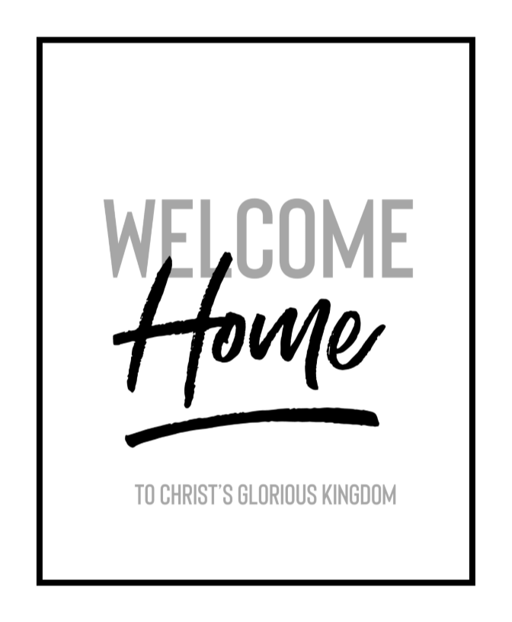

**Fourth Sunday in End Time / Christ the King**

**November 24, 2019**

Church Name

**CHURCH**

**LOGO**

**HERE**

EVANGELICAL LUTHERAN CHURCH

*Church tagline, i.e. a very brief summary of your mission statement*

W

**elcome!** Thank you for joining us for worship this morning. In our service we gather before our almighty God to offer him our worship and praise. We also gather to strengthen ourselves through the study of God’s holy and powerful Word.

* **Restrooms** are located in the hallway directly opposite the entrance to the sanctuary.
* **Staffed nursery.** We offer a staffed nursery for ages 2 to 6 and special needs children. It is located to the left of the entry foyer near the kitchen.
* **Connection Cards** are inside the worship folder. We ask that before worship or during the offering, you fill those out, front and back. Then place them in the offering plate after the sermon.
* Additional info: church contact info, etc.
* **Prayer before worship**

**The Season of End Time**

The Church Year comes a close in November with the season of End Time. In this season, we are reminded that we are living in the “last days” between Christ’s first coming at Christmas and his second coming on Judgment Day. The world could be ended any time. For a believer, the end of his life or the end of the world is a wonderful thing! It means the beginning of a new and better existence in a much more glorious world than this one.

**Our Worship Series: Welcome Home**

|  |
| --- |
| **Welcome Home!** |
| *Our Need for Christian Community* |
| *The Lost Are Now Found* |
| *You Are Free to Be Yourself* |
| *You Are Perfectly Safe Here* |
| *You Have an Everlasting Family* |
| *You Are Part of Christ’s Glorious Kingdom* |

The Holy Spirit wants believers to think of each other as family. Having a spiritual family is essential to our well-being. In this worship series, we look at how our Father knits us together in love and unity. We see the benefits of being part of this family. In the Church, Christ has given us a better home.

**Our Theme for Today: You Are Part of Christ’s Glorious Kingdom**

Windsor. Bernadotte. Bourbon-Anjou. Orange-Nassau. Glücksburg. Liechtenstein.

Do you know what those names have in common? They are all names of royal families. A member of each of those families serves as a monarch. The extended members of those families enjoy fabulous privileges, even if the monarch serves largely as a figurehead.

For the past month, we have seen that Christ has welcomed us into his home and made us part of this family. Today, we see that this is a royal family. For our brother Jesus is King. He does more than serve as a figurehead. Christ rules over all Creation for the benefit of his family. He promises us that one day we will sit with him on his throne (Revelation 3:21).

Today—Christ the King Sunday—the Church Year comes to an end. We praise Christ for his glorious reign. We thank him for making us part of his royal family, giving us a claim to the Kingdom.

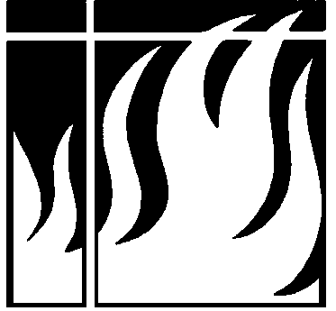

**Order of Service for**

**CHRIST THE KING**

** Gathering **

**OPENING HYMN — 579 *Lift High the Cross***

**INVOCATION**

M: Grace and peace to you from him who is, and who was, and who is to come, and from the seven spirits before his throne, and from Jesus Christ, who is the faithful witness, the firstborn from the dead, and the ruler of the kings of the earth.

**C: To him who loves us and has freed us from our sins by his blood, and has made us to be a kingdom and priests to serve his God and Father—to him be glory and power for ever and ever! Amen.** *Revelation 1:4-6*

**CONFESSION OF SINS**

M: The days are coming," declares the Lord, “when I will raise up to David a righteous Branch, a King who will reign wisely and do what is just and right in the land. In his days Judah will be saved and Israel will live in safety. This is the name by which he will be called: The Lord Our Righteousness.” *Jeremiah 23:5-6*

Since we have such a merciful King, let us humbly approach his throne, confess our sins, and plead for his mercy.

**C: Listen to my cry for help, my King and my God, for to you I pray. You are not a God who takes pleasure in evil; with you the wicked cannot dwell. The arrogant cannot stand in your presence; you hate all who do wrong. But I, by your great mercy, will come into your house; in reverence will I bow down toward your holy temple. Lead me, O Lord, in your righteousness. For surely, O Lord, you bless the righteous; you surround them with your favor as with a shield.**  *Psalm 5:2-5,7-8,12*

M: As God’s called servant I announce to you what the LORD says—your Redeemer, the Holy One of Israel:

“I am the LORD, your Holy One, Israel’s Creator, your King. Fear not, for I have redeemed you; I have summoned you by name; you are mine. You are my witnesses, and my servant whom I have chosen, so that you may know and believe me and understand that I am he.   
I am the LORD, and apart from me there is no savior. I am he who blots out your transgressions, for my own sake, and remembers your sins no more. *Isaiah 43:1,10-11,15,25*

C: **Amen.**

*The rite of Holy Baptism may take place here.*

M: In the peace of forgiveness, let us praise the Lord.

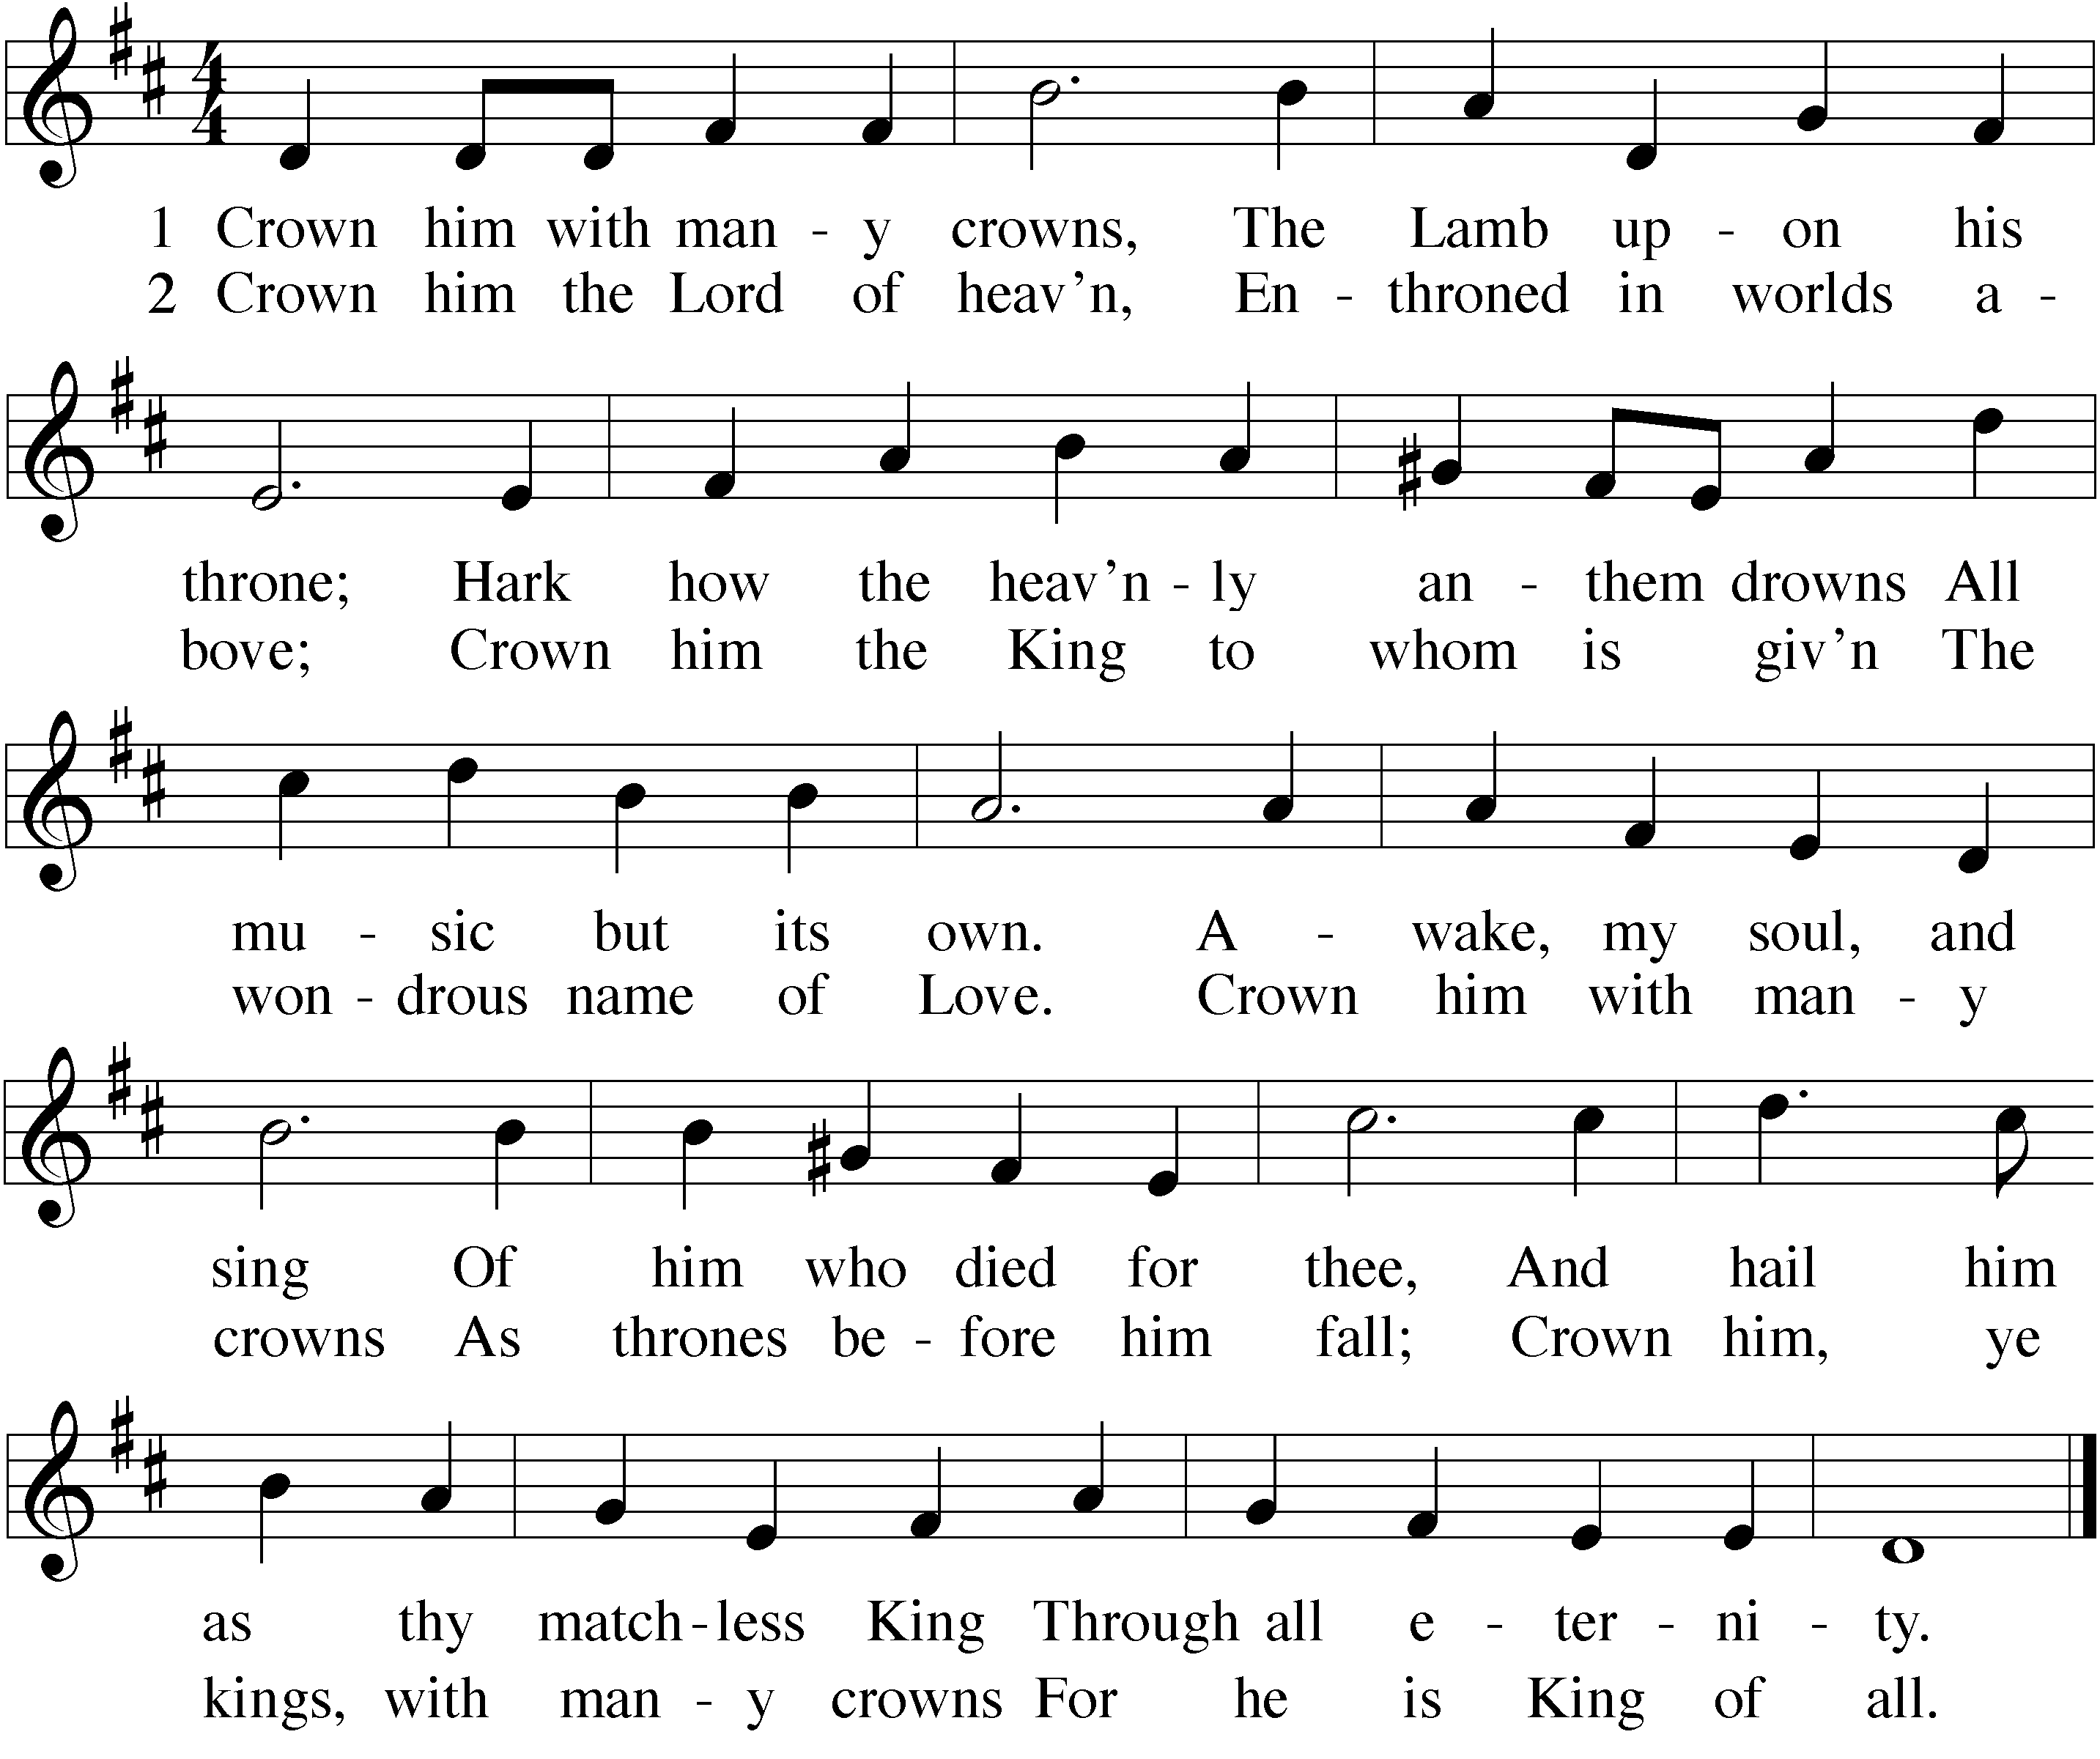 *After a brief musical introduction, the congregation sings:*

**PRAYER OF THE DAY**

M: Lord Jesus Christ,

by your victory you have broken the power of the evil one. Fill our hearts with joy and peace as we look with hope to that day when every creature in heaven and earth will acclaim you King of kings and Lord of lords to your unending praise and glory; for you live and reign with the Father and the Holy Spirit, one God, now and forever.

**C: Amen.**

** The Word **

**FIRST LESSON Jeremiah 23:2-6**

*Christ is the King of kings, with countless sheep in his flock. Yet he cares for every single one.  
 He knows us by name. He leads into his kingdom of peace and righteousness.*

2Therefore this is what the Lord, the God of Israel, says to the shepherds who tend my people: “Because you have scattered my flock and driven them away and have not bestowed care on them, I will bestow punishment on you for the evil you have done,” declares the Lord. 3“I myself will gather the remnant of my flock out of all the countries where I have driven them and will bring them back to their pasture, where they will be fruitful and increase in number. 4I will place shepherds over them who will tend them, and they will no longer be afraid or terrified, nor will any be missing,” declares the Lord.

5“The days are coming,” declares the Lord,  
 “when I will raise up for David a righteous Branch,  
 a King who will reign wisely and do what is just and right in the land.  
 6In his days Judah will be saved and Israel will live in safety.  
 This is the name by which he will be called: The Lord Our Righteous Savior.

They will neither harm nor destroy on all my holy mountain,”  
 says the Lord.

**PSALM OF THE DAY Psalm 45**

M: *Refrain*

**C: *Refrain***

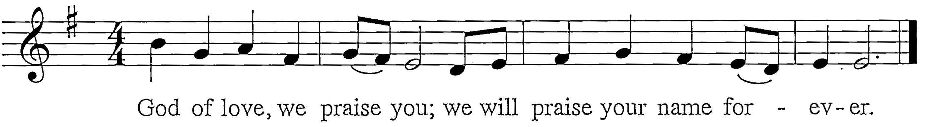

M: My heart is stirred by a noble theme.

[CLICK HERE TO BUY THIS PSALM.](https://online.nph.net/the-peoples-psalter.html)

[THEN YOU CAN DELETE THIS TEXT BOX.](https://online.nph.net/the-peoples-psalter.html)

[PUT YOUR REPRINT LICENSE ON THE BACK OF THE WORSHIP FOLDER UNDER COPYRIGHT INFORMATION.](https://online.nph.net/the-peoples-psalter.html)

I recite verses for the King.

We would try our love to express.

We would speak your righteousness.

**C: *Refrain***

M: Fairer still than human frame,

To our eyes for years the same,

Steadfast love shines from your face.

From your lips flow words of grace.

**C: *Refrain***

M: Yours the scepter, yours the throne.

You, O Lord, are God alone.

Mercies, vast, to all are giv’n:

Wealth of earth, and joy of heav’n.

**C: *Refrain*** *(During the final refrain, the children come forward for the Children’s Message.)*

**CHILDREN’S MESSAGE**

**SECOND LESSON Colossians 1:13-20**

*Everyone is part of a kingdom. The only question is if it is a kingdom of darkness or light. Everyone has a king.  
 The only question is if your king really cares for you. Our Savior-King has proven his love in blood.*

13For he has rescued us from the dominion of darkness and brought us into the kingdom of the Son he loves, 14in whom we have redemption, the forgiveness of sins.

15The Son is the image of the invisible God, the firstborn over all creation. 16For in him all things were created: things in heaven and on earth, visible and invisible, whether thrones or powers or rulers or authorities; all things have been created through him and for him. 17He is before all things, and in him all things hold together. 18And he is the head of the body, the church; he is the beginning and the firstborn from among the dead, so that in everything he might have the supremacy.19For God was pleased to have all his fullness dwell in him, 20and through him to reconcile to himself all things, whether things on earth or things in heaven, by making peace through his blood, shed on the cross.

**VERSE OF THE DAY Revelation 22:13**

M: Alleluia. I am the Alpha and the Omega, the First and the Last, the Beginning and the End.

Alleluia.

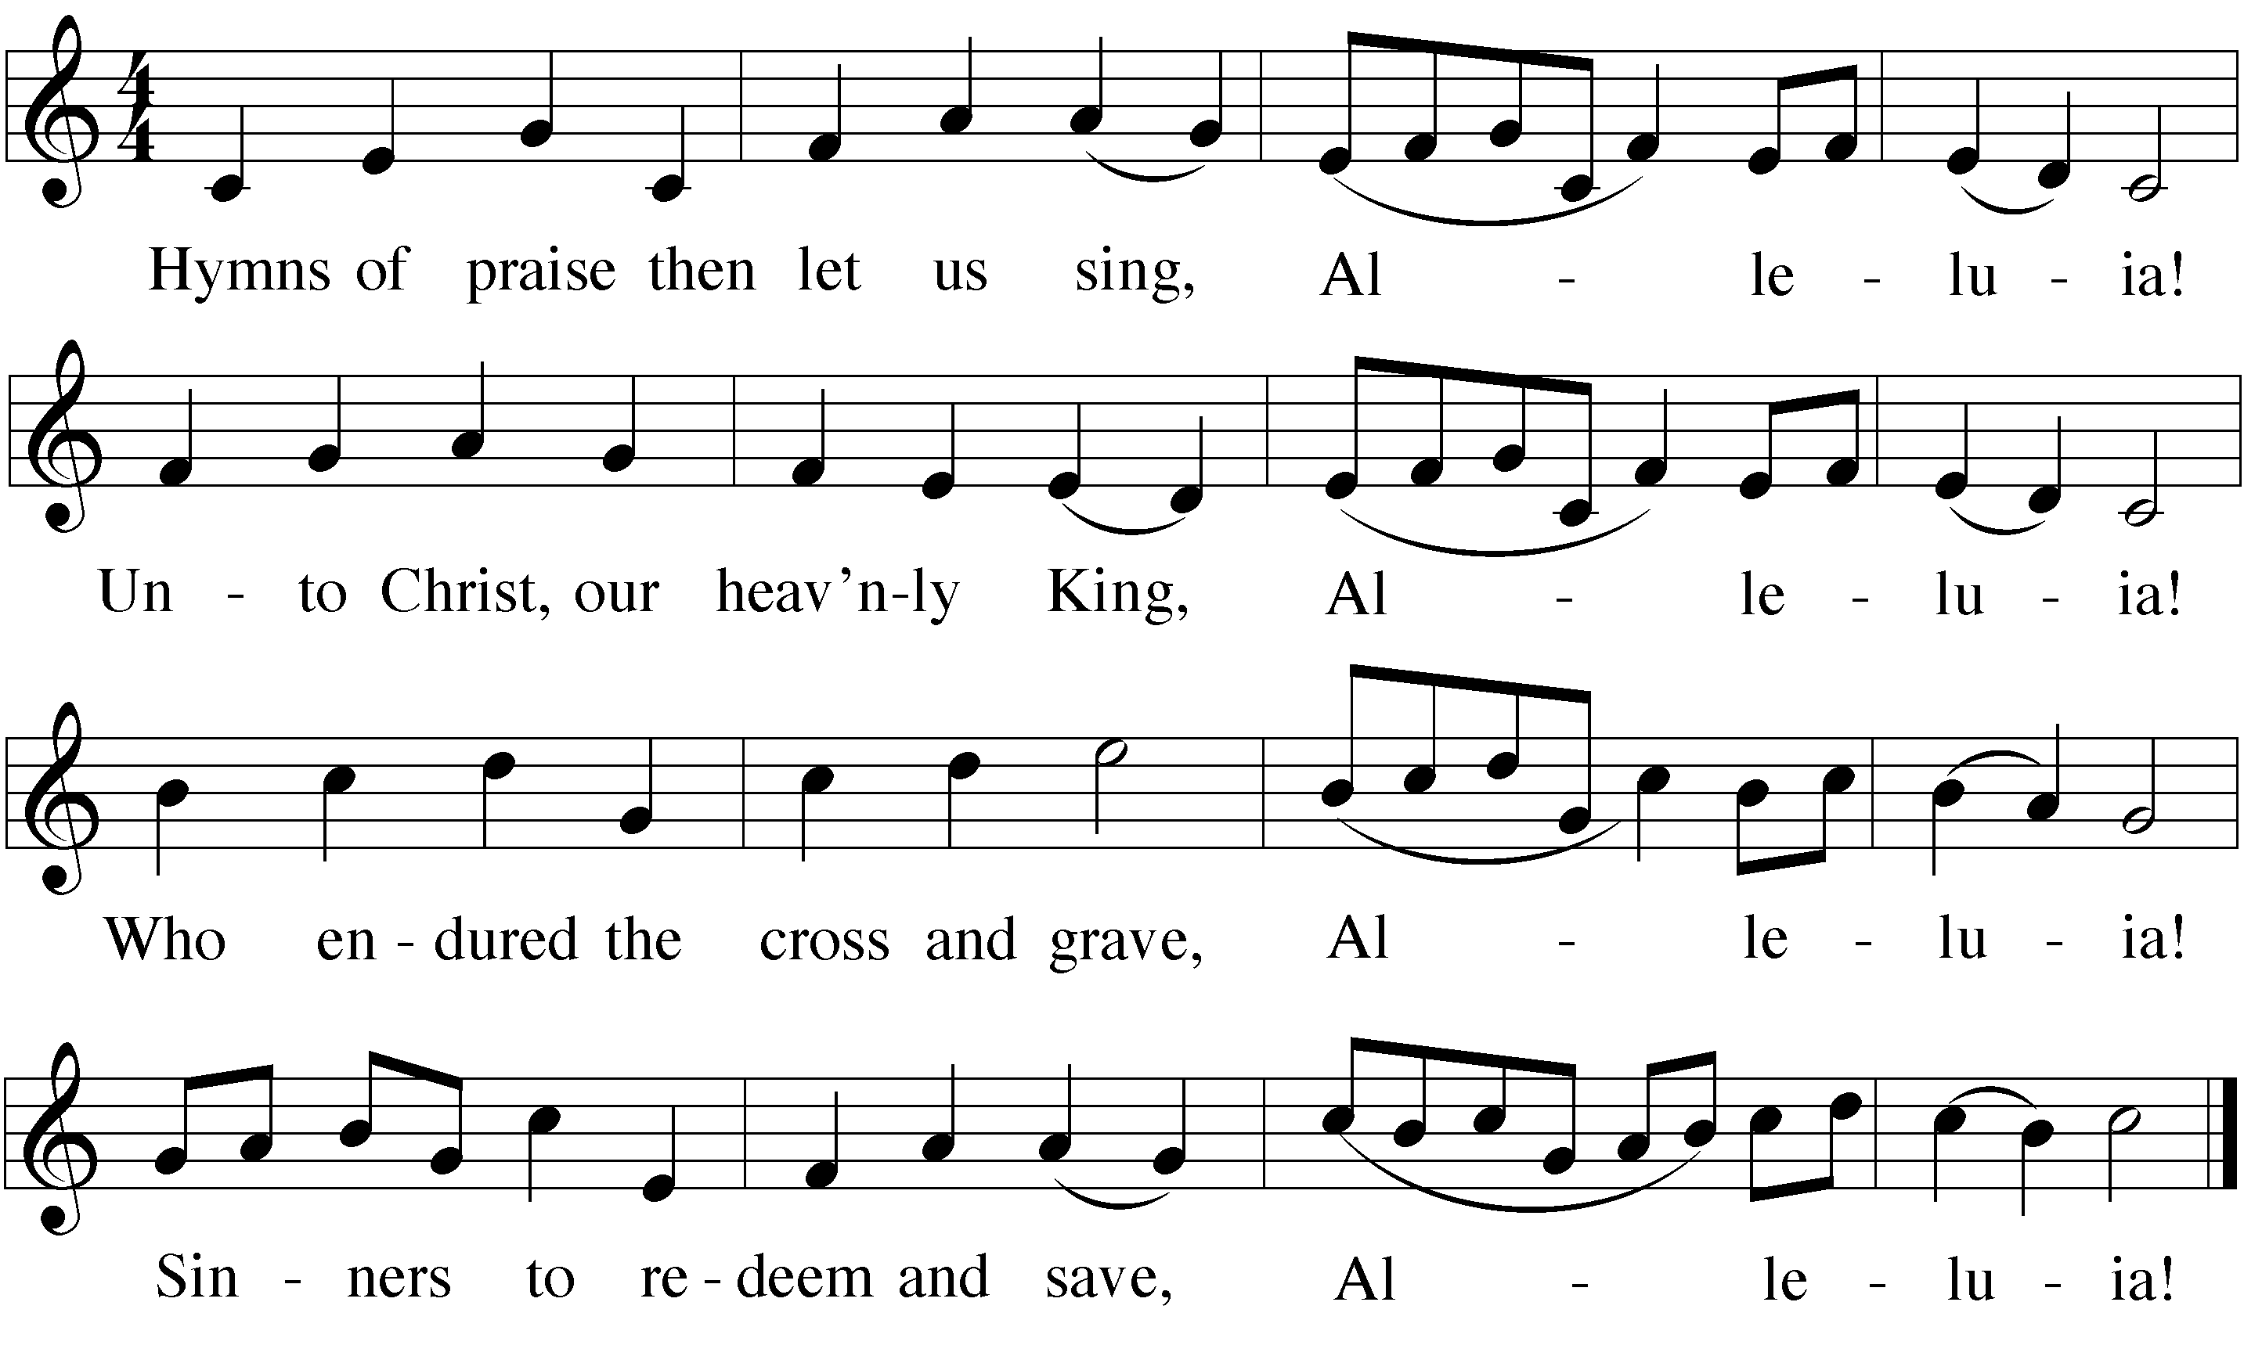*After a one verse musical introduction, the congregation sings*

**GOSPEL Luke 23:35-43**

*With eyes of faith, the criminal sees Jesus for whom he really is—a gracious  
 king, suffering and dying that we might be forgiven.*

35The people stood watching, and the rulers even sneered at him. They said, “He saved others; let him save himself if he is God’s Messiah, the Chosen One.”

36The soldiers also came up and mocked him. They offered him wine vinegar 37and said, “If you are the king of the Jews, save yourself.”

38There was a written notice above him, which read: this is the king of the jews.

39One of the criminals who hung there hurled insults at him: “Aren’t you the Messiah? Save yourself and us!”

40But the other criminal rebuked him. “Don’t you fear God,” he said, “since you are under the same sentence? 41We are punished justly, for we are getting what our deeds deserve. But this man has done nothing wrong.”

42Then he said, “Jesus, remember me when you come into your kingdom.”

43Jesus answered him, “Truly I tell you, today you will be with me in paradise.”

**HYMN OF THE DAY — 351 *Hail, O Once-Despised Jesus***

**SERMON**

**CONFESSION OF FAITH *Apostles’ Creed***

**I believe in God, the Father almighty,**

**maker of heaven and earth.**

**I believe in Jesus Christ, his only Son, our Lord,**

**who was conceived by the Holy Spirit,**

**born of the virgin Mary,**

**suffered under Pontius Pilate,**

**was crucified, died, and was buried.**

**He descended into hell.**

**The third day he rose again from the dead.**

**He ascended into heaven,**

**and is seated at the right hand of God the Father almighty. From there he will come to judge the living and the dead.**

**I believe in the Holy Spirit,**

**the holy Christian Church,**

**the communion of saints,**

**the forgiveness of sins,**

**the resurrection of the body,**

**and the life everlasting. Amen.**

**THANK OFFERING**

** Prayers **

**PRAYER OF THE CHURCH**

*Prayers and petitions are made on behalf of the Church*

M: Hear us, Lord, as we bring you our private petitions.

Silent prayer

**LORD’S PRAYER**

M: Into your hands, O Lord, we commend all for whom we pray, trusting in your mercy, through your Son, Jesus Christ, our Lord, who taught us to pray:

**C:** **Our Father in heaven,**

**hallowed be your name,**

**your kingdom come,**

**your will be done on earth as in heaven.**

**Give us today our daily bread.**

**Forgive us our sins, as we forgive those who sin against us.**

**Lead us not into temptation,**

**but deliver us from evil.**

**For the kingdom, the power, and the glory are yours now and forever.**

**Amen.**

**BLESSING**

M: Brothers and sisters, go in peace.

Live in harmony with one another.

Serve the Lord with gladness.

The Lord bless you and keep you.

The Lord make his face shine on you and be gracious to you.

The Lord look on you with favor and give  you peace.

**C: Amen.**

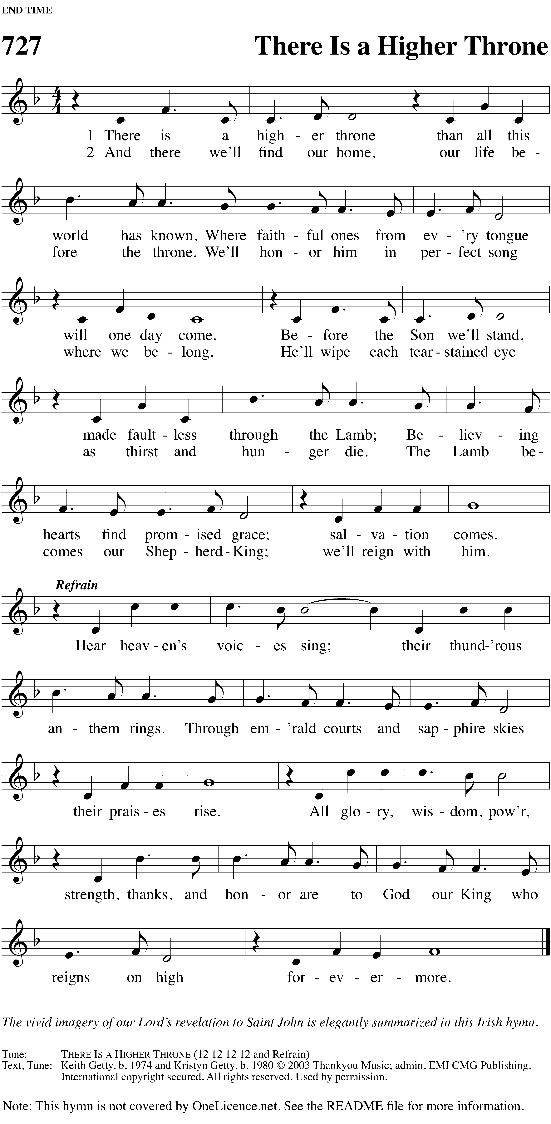**CLOSING HYMN — 727 *There Is a Higher Throne***



A drawing of a face

Description generated with high confidence

There Is a Higher Throne: CCLI……….. [If you have CWS. See CWS README file.]

[If you do not have CWS: …] © 2003 Thankyou Music (PRS) (adm. Worldwide at CapitolCMGPublishing.com excluding   
Europe which is adm. by Integrity Music, part of the David C Cook family. Songs@integritymusic.com) All rights reserved. Used by permission.

The following items are reprinted under OneLicense.net #A-000000

Psalm 45: Refrain text and music: Hal H. Hopson © 2008 Birnamwood Publications, a division of Morningstar Music