October 27, 2019
Sundays after Pentecost

Church Name
CHURCH
LOGO
HERE
EVANGELICAL LUTHERAN CHURCH
Church tagline, i.e. a very brief summary of your mission statement

W
elcome! Thank you for joining us for worship this morning. In our service we gather before our almighty God to offer him our worship and praise. We also gather to strengthen ourselves through the study of God’s holy and powerful Word.
- Restrooms are located in the hallway directly opposite the entrance to the sanctuary.

- Staffed nursery. We offer a staffed nursery for ages 2 to 6 and special needs children. It is located to the left of the entry foyer near the kitchen.

- Connection Cards are inside the worship folder. We ask that before worship or during the offering, you fill those out, front and back. Then place them in the offering plate after the sermon.

- Additional info: church contact info, etc.

- Prayer before worship

Our Worship Series
Read through Scripture and count the times it refers to believers as “brothers and sisters.” You will reach the triple digits quickly. The Holy Spirit is deliberate with his choice of words. If he frequently refers to the Church in those terms, there can be only one explanation. He wants us to think of each other as family. Scripture teaches that what unites us to our spiritual family is infinitely more powerful than any biological bond. Moreover, you can lose a blood relative. They can be taken away from you by death. But you will enjoy the companionship of your spiritual family for all eternity.
In this worship series, we will look at how our Father knits us together in love and unity into a spiritual family. We will see the benefits of being part of this family. In the Church, Christ has given us a better home.

Welcome Home!
Our Need for Christian Community
The Lost Are Now Found
You Are Free to Be Yourself
You Are Perfectly Safe Here
You Have an Everlasting Family
You are Part of Christ’s Glorious Kingdom

Our Theme for Today
Is the church more of a country club or a hospital? Is a Christian community full of people who have it all together, whose lives are perfectly in line with God’s will? Or is the family of God an assembly of individuals who are all flawed and broken in multiple ways? Scripture answers that question. God’s Word tells us everyone within the church was at one point deeply lost. What changed that? How were we “found”? Amazing grace! God, in his grace, sought us out, called us to faith, adopted us into his family, and welcomed us home into his Church. Think of what this means. If the church is a collection of people who were lost in their sin, it is unrealistic to think that in the church everyone will be a perfect model of righteous behavior. No one is like that except Christ! Our salvation is an accomplished fact. But our Christian life is going to be one that often takes two steps forward and then at least one step back.
This is another reason we need Christian community! As a loving Christian family, we love one another, forgive one another, proclaim God’s forgiveness to one another. And when a brother or sister drifts backs towards lostness, we give chase, striving to bring them back home.
This service offers the congregation a form of worship that focuses on the proclamation of God’s Word. Believers respond to this divine gift with prayer, praise, and thanksgiving.

SERVICE OF THE WORD

 Gathering 

OPENING HYMN — 379 Amazing Grace
INVOCATION

M: In the name of the Father and of the  Son and of the Holy Spirit.
C: Amen.
Confession and absolution
M: If we say we have no sin, we deceive ourselves, and the truth is not in us.
But if we confess our sins, God who is faithful and just will forgive our sins
And cleanse us from all unrighteousness. 1 John 1:8-9
C: For the wrong we have done, and all the good we have failed to do;
for angry deeds, for hurtful words, for uncharitable thoughts;
for self-centered living, and for failing to walk with humility and gentleness;
for longing to have what is not ours, and for failing to give thanks for what is ours;
for those sins we do not even remember committing:
Holy God, holy and mighty, holy and immortal, have mercy on us.
M: God, who is rich in mercy, loved us even when we were dead in sin,
and made us alive together with Christ. By grace you have been saved.
In the name of  Jesus Christ, your sins are forgiven.
Almighty God strengthen you with power through the Holy Spirit,
that Christ may live in your hearts through faith.
C: Amen.
The Sacrament of Holy Baptism may take place here
M: In that peace of forgiveness, let us praise the Lord!

FATHER, WE PRAISE YOU Christe Sanctorum ¹
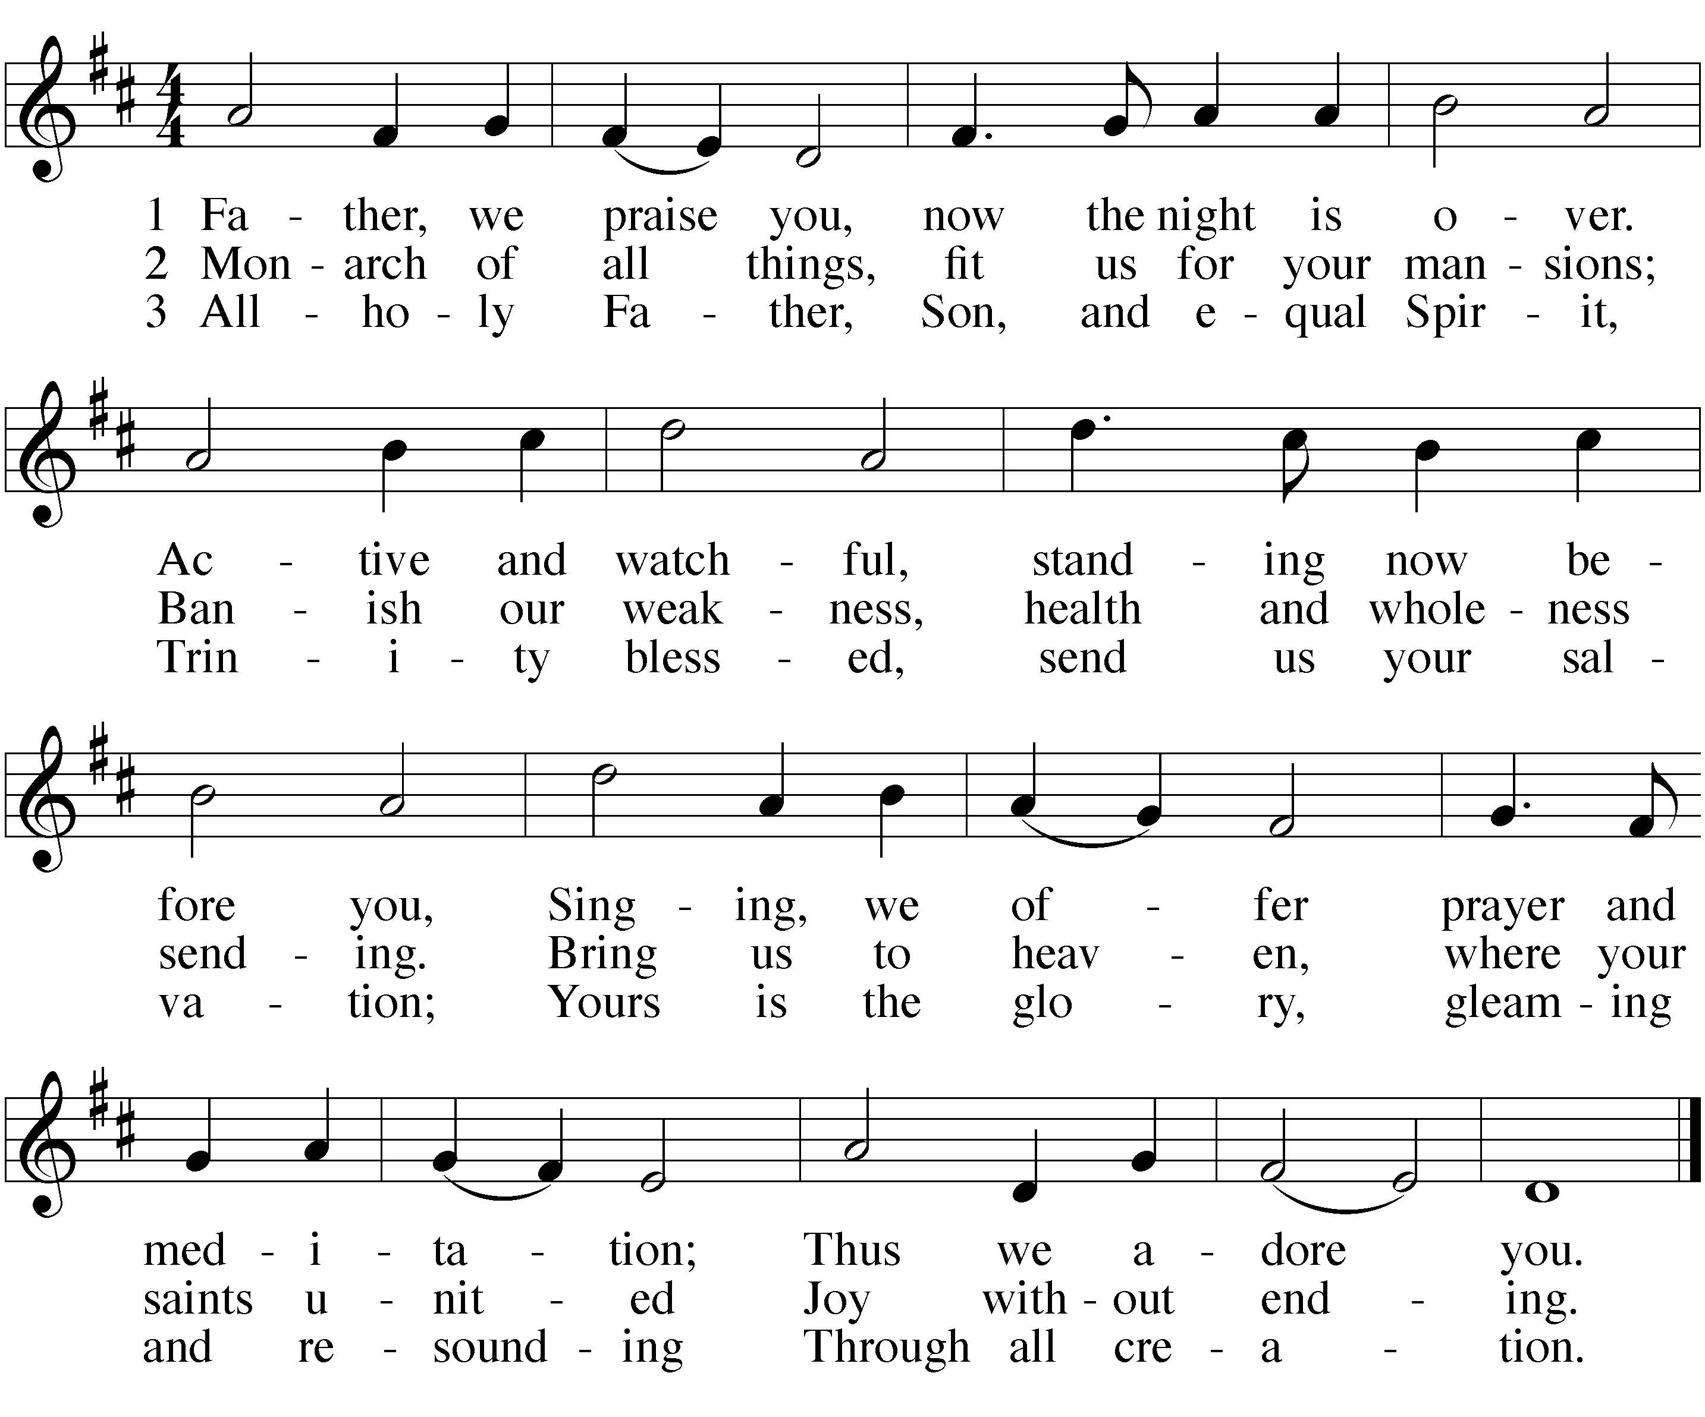

PRAYER OF THE DAY
M: Lord, we pray that your mercy and grace may always go before and follow after us that, loving you with undivided hearts, we may be ready for every good and useful work; through your Son, Jesus Christ our Lord, who lives and reigns with you and the Holy Spirit, one God, now and forever.
C: Amen.

¹ We worship our God this morning with the ancient song of praise, Christe Sanctorum. This hymn was written by Gregory the Great in the 6th century A.D. It was used by Christians to begin worship during the Sundays after Pentecost. Utilizing this song celebrates the wonderful legacy that historic Christianity has left for the Church today.

 The Word 

FIRST LESSON Hosea 3:1-5

The Lord asked the prophet Hosea to turn his entire life into an object lesson. Hosea was to marry a prostitute, to love
her and bring her into his home, in spite of her adulteries. This illustrates our God’s love. We all often love other
things more than our God. Yet he forgives us and welcomes us lost and broken people back into his home.

¹The Lord said to me, “Go, show your love to your wife again, though she is loved by another man and is an adulteress. Love her as the Lord loves the Israelites, though they turn to other gods and love the sacred raisin cakes.”
² So I bought her for fifteen shekels of silver and about a homer and a lethek of barley. ³ Then I told her, “You are to live with me many days; you must not be a prostitute or be intimate with any man, and I will behave the same way toward you.”
⁴ For the Israelites will live many days without king or prince, without sacrifice or sacred stones, without ephod or household gods. ⁵ Afterward the Israelites will return and seek the Lord their God and David their king. They will come trembling to the Lord and to his blessings in the last days.

PSALM OF THE DAY Psalm 133

Cantor(s): Refrain
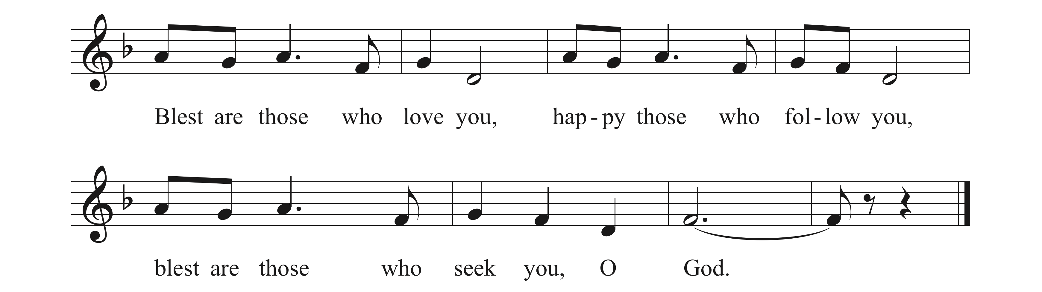
ALL: Refrain
ORDER THIS PSALM BY CLICKING HERE. THEN DELETE THIS TEXT BOX.

Cantor(s): Happy all those who fear the Lord, and walk in God’s pathway;
You will find what you long for—the riches of God.
ALL: Refrain
Cantor(s): Your wife shall be like a fruitful vine in the midst of your home,
your children flourish like olive plants rejoicing at your table.
ALL: Refrain
Cantor(s): May the blessings of God be yours all the days of your life;
May the peace and the love of God live always in your heart.
ALL: Refrain (During this final refrain the children may come forward.)

CHILDREN’S MESSAGE

SECOND LESSON 2 Corinthians 2:5-11

A member of the Corinthian congregation had scandalized the congregation by living in public sin. He had
repented. St. Paul urges the Corinthians to welcome him home with open arms, to forgive and comfort
him. Why? Because Christ has forgiven us our countless sins and welcomed us into his eternal home.

⁵ If anyone has caused grief, he has not so much grieved me as he has grieved all of you to some extent—not to put it too severely. ⁶ The punishment inflicted on him by the majority is sufficient. ⁷ Now instead, you ought to forgive and comfort him, so that he will not be overwhelmed by excessive sorrow. ⁸ I urge you, therefore, to reaffirm your love for him. ⁹ Another reason I wrote you was to see if you would stand the test and be obedient in everything. ¹⁰ Anyone you forgive, I also forgive. And what I have forgiven—if there was anything to forgive—I have forgiven in the sight of Christ for your sake, ¹¹ in order that Satan might not outwit us. For we are not unaware of his schemes.

VERSE OF THE DAY Hebrews 2:11

M: Alleluia! Both the one who makes people holy and those who are made holy are of the same family. So Jesus is not ashamed to call them brothers and sisters. Alleluia!
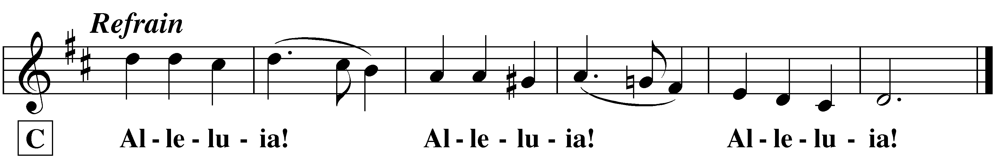

C:

GOSPEL Luke 15:1-10

There is rejoicing in heaven when the lost are found.

¹Now the tax collectors and sinners were all gathering around to hear Jesus. ² But the Pharisees and the teachers of the law muttered, “This man welcomes sinners and eats with them.”
³ Then Jesus told them this parable: ⁴ “Suppose one of you has a hundred sheep and loses one of them. Doesn’t he leave the ninety-nine in the open country and go after the lost sheep until he finds it? ⁵ And when he finds it, he joyfully puts it on his shoulders ⁶ and goes home. Then he calls his friends and neighbors together and says, ‘Rejoice with me; I have found my lost sheep.’ ⁷ I tell you that in the same way there will be more rejoicing in heaven over one sinner who repents than over ninety-nine righteous persons who do not need to repent.
⁸ “Or suppose a woman has ten silver coins and loses one. Doesn’t she light a lamp, sweep the house and search carefully until she finds it?⁹ And when she finds it, she calls her friends and neighbors together and says, ‘Rejoice with me; I have found my lost coin.’ ¹⁰ In the same way, I tell you, there is rejoicing in the presence of the angels of God over one sinner who repents.”

M: This is the Gospel of our Lord.
C: Praise be to you, O Christ!

HYMN OF THE DAY — 388 Redeemed, Restored, Forgiven

SERMON

CONFESSION OF FAITH Apostles’ Creed
I believe in God, the Father almighty, maker of heaven and earth.
I believe in Jesus Christ, his only Son, our Lord, who was conceived by the Holy Spirit, born of the virgin Mary, suffered under Pontius Pilate, was crucified, died, and was buried. He descended into hell. The third day he rose again from the dead. He ascended into heaven, and is seated at the right hand of God the Father almighty. From there he will come to judge the living and the dead.
I believe in the Holy Spirit, the holy Christian Church, the communion of saints, the forgiveness of sins, the resurrection of the body, and the life everlasting. Amen.

OFFERING

 Prayers 

PRAYER OF THE CHURCH
Prayers and petitions are made on behalf of the Church
M: Hear us, Lord, as we bring you our private petitions.
Silent prayer

LORD’S PRAYER
M: We pray in Jesus’ name and as he taught.
C: Our Father in heaven,
hallowed be your name,
your kingdom come,
your will be done on earth as in heaven.
Give us today our daily bread.
Forgive us our sins, as we forgive those who sin against us.
Lead us not into temptation,
but deliver us from evil.
For the kingdom, the power, and the glory are yours now and forever.
Amen.

BLESSING
M: Brothers and sisters, go in peace.
Live in harmony with one another.
Serve the Lord with gladness.

The Lord bless you and keep you.
The Lord make his face shine on you and be gracious to you.
The Lord look on you with favor and give  you peace.
C: Amen.

CLOSING HYMN Oh, How Good It Is

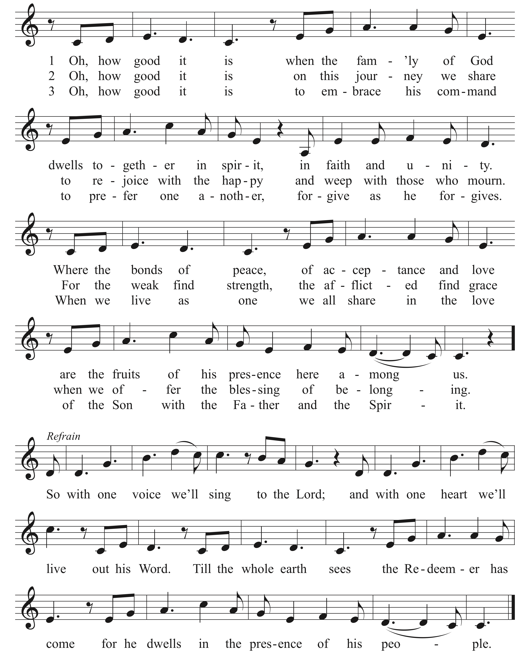

COPYRIGHT INFORMATION
Greek cross image: © Ian Welch www.paramentics.com. Used by permission.
Oh, How Good It Is: © 2012 Getty Music Publishing (BMI) (admin. by Music Services) / Parakeet Boots Music (ASCAP) (admin. by Getty Music Publishing c/o Music Services) / Townend Songs (PRS) (admin. in North America by Music Services and elsewhere by Song Solutions) All Rights Reserved.

The following items are reprinted under OneLicense.net #A-000000
Psalm 128 Music: Marty Haugen © 1988 by GIA Publications.

