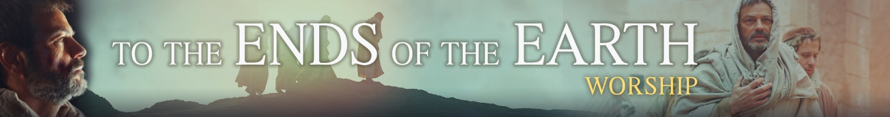
Mission & Ministry Sunday 2018

Musical Resources for: “We Are Sent by the Lord”
Various resources are available for a new hymn with text by Laurie Gauger-Hested, tune/harmony by Sarah Lambrecht, and additional musical arrangements by Jeremy S. Bakken. WELS congregations are granted permission to use these copyrighted resources. Include in the worship folder this notice:
Text: © 2018 Laurie F. Gauger. Tune: © 2018 Sarah R. Lambrecht. All rights reserved. Used with permission.
The hymn is provided both in D Major and E-flat Major with the following resources. E-flat Major allows melody/descant instrumental parts with fewer accidentals in some keys. (An alto saxophone playing in concert pitch D has five sharps!) If no additional instruments are available and if using a transposing keyboard (piano or organ), the hymn may be lowered a half step to D-flat Major.
- TIFF melody graphics
- Text-only stanzas are below if the
congregation sings only the refrains
A children’s song suitable also for unison choir or vocal soloist is available as a digital download (full score, choral score, mp3 and MIDI accompaniment tracks) at http://online.nph.net/catalog/product/view/id/21609/

- Organ prelude
- Organ hymn accompaniment
- Piano prelude
- Piano hymn accompaniment
- PVG – piano, vocal, guitar; a bass guitar or electronic keyboard may double the bass line.
- PVG descant. This descant does not work with the standard piano or organ settings.
- Instrumental descant, with melody. Solo instruments may play melody on some stanzas, descant on others. This descant does not work with the PVG setting.
- Unison choral stanza, for soloist or choir (adult or children); both piano and organ versions
- SAB choral stanza
- SATB choral stanza
- Four m4a audio files.
Using a combination of these resources enables the new hymn to be presented as a concertato. For example, assuming a congregation with piano, organ, and two wind instruments:
- Intro = Prelude (either piano or organ): used as a longer introduction to singing the hymn (not as service music elsewhere in the service).
- Refrain and Stanza 1 = soloist or choir, with standard accompaniment (piano or organ)
- Stanza 2 and remaining refrains = congregation, with standard accompaniment
(piano or organ ); one or both wind instruments double the tune
- Stanza 3 = one of the choral options
- Stanza 4 and final refrain = PVG on piano, one wind instrument doubles the tune, one wind instrument plays the descant
- OR Stanza 4 and final refrain = on organ (if piano is not strong enough), one wind instrument doubles the tune, one wind instrument plays the descant
We are sent by the Lord, by the King Crucified.
To the ends of the earth, share his love far and wide!

- So many souls are dying—can you see them
in dark and distant corners of the world?
They bend their knees to gods that cannot hear them
because they don’t know Jesus or his Word. REF
- And do you hear the doubting of the cynics
who think our Lord was just another man?
Let’s tell them he is God; his way is wisdom;
there’s wonder, beauty, purpose in his plan. REF
- And do you know a neighbor who has drifted,
departed from the church in grief or pain?
Through Jesus’ love their burden can be lifted.
Let’s listen well and welcome them again. REF
- Our gracious Lord wants nobody to perish.
For ev’ry child of earth his hands are scarred.
Each soul is his to know and name and cherish.
There’s room for ev’ry sinner in his heart. REF

To avoid fuzzy graphics in Word, search for help on “turn off picture compression”. The TIFF files are 1200 dpi resolution. If the congregation sings only the refrain, the stanzas above can be copied into the worship folder.
The piano and organ samples are meant for review, not to accompany singing. The “credits” file may be used as service music in congregations without live musicians. It might be used in the movie while the credits roll. A piano version of the entire song is meant to accompany congregational singing in a small setting without live musicians. This version has “Piano Accompaniment” in the file name.
Depending on your congregation’s comfort with new music, you might have soloist or choir also sing Stanza 2. Or before worship begins, teach the first stanza that the congregation will sing. Or the soloist/choir may sing all stanzas and congregation only the refrains after the stanzas.
If piano is not strong enough to lead the congregation, use organ. The plan above is easily modified for organ and instruments alone, with no piano.

