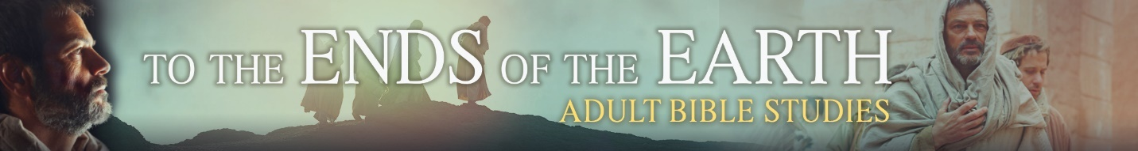
Session Three: Plan to Share the Power of the Gospel

Introduction
Using the power of the gospel to share the gospel is a combination of general preparedness for unexpected opportunities God provides as well as intentional planning and creation of opportunities. We see both in the episodes that took place in Philippi.
Discussion

Planning To Share Jesus
- Paul had a standard practice for trying to find an audience for the gospel upon arrival in each new town or city. Identify the two places he would seek to find those who might be “ready” to hear the gospel. (watch 5:00–5:45 and 11:54–12:421)
- From the movie or Acts 17:22-23, explain why Paul would explore a new location.
- List possible reasons that Paul would initially seek to share the message of Jesus with Jews or converts to Judaism, like Lydia, who knew the Old Testament.
- Read Acts 16:13-14 and 2 Timothy 3:14-4:2. Paul demonstrates to young Timothy in Philippi what he later instructs Timothy to do after he is gone. (2 Timothy is the last letter of Paul we have before his execution). From the movie or from Scripture, list actions that we can take to be prepared to share the gospel.

Sharing Jesus In Unplanned Ways
- Obviously, the imprisonment and subsequent earthquake was orchestrated by God to present Paul with an opportunity to first trust God’s promises and then share them. Though likely less dramatic, list situations that may give us an unexpected opportunity to share Jesus.
- Read 1 Peter 3:15-16. Peter urges us to be prepared for these situations. As a group pick one or more of the situations listed above and plan a way to “give the reason for the hope that you have.” Jot down a brief outline and note any verses or Bible stories you might use.
- To share the power of the gospel, we need to trust the power of the gospel; otherwise fear may prevent us from speaking or acting. Let us help each other build that trust.
  - The Holy Spirit uses the “Means of Grace,” that is, the gospel that comes to us in either Word or Sacrament (baptism and Lord’s Supper). Read Galatians 3:27 and Matthew 26:26-28. Describe the role of recalling our baptism or taking communion in helping us trust Jesus’ gospel promises.
  - Reread the first phrase of 1 Peter 3:15 and Hebrews 12:2-3. List specific actions the members of the group can do to help each other keep Jesus as Lord and not take our eyes off of him.
- Find similarities and differences in the ways we prepare to share Jesus in deliberate planned ways versus spontaneous unplanned ways.

Closing Prayer
Dear Jesus, you have given us the privilege of taking you to our neighbors next door as well as the ends of the earth. Help us get ready to share the reason for the hope that we have by constantly reviewing the promises you kept when you lived, died, and rose to save us. Amen

