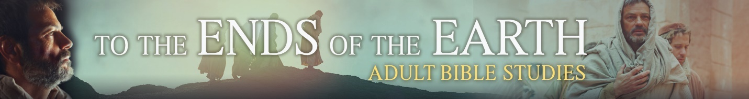
Session One: See the Power of the Gospel

Introduction
Participants will view the entire movie in the first session, then view movie clips in the subsequent sessions. Even if some have already viewed the video previously, watching it again will refresh memories and help the truths presented in it to be cemented in long-term memory.

Watch entire movie “To the Ends of the Earth”
Before starting the movie, note the upcoming discussion activities. You may want to take notes during the movie to help you recall specific scenes. Note that the movie adds details not present in the biblical account. While we have no evidence that these additions actually happened as depicted, they are consistent with Scripture. For the purpose of this study, we will assume the scenes accurately depict the words and actions of the people in Philippi.
Discussion

Evidence That The Gospel Is Powerful
- List evidence from the movie of these people’s lack of trust in Jesus:
- Paul’s companions
- Lydia
- The jailer
- The idol merchant
- The slave girl
- For the same individuals, list evidence from the movie that indicates the power of the gospel, that is, the good news about Jesus, had a positive effect.
- Paul’s companions
- Lydia
- The jailer
- The idol merchant
- The slave girl
- Read Romans 1:16 and Colossians 1:3-7. With the person next to you, talk about the gospel’s power to change the life of those who do not follow Jesus yet as well as those who do. Agree on one to three major changes the good news about Jesus can make in each person.
- One who has not yet become a Jesus follower (unbeliever):
- One who already is a Jesus follower (believer):
- Some effects of the power of the gospel are more noticeable than others. Take a minute to reflect on positive changes you have observed in yourself or others close to you because the Spirit has worked his power through the gospel. Think in terms of your outlook on life, ability to handle challenges and setbacks, how you spend your time or money, and the like. If you are willing, tell the others about one change (in addition to giving you trust in Jesus).

Upcoming Sessions
This time we looked at evidence that demonstrates the power of the gospel. Not only does the gospel have the power, through the Spirit, to create trust in Jesus, but it strengthens that trust and enables us to say and do things that were previously impossible. In the following sessions, we’ll take a closer look at why the good news about Jesus is so powerful and find ways we can experience and use that power in our lives.

Closing Prayer
Dear Jesus, the evidence of your power is all around us in creation. The evidence of your love is all around us in your Word. The events in Philippi are strong evidence of both. Help us to trust that the gospel is powerful even if we don’t see immediate results. May that power, fueled by your love, enable us to serve and glorify you in the world. Amen.

