____ Evangelical Lutheran Church

Pick and resize one of the graphics below for your worship folder cover if you need a cover image.

The Festival of the Resurrection of Our Lord
Easter Day
April 4, 2021

Welcome to _____ !

Alleluia! Christ is risen! In the name of our risen Savior, Jesus Christ, we welcome you to _____ Lutheran Church on this Easter morning! We pray that the message of Jesus’ resurrection from the dead fills your heart with faith in Christ and confidence in his gracious gifts of forgiveness and eternal life.

For Everyone
We ask all worshippers—both members and guests—to help us to be a friendly church by signing the red Friendship Register kept near the center aisle in each pew. The registers are usually signed while the offering is gathered. After you sign it, please pass it to the others in your pew for them to sign.
Restrooms are located down the hallway toward the school wing of the building. As you exit the church sanctuary, turn to your left and walk down the hallway to access the restrooms.

For Families
Children’s bulletins are available from the ushers. Children’s activity bags are available in the Quiet Room located at the left (west) back corner of the sanctuary; the activity bags can be taken into the sanctuary. Families may use the Quiet Room as needed during the service; speakers in the room allow those inside to hear the service.

Other information

_______ Evangelical Lutheran Church and School
address phone www.____.com

Thursday Service at 7:00 p.m. Sunday Services at 8:00 & 10:30 a.m.
Affiliated with the Wisconsin Evangelical Lutheran Synod
The Festival of the Resurrection of Our Lord

HYMN Jesus Christ Is Risen Today
Christian Worship #157

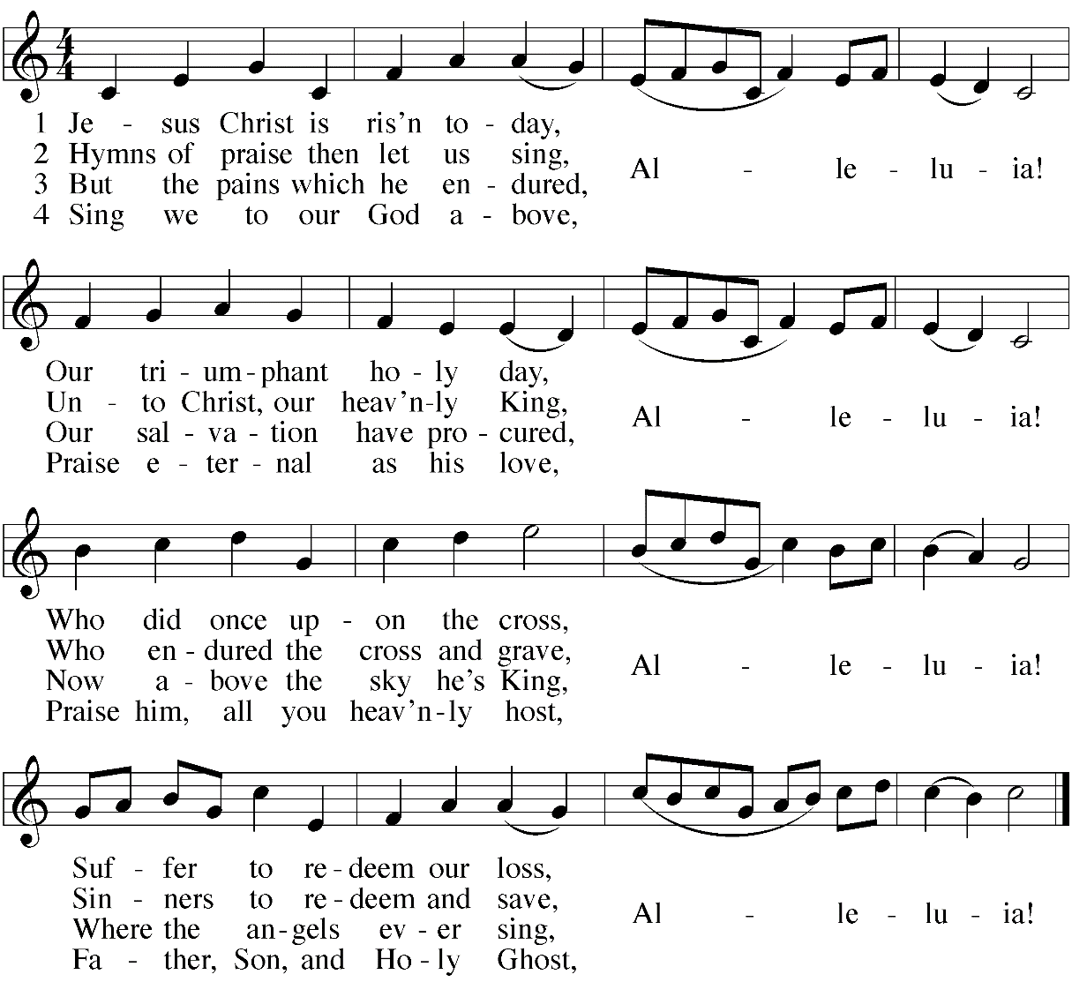

STAND

INVOCATION

Minister: In the name of the Father and of the  Son and of the Holy Spirit.
Congregation: Amen.

RESURRECTION DIALOGUE

M: Alleluia! Christ is risen!
C: He is risen indeed! Alleluia!

M: This is the day the Lord has made.
C: We will rejoice and be glad in it. ^{Psalm 118:24}

M: I will sing to the Lord, for he is highly exalted.
The Lord is my strength and my song; he has become my salvation. ^{Exodus 15:1-2}
C: Let us come before him with thanksgiving, and extol him with music and song.
^{Psalm 95:2}
M: I will not die but live, and will proclaim what the Lord has done. _{Psalm 118:17}
C: Christ has died. Christ is risen. Christ will come again.

M: The Lord’s right hand is majestic in power.
The Lord’s right hand has shattered the enemy.
In the greatness of his majesty he threw down those who opposed him. ^{Exodus 15:6-7}
C: Death has been swallowed up in victory. _{1 Corinthians 15:54}

M: Where, O death, is your victory? Where, O death, is your sting? ^{1 Corinthians 15:55, 57}
C: Thanks be to God! He gives us the victory through our Lord Jesus Christ.

M: I know that my Redeemer lives, and that in the end he will stand upon the earth. ^{Job 19:25}
C: The kingdom of the world has become the kingdom of our Lord and of his Christ,
and he will reign forever and ever. _{Revelation 11:15}

M: Salvation belongs to our God, who sits on the throne, and to the Lamb. _{Revelation 7:10}
C: Worthy is the Lamb, who was slain,
to receive power and wealth and wisdom and strength
and honor and glory and praise! ^{Revelation 5:12}

M: Alleluia! Christ is risen!
C: He is risen indeed! Alleluia!

SONG OF PRAISE This Is the Feast of Victory
Christian Worship #265
If choir is involved, include or modify this rubric. The congregation sings the refrains. The choir sings the verses. There is no refrain after verse three.
Insert hymn graphic here, or make a substitution. For the sake of a congregation that doesn’t have the electronic edition of CW, an alternate hymn is included below.

HYMN Christ the Lord Is Risen Today
Christian Worship #150

PRAYER OF THE DAY

M: The Lord be with you.
C: And also with you.
M: Let us pray.
Almighty God, by the glorious resurrection of your Son Jesus Christ you conquered death and opened the gate to eternal life. Grant that we, who have been raised with him through baptism, may walk in newness of life and ever rejoice in the hope of sharing his glory; through Jesus Christ our Lord, to whom, with you and the Holy Spirit, be dominion and praise now and forever.
C: Amen.

BE SEATED

FIRST READING Isaiah 25:6-9
Christ’s resurrection removes the shroud of death.
M: A reading from the prophet Isaiah, chapter twenty-five:

⁶ On this mountain the Lord Almighty will prepare
a feast of rich food for all peoples,
a banquet of aged wine—
the best of meats and the finest of wines.
⁷ On this mountain he will destroy
the shroud that enfolds all peoples,
the sheet that covers all nations;
⁸ he will swallow up death forever.
The Sovereign Lord will wipe away the tears
from all faces;
he will remove his people’s disgrace
from all the earth.
The Lord has spoken.
⁹ In that day they will say,
“Surely this is our God;
we trusted in him, and he saved us.
This is the Lord, we trusted in him;
let us rejoice and be glad in his salvation.”

M: The Word of the Lord.
C: Thanks be to God.

PSALM OF THE DAY Selected Verses of Psalm 118
Music by Kermit Moldenhauer, 2006
from Christian Worship: Supplement
The cantor introduces the refrain and the congregation repeats the refrain.
The congregation sings the verses in bold print and the remaining refrains.

The Lord is my strength and my song;
he has become my salvation.
“The Lord’s right hand is lifted high;
the Lord’s right hand has done mighty things!”
I will not die but live,
and will proclaim what the Lord has done.
Refrain
I will give you thanks, for you answered me;
you have become my salvation.
The stone the builders rejected has become the capstone;
the Lord has done this, and it is marvelous in our eyes.

This is the day the Lord has made;
let us rejoice and be glad in it.
Glory be to the Father and to the Son
and to the Holy Spirit,
as it was in the beginning,
is now, and will be forever. Amen.
Refrain

SECOND READING 1 Corinthians 15:19-26
Christ’s resurrection gives certain hope for this life and the next.

M: A reading from Saint Paul’s first letter to the Corinthians, chapter fifteen:

¹⁹ If only for this life we have hope in Christ, we are of all people most to be pitied.
²⁰ But Christ has indeed been raised from the dead, the firstfruits of those who have fallen asleep. ²¹ For since death came through a man, the resurrection of the dead comes also through a man. ²² For as in Adam all die, so in Christ all will be made alive. ²³ But each in turn: Christ, the firstfruits; then, when he comes, those who belong to him. ²⁴ Then the end will come, when he hands over the kingdom to God the Father after he has destroyed all dominion, authority and power. ²⁵ For he must reign until he has put all his enemies under his feet. ²⁶ The last enemy to be destroyed is death.

M: The Word of the Lord.
C: Thanks be to God.

VERSE OF THE DAY 1 Corinthians 15:54 / Isaiah 25:8
Music by Ronald Shilling

The Lord is risen! He is risen indeed! Alleluia! Death has been swallowed up in victory. Alleluia!

STAND

GOSPEL Mark 16:1-8
Victory made certain by the resurrection

M: The Gospel according to Saint Mark, chapter sixteen:
C: Glory be to you, O Lord.

¹ After the Sabbath, at dawn on the first day of the week, Mary Magdalene and the other Mary went to look at the tomb.
² There was a violent earthquake, for an angel of the Lord came down from heaven and, going to the tomb, rolled back the stone and sat on it. ³ His appearance was like lightning, and his clothes were white as snow. ⁴ The guards were so afraid of him that they shook and became like dead men.
⁵ The angel said to the women, “Do not be afraid, for I know that you are looking for Jesus, who was crucified. ⁶ He is not here; he has risen, just as he said. Come and see the place where he lay. ⁷ Then go quickly and tell his disciples: ‘He has risen from the dead and is going ahead of you into Galilee. There you will see him.’ Now I have told you.”
⁸ So the women hurried away from the tomb, afraid yet filled with joy, and ran to tell his disciples. ⁹ Suddenly Jesus met them. “Greetings,” he said. They came to him, clasped his feet and worshiped him. ¹⁰ Then Jesus said to them, “Do not be afraid. Go and tell my brothers to go to Galilee; there they will see me.”

M: The Gospel of the Lord.
C: Praise be to you, O Christ.

BE SEATED

ANTHEM ?????
Music by _____
Include text

HYMN OF THE DAY Christ Jesus Lay in Death’s Strong Bands

The hymn is on pp 18-19.

SERMON 1 Corinthians 15:19-26
Certain Hope for Uncertain Times
- ….
- ….

STAND

APOSTLES CREED

I believe in God, the Father almighty, maker of heaven and earth.
I believe in Jesus Christ, his only Son, our Lord,
who was conceived by the Holy Spirit,
born of the virgin Mary,
suffered under Pontius Pilate,
was crucified, died, and was buried.
He descended into hell.
The third day he rose again from the dead.
He ascended into heaven
and is seated at the right hand of God the Father almighty.
From there he will come to judge the living and the dead.
I believe in the Holy Spirit,
the holy Christian Church,
the communion of saints,
the forgiveness of sins,
the resurrection of the body,
and the life everlasting. Amen.

REMAIN STANDING

PRAYER OF THE CHURCH

M: Almighty and merciful God, on this glorious day we rejoice in the resurrection of Jesus Christ. Increase our faith that the grace of the empty tomb may fill our lives and make us glad each day.
C: When we are weak be our strength, when we are sad be our song, and when we sin be our salvation.
M: Remove the shroud of death from all who mourn. In moments of grief call believers through the voice of our Good Shepherd, and embolden us to follow his promises. In their hopelessness of despair turn the faithless to trust in the only Way, Truth, and Life.
C: Wipe away tears born of death, and give new birth to a living hope in the hearts of the lost and troubled. Use our witness as compassion and comfort for others in need of mercy.
M: King of kings and Lord of lords, destroy all dominion, authority, and power that stands against you, whether seen or unseen. Whatever evil exerts itself against your saving will—false teaching or lukewarm faith, Satan’s lies or worldly pleasures, empty worship or futile religion—rule it for the sake of the gospel’s free course.
C: Triumph over our enemies, and empower the Church to fight the good fight to the end. Never leave us or forsake us.
M: Walk among our churches, O Living One, as the faithful witness and firstborn from the dead. As your angel sent women with news of the risen Christ, call women in our church to announce, “He is risen!” As you sent your disciples with the power of the Spirit, use all of us to share with a broken and dying world the news of your eternal victory.
C: Empower us to speak your truth and love to our circles of friends, relatives, and neighbors. Bless our efforts to help others to trust the certain hope that Easter promises.

M: Heavenly Father keep the baptized united with your Son in his resurrection. Put to death the fleshly urges of those caught in addictions, clothe in your righteousness anyone ashamed of good intentions which have fallen short, and assure those searching for purpose that their eternal identity as your dear children is sealed.
C: Thank you for the power of baptism working in our lives, and for the certainty of its promises through the resurrection. Enrich us with everything we need for life and godliness.
M: O Lord of life, you have done mighty things for us! We pray through him who is the Beginning and the End, Jesus Christ, our Lord.
C: His name is above every name, to the glory of God the Father! Amen.

LORD’S PRAYER

Our Father in heaven, hallowed be your name, your kingdom come, your will be done on earth as in heaven. Give us today our daily bread. Forgive us our sins, as we forgive those who sin against us. Lead us not into temptation, but deliver us from evil. For the kingdom, the power, and the glory are yours now and forever. Amen.

BE SEATED

OFFERING

The offerings of the congregation are gathered. During this time, please sign the red attendance register that is kept near the center aisle of each pew, then pass it to the others in your pew for them to sign.

HYMN Come, You Faithful, Raise the Strain
Christian Worship #142

The hymn is on the next page.

STAND

PRAYER

M: Almighty God, you give us the joy of celebrating our Lord’s resurrection. Give us also the joys of life in your service, and bring us at last to the full joy of life eternal, through your Son, Jesus Christ our Lord, who lives and reigns with you and the Holy Spirit, one God, now and forever.
C: Amen.

BLESSING

M: The Lord bless you and keep you.
The Lord make his face shine on you and be gracious to you.
The Lord look on you with favor and  give you peace.
C: Amen.

REMAIN STANDING

HYMN He Is Arisen! Glorious Word
Christian Worship #162

BE SEATED

Copyright and credit information: Bible translation from the New International Version, © 1984, 2011 by Biblia, Inc. | “This Is the Feast” text © 1978 Lutheran Book of Worship, reprinted by permission of Augsburg-Fortress; tune © 1975, 1988 by Richard Hillert. | Psalm 118 tune © 2006 by Kermit Moldenhauer, reprinted from Christian Worship: Supplement. | Verse of the Day © 1994 by Northwestern Publishing House. | “Christ Jesus Lay in Death’s Strong Bands” tune © 2005 by Kermit Moldenhauer. | Prayer of the Church by Daron Lindemann (alt.), from the 2011 WELS National Worship Conference. | Artwork by Ian Welch (ianmwelch.com). Used by permission. | Copyrighted hymns and liturgical music are reprinted with permission under OneLicence.net #####. All rights reserved.

ANNOUNCEMENTS

HYMN OF THE DAY Christ Jesus Lay in Death’s Strong Bands
Christian Worship: Supplement #720
The choir sings stanzas [1], 4, and 6. Tune by Kermit Moldenhauer, 2005. Setting by Benjamin Culli, 2020
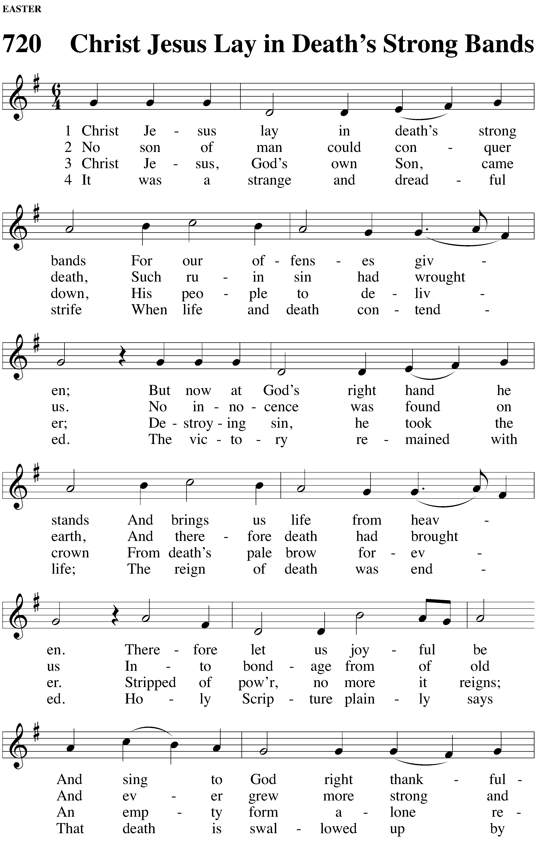

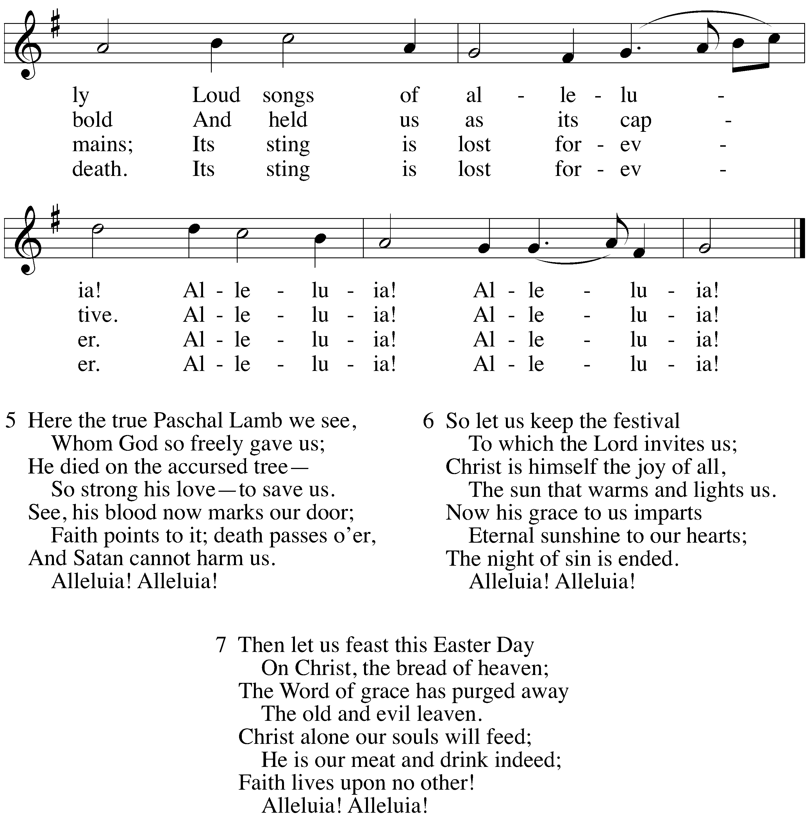

EASTER SERMON SERIES

Join us throughout the Easter season for celebration of the certain hope Easter gives.

4-11, Easter 2 | Resurrection hope gives us peace.
4-18, Easter 3 | Resurrection hope is certain through the Word.
4-25, Easter 4 | Resurrection hope comes from Christ, our Good Shepherd.
5-2, Easter 5 | Resurrection hope has rich consequences for life every day.
5-9, Easter 6 | Resurrection hope comes from Christ living in us.
5-13, Ascension | Christ’s Ascension triumph makes our resurrection hope certain.
5-16, Easter 7 | The risen Christ prays for us in heaven to fortify our resurrection hope.

If your church does not offer an Ascension service, consider moving Ascension to May 16.

BIBLE STUDIES OPTIONS
Deepen your knowledge
Strengthen your faith

Wednesdays at 10:00 a.m. in the Fireside Room
The class is currently studying Romans chapter eight.

[alternate] HYMN OF THE DAY I Know that My Redeemer Lives
Christian Worship #152
The choir/soloist sings stanzas 4 and 6.

