**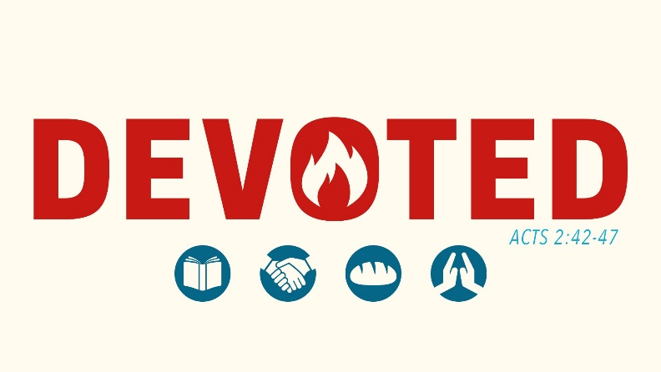**Devoted to Fellowship with God + others

Open the Bible in front of you to the Contents page where the books of the Old and New Testament are listed.

Of all the 27 books in the New Testament, which ones are the least familiar to you?

Think of 3 and be prepared to share your answers with the group.

If I learn something new, from God, in this class – how will that affect my daily life… the groups I associate with… the prayers I pray…. the things I say…. the life of faith I lead?

# **God’s Devotion to Me – Fellowship**

**1 Corinthians 6:9-11 9 Do you not know that the wicked will not inherit the kingdom of God?**

**Do not be deceived: Neither the sexually immoral nor idolaters nor adulterers nor male prostitutes nor homosexual offenders 10 nor thieves nor the greedy nor drunkards nor slanderers nor swindlers will inherit the kingdom of God.**

**11 And that is what some of you were.**

**But you were washed, you were sanctified, you were justified in the name of the Lord Jesus Christ and by the Spirit of our God.**

1. What is our natural state – without God or faith in God?
   1. A pretty good person who just needs some minor tweaks
   2. Neutral but you can be molded to be good or bad
   3. A wicked sinner who will not inherit the kingdom of God
   4. Unsure, but perhaps deep introspection will tell me
2. Do you see yourself in verses 9-10? Why did God jam together so many sins in two verses?
3. What has changed for us, according to verse 11? What does that mean for our daily lives?

**1 Corinthians 1:9 God, who has called you into fellowship (κοινωνία) with his Son Jesus Christ our Lord, is faithful.**

**Galatians 3:26-27 26 You are all sons of God through faith in Christ Jesus, 27 for all of you who were baptized into Christ have clothed yourselves with Christ**

1. What has God done for you?
2. What does the term “fellowship” mean? (Consider our usage of a Fellowship Hall)
3. Consider the image of being “clothed with Christ” and the perfection of his holiness by faith. Where do we see weekly a reminder of this teaching in our worship services?

# **My devotion to god – separating from darkness**

**1 John 1:6-7** **6 If we claim to have fellowship (κοινωνία) with him yet walk in the darkness, we lie and do not live by the truth. 7 But if we walk in the light, as he is in the light, we have fellowship (κοινωνία) with one another, and the blood of Jesus, his Son, purifies us from all sin.**

1. Can you give an example of someone who claims fellowship with God but walks in the darkness?
2. According to verse 7, what does fellowship with God naturally result in?
3. T/F Claiming to be a Christian but living an unrepentant sinful life is sending a mixed message.

**2 Corinthians 6:14-16a 14 Do not be yoked together with unbelievers. For what do righteousness and wickedness have in common? Or what fellowship can light have with darkness? 15 What harmony is there between Christ and Belial? What does a believer have in common with an unbeliever? 16 What agreement is there between the temple of God and idols?**

1. How many ways does Paul ask the same question? Why?
2. Before, God used the image of light and darkness. Now, he talks about farm animals being yoked together. Which one do you prefer, and why?
3. The Cathedral Church of St. John the Divine, the largest Gothic church in America (bigger than Notre Dame) and 5th largest Cathedral in the world, is proud of its interfaith worship services. Its interior is larger than two football fields.

On its altar it has Menorahs and Shinto vases. What would Paul say?

1. Do you see other movements in society towards interfaith worship, prayer, study, and service? How should we respond?

**2 Corinthians 7:1 Since we have these promises, dear friends, let us purify ourselves from everything that contaminates body and spirit, perfecting holiness out of reverence for God.**

1. If we were called to light and told never to be yoked with unbelievers, why must we purify ourselves and perfect our holiness out of reverence for God?
2. Describe how wonderfully Lutheran this passage is.

### **Discussion Questions**

**Help** Pastor regularly receives calls, emails, and impromptu visits from various religious organizations, Christian or not, that wish to “partner” with him in his ministry. They often desire to preach for a worship service, have a joint prayer session, teach a Bible class, (and always) take a small collection.

How should Pastor respond to these nice salespeople?

**A/D** With the increasing attacks against our faith by society and the government, faith-based persons should bond together into agencies to wield our political power and might.

**A/D** We should not attend an interfaith worship service.

Blessings of fellowship

Beards are making a comeback. Long, thick, and shaggy are preferred for many men with beards.

Whether you have a beard or not, consider the following passage.

**Psalm 133:1-2 How good and pleasant it is when brothers live together in unity! 2 It is like precious oil poured on the head, running down on the beard, running down on Aaron’s beard, down upon the collar of his robes.**

Perhaps a gentleman would be willing to demonstrate?

# **Fellowship – walking together in love**

**2 John 1-6 1 The elder,**

**To the chosen lady and her children, whom I love in the truth—and not I only, but also all who know the truth— 2 because of the truth, which lives in us and will be with us forever:**

**3 Grace, mercy and peace from God the Father and from Jesus Christ, the Father’s Son, will be with us in truth and love.**

1. The Apostle John refers to himself as “the elder.” As an old Pastor, he seems to be using some imagery here with the terms of “lady” and “children.” Who is he probably referring to?
   1. A house church with a strong lay leader (woman) and her children
   2. One of his previous congregations in Asia Minor and its members
   3. A Christian woman and her children
2. What word is repeated 3 times in his opening? Why?

**4 It has given me great joy to find some of your children walking in the truth, just as the Father commanded us. 5 And now, dear lady, I am not writing you a new command but one we have had from the beginning. I ask that we love one another. 6 And this is love: that we walk in obedience to his commands. As you have heard from the beginning, his command is that you walk in love.**

1. What gives Pastor John such great joy?
2. How might you summarize this section:
   1. Pastor John is joyous that they are loving each other.
   2. Pastor John is joyous that they are walking in the truth and loving each other.
   3. Pastor John is joyous that they are walking in the truth, in obedience to God’s commands, and therefore loving each other.
3. On occasion, I will send an email to the former Pastor of our congregation thanking God for certain things in our congregation that I have found a blessing as the current Pastor. What might I write to him?

Can you guess some of the things I might email him about?

# **Blessings of Fellowship we share**

There are many blessings of fellowship that we share individually at our congregation and corporately as a member of the Wisconsin Evangelical Lutheran Synod. We can occasionally take those blessings for granted.

As you are grouped up, work through one of the passages. Understand the kernel of truth that each passage has, and then link up an event that illustrates this every day. Bonus points to anyone who can think of corresponding items not listed.

Can you imagine how different these events would be if we weren’t united in faith?

|  |  |  |
| --- | --- | --- |
| Passage | Truth | Events |
| Acts 2:42 42They devoted themselves to the apostles’ teaching and to the fellowship, to the breaking of bread and to prayer. |  |  |
| Acts 2:43 43Everyone was filled with awe, and many wonders and miraculous signs were done by the apostles. |  |  |
| Acts 2:44-45 44All the believers were together and had everything in common. 45Selling their possessions and goods, they gave to anyone as he had need. |  |  |
| Acts 2:46-47 46Every day they continued to meet together in the temple courts. They broke bread in their homes and ate together with glad and sincere hearts, 47praising God and enjoying the favor of all the people. And the Lord added to their number daily those who were being saved. |  |  |

1. Worship service
2. Bible study and Sunday School
3. Food / Drink after the service
4. Confirmation Meal provided after Confirmation
5. Two infants baptized
6. 6 young people confirmed in their faith
7. Communion
8. Members getting together outside of church for prayer, support, and encouragement
9. Members helping each other out
10. Prayer Chain
11. Outreach events like booth at Independence Day Celebration
12. Men meeting for Grill Kings or Ladies for Ladies Night Out
13. Wednesday Evening Confirmation Classes
14. Monday evening Faith builders classes
15. Sending a portion of our offerings to support the WELS

### https://scontent.fash1-1.fna.fbcdn.net/v/t1.0-1/c0.0.160.160/p160x160/149673_140140116037216_4374583_n.jpg?oh=87f52bf2740b0fe7561290fde5c93432&oe=5881F8FC**Discussion Questions**

**Discuss** Vanderbilt University has a world-recognized Divinity School that trains the next generation of Pastors. One of their ministries includes the Vanderbilt Interfaith Council.

Describe a worship service or Bible study where Jews, Muslims, Christians, Buddhists, Unitarians, and Pagans join together in the blessings of shared fellowship.

**Discuss** With a world that does not understand the blessings or the doctrine of the fellowship, how should we teach them God’s truths?

**A/D** As mentioned in a recent Interfaith Observer article[[1]](#footnote-1), we can deepen our own Christian beliefs through practicing Zen mediations, Buddhist principles, and Zoroastrianism.

purpose of fellowship

# **Romans 16**

**I commend to you our sister Phoebe, a servant of the church in Cenchrea. 2 I ask you to receive her in the Lord in a way worthy of the saints and to give her any help she may need from you, for she has been a great help to many people, including me.**

**3 Greet Priscilla and Aquila, my fellow workers in Christ Jesus. 4 They risked their lives for me. Not only I but all the churches of the Gentiles are grateful to them.**

**5 Greet also the church that meets at their house. Greet my dear friend Epenetus, who was the first convert to Christ in the province of Asia.**

**6 Greet Mary, who worked very hard for you. 7 Greet Andronicus and Junias, my relatives who have been in prison with me. They are outstanding among the apostles, and they were in Christ before I was.**

**8 Greet Ampliatus, whom I love in the Lord. 9 Greet Urbanus, our fellow worker in Christ, and my dear friend Stachys.**

**10 Greet Apelles, tested and approved in Christ. Greet those who belong to the household of Aristobulus.**

**11 Greet Herodion, my relative. Greet those in the household of Narcissus who are in the Lord.**

**12 Greet Tryphena and Tryphosa, those women who work hard in the Lord. Greet my dear friend Persis, another woman who has worked very hard in the Lord.**

**13 Greet Rufus, chosen in the Lord, and his mother, who has been a mother to me, too.**

**14 Greet Asyncritus, Phlegon, Hermes, Patrobas, Hermas and the brothers with them.**

**15 Greet Philologus, Julia, Nereus and his sister, and Olympas and all the saints with them.**

**16 Greet one another with a holy kiss. All the churches of Christ send greetings.**

1. What word is repeated in this section?
2. How many times do you see the phrase “in the Lord” or “in Christ”? What importance is shown in their fellowship and their ministry?
3. Paul commends many members for their faith. What themes of commendation stand out?
4. What stands out to you in verse 16?
5. How might we define fellowship according to these verses?

**17 I urge you, brothers, to watch out for those who cause divisions and put obstacles in your way that are contrary to the teaching you have learned. Keep away from them. 18 For such people are not serving our Lord Christ, but their own appetites. By smooth talk and flattery they deceive the minds of naive people.**

1. Has there been a shift in tone? Why?
2. What should the Christians in Rome “watch out” and “keep away” from?
3. Can you think of any examples in the Old or New Testament where believers led other believers into sin?
4. The phraseology of “causing divisions” and “put obstacles in your way” refer to continuous, habitual actions. We might use the term persistent errorist to describe them. What will happen to a church if someone is persistent in the error and preaches/teaches that error?
   1. What might happen to our church if we invite someone to persistently preach and teach error in our midst?
5. What is the goal of a false teacher or false teaching?
   1. Division in the church
   2. Obstacles to the true faith
   3. Self-serving
   4. Deception
   5. All of the above

**Matthew 7:15-16a, 21-23 15 “Watch out for false prophets. They come to you in sheep’s clothing, but inwardly they are ferocious wolves. 16 By their fruit you will recognize them.**

**21 “Not everyone who says to me, ‘Lord, Lord,’ will enter the kingdom of heaven, but only he who does the will of my Father who is in heaven. 22 Many will say to me on that day, ‘Lord, Lord, did we not prophesy in your name, and in your name drive out demons and perform many miracles?’ 23 Then I will tell them plainly, ‘I never knew you. Away from me, you evildoers!’**

1. “Don’t judge me or anyone else!” is the constant message of our society. Are we supposed to judge other’s teachings or beliefs? How?
2. What happens if we do not judge other’s teachings or beliefs?

# **Putting Principles into practice**

We have learned two principles so far:

1. Fellowship is working together for the truth.
2. We watch out for those who teach/preach against the truths of Scripture and keep away from them.

Respond to some of the following situations:

1. A young woman from our congregation goes to college away from home. She attends a church called the Harvest Church. She likes the music and the people, but doctrine is minimized. When asked, the Pastor says “It doesn’t really matter what you believe – no one’s perfect – let’s work together so we can do more for Jesus!”
2. A young couple with 4 children attend our congregation on Sunday. Pastor later in the week meets with them in their home. They state that they were Lutheran at one time, but have attended many different churches since then. They like our congregation and want to join immediately so they can get involved.
3. A Swiss Pastor and a German Pastor sit down to agree on doctrine. They agree on 95% of the Bible. The Catholics are preparing for war against the Protestants, and if the German churches / Swiss churches unite, they can defend themselves against war. Should they join together if they agree on 95% of the Bible, but disagree on 5%?

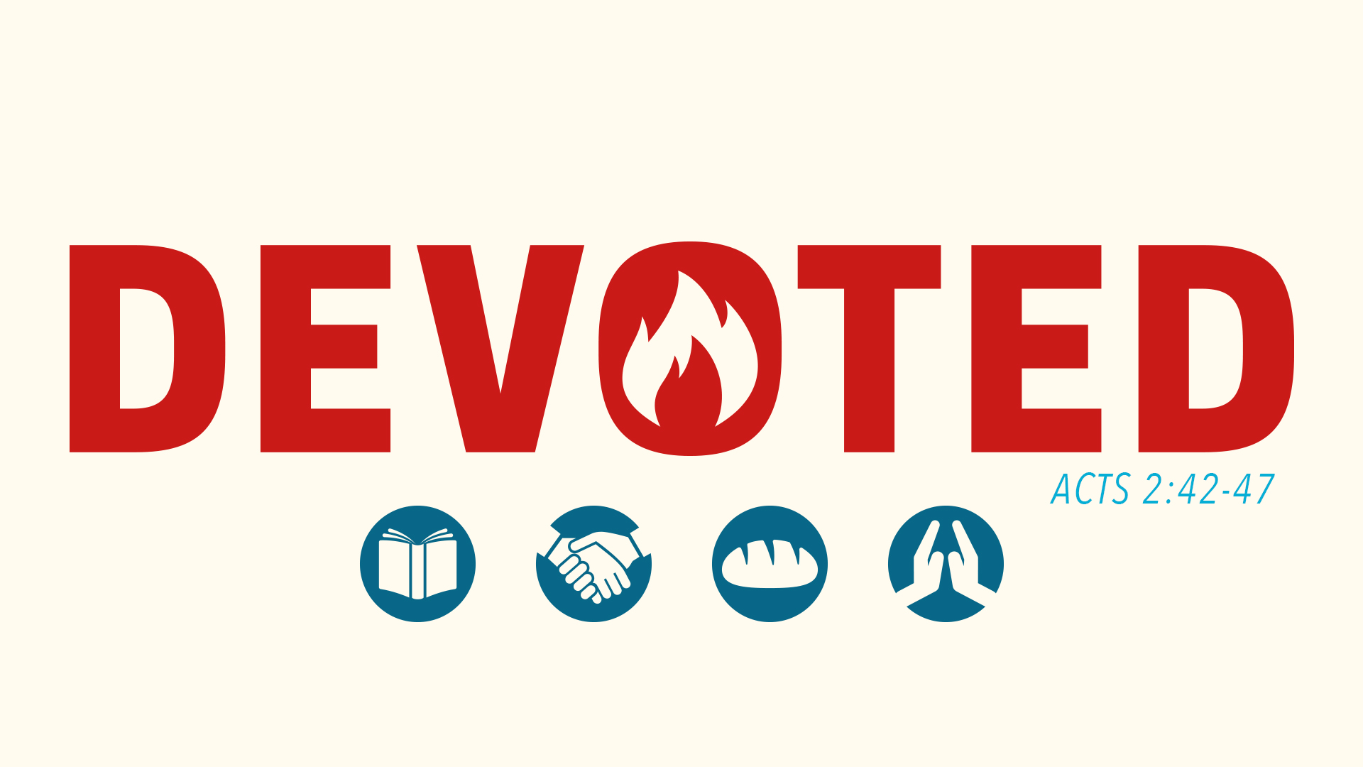Differences in Fellowship

1. Implementation of Fellowship
2. Blessings of Fellowship
3. Purpose of Fellowship
4. **Differences in Fellowship**

# **Herchurch**

Below are phrases taken from [www.herchurch.org](http://www.herchurch.org) , a Lutheran congregation in CA.

Our mission is to embody and voice the prophetic wisdom and word of the**Divine Feminine… All persons are welcome and loved in the love of Christ-Sophia and Great Mother of us All… we have been in the Goddess’ service in the City since 1882.**

At herchurch, we create a sacred space for those who wish to worship at the cutting edge and outside of the  traditional Christian framework, both slightly outside, and waaaaay outside. We are fortunate to have pagans, non-theists, yogis, spiritual seekers of all sorts as well as Christians, Jews, Muslims, and life-long Lutherans as members of our faith/spiritual community.

The voice of the Divine Feminine is not only mined from the pages of scriptures and the stories trapped between the lines, but also from ancient and modern Goddess traditions.

1. Do all Lutheran churches believe the same thing?
2. Are we in fellowship with herchurch? Why or Why Not?
3. Consider the two principles we have learned so far. How might we apply them if one of our sister congregations began to subscribe to herchurch’s views?
   1. Fellowship is working together for the truth.
   2. We watch out for those who teach/preach against the truths of Scripture and keep away from them.

# **Galatians 1:6-12**

**6 I am astonished that you are so quickly deserting the one who called you by the grace of Christ and are turning to a different gospel— 7 which is really no gospel at all. Evidently some people are throwing you into confusion and are trying to pervert the gospel of Christ.**

1. What descriptive verb does Paul use for false teaching in verse 7? Should we speak this strongly today?
2. Why might Christians or Christian churches be tempted to desert the Gospel of Christ?
3. What confusion might be seen in the life of the church if groups of believers (or beliefs) form?

**8 But even if we or an angel from heaven should preach a gospel other than the one we preached to you, let him be eternally condemned! 9 As we have already said, so now I say again: If anybody is preaching to you a gospel other than what you accepted, let him be eternally condemned!**

1. What do these verses mean to you?

**10 Am I now trying to win the approval of men, or of God? Or am I trying to please men? If I were still trying to please men, I would not be a servant of Christ.**

**11 I want you to know, brothers, that the gospel I preached is not something that man made up. 12 I did not receive it from any man, nor was I taught it; rather, I received it by revelation from Jesus Christ.**

1. List multiple reasons why people pervert the Gospel of Jesus.
2. Respond to this statement, found on a bulletin at a large church:

*It is our commitment to major on the major doctrines, while minoring on the minors: “In essentials unity, in non-essentials diversity, in all things charity.”*

# **Tolerate or divide?**

**Titus 3:8-11 8 This is a trustworthy saying. And I want you to stress these things, so that those who have trusted in God may be careful to devote themselves to doing what is good. These things are excellent and profitable for everyone.**

**9 But avoid foolish controversies and genealogies and arguments and quarrels about the law, because these are unprofitable and useless.**

**10 Warn a divisive person once, and then warn him a second time. After that, have nothing to do with him. 11 You may be sure that such a man is warped and sinful; he is self-condemned.**

1. What is good (verse 8) and bad (verse 9)?
2. If someone persists in false teaching, how should we respond?
3. What are we warning them about?

**Revelation 22:18-19 18 I warn everyone who hears the words of the prophecy of this book: If anyone adds anything to them, God will add to him the plagues described in this book. 19 And if anyone takes words away from this book of prophecy, God will take away from him his share in the tree of life and in the holy city, which are described in this book.**

1. During the time of the 1st century, the Christian faith was undermined by Jewish teachings (genealogies, arguments, quarrels about the law) and some lost their faith.

What teachings are present today that undermine the Christian faith?

**Jude 17-20 17 But, dear friends, remember what the apostles of our Lord Jesus Christ foretold. 18 They said to you, “In the last times there will be scoffers who will follow their own ungodly desires.” 19 These are the men who divide you, who follow mere natural instincts and do not have the Spirit.**

**20 But you, dear friends, build yourselves up in your most holy faith and pray in the Holy Spirit.**

1. How should we respond to the false teaching and false teachers of today:
   1. Sarcastic internet memes
   2. Jokes with bros over beer
   3. Bible study and prayer
   4. “back in the olden days, this would have never….”
2. How should we respond if we are part of an ecumenical group, gathering, or congregation that tolerates false teaching?
3. Explain this statement: False teaching will always lead to false faith.

Loving Truth & Loving Souls

1. Implementation of Fellowship
2. Blessings of Fellowship
3. Purpose of Fellowship
4. Differences in Fellowship
5. **Loving Truth and Loving Souls – Lord’s Supper**

# **Pastors & Priests REtreat 2017**

As Pastor, I recently received an invitation to a spiritual retreat in January 2017. It costs $399.

* Pastors, priests, and worship leaders are invited to an ecumenical retreat at a Jesuit Center in IL. The retreat is led by Father Michael Sparough, a Jesuit priest. Tuesday evening has a joint Eucharist service.
* 70 church leaders from different churches and backgrounds will gather for joint spiritual formation, prayer, worship, and study. This retreat is hosted by Willow Creek church, a very large non-denominational church.

What should I do?

1. What theological differences might exist between a Jesuit priest, non-denominational minister, a “spiritual but not religious person” and a confessional Lutheran Pastor?
2. What message would be sent if a Lutheran Pastor receives the Eucharist from a Jesuit Priest?
3. Would it be spiritually wise for me to attend?

# **Loving Truth and Loving Souls**

**2 Timothy 2:16-18 15 Do your best to present yourself to God as one approved, a workman who does not need to be ashamed and who correctly handles the word of truth.**

**16 Avoid godless chatter, because those who indulge in it will become more and more ungodly. 17 Their teaching will spread like gangrene. Among them are Hymenaeus and Philetus, 18 who have wandered away from the truth. They say that the resurrection has already taken place, and they destroy the faith of some.**

1. Fellow workers of the Most High God – what should we do (verse 15)?
2. Describe what it means to correctly handle the word of truth.
3. What happens if pastors, teachers, and members of a congregation do not correctly handle the word of truth but permit false teaching/ teachers in their midst (verse 17-18)?
4. Complete this sentence: A family of believers working together for the truth will love \_\_\_\_\_\_\_\_\_\_\_\_ and will love \_\_\_\_\_\_\_\_\_\_\_\_\_\_ by \_\_\_\_\_\_\_\_\_\_\_\_\_\_ from those who preach/teach falsely.
5. Respond:
   1. Jesus never made distinctions on doctrine, and we shouldn’t either. We should love everyone and focus on what unites us, instead of what divides us.
   2. Each person’s faith is their individual choice. I have no right to correct or admonish anyone!

# **Loving Truth and Loving Souls – Lord’s Supper**

**Matthew 20:26-28 26 While they were eating, Jesus took bread, gave thanks and broke it, and gave it to his disciples, saying, “Take and eat; this is my body.”**

**27 Then he took the cup, gave thanks and offered it to them, saying, “Drink from it, all of you. 28 This is my blood of the covenant, which is poured out for many for the forgiveness of sins.**

1. Jesus institutes the Lord’s Supper. What visible element did he first give to them? What did he call it?
2. Jesus also gives them the wine. What does he say about that?
3. What is the purpose of the Lord’s Supper?

|  |  |  |  |
| --- | --- | --- | --- |
| Who teaches it: | **THE BIBLE** | **ROMAN CATHOLIC**  **CHURCH** | **EVANGELICAL / ARMINIAN CHURCHES** |
| Name of the doctrine: | Real Presence | Transubstantiation | Representation |
| Summary of the Doctrine: | Partakers of the Lord’s Supper receive the body and blood of our Lord “in, with, and under” the bread and wine. | Partakers of the Lord’s Supper receive only the body and blood of Christ. | Partakers of the Lord’s Supper receive only the bread and wine, which are symbolic of the body and blood of Christ. |
| Reason for belief in the  doctrine*:* | Matthew 26:26-29  Mark 14:22-25  Luke 22:18-20  1 Corinthians 11:23-29 | False belief that the sacrament of the Lord’s Supper is a sacrifice to offer payment for sin. | Human reason |

1. Could a Lutheran, Jesuit Priest, and non-denominational minister receive the Eucharist together? Why or why not?

**1 John 1:5-6 5 This is the message we have heard from him and declare to you: God is light; in him there is no darkness at all. 6 If we claim to have fellowship with him yet walk in the darkness, we lie and do not live by the truth.**

**Colossians 1:21,22 Once you were alienated from God and were enemies in your minds because of your evil behavior. But now he has reconciled you by Christ’s physical body through death to present you holy in his sight, without blemish and free from accusation.**

1. What fellowship do we have with God?

**1 Corinthians 10:16-17 Is not the cup of thanksgiving for which we give thanks a participation (fellowship) in the blood of Christ? And is not the bread that we break the participation (fellowship) in the body of Christ? We, who are many, are one body, for we all partake of one loaf.**

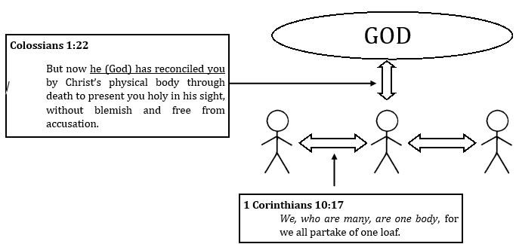**Ephesians 4:4 There is one body and one Spirit -- just as you were called to one hope when you were called -- one Lord, one faith, one baptism;**

1. What fellowship do we have with fellow communicants?

**1 Corinthians 11:27-29 27 Therefore, whoever eats the bread or drinks the cup of the Lord in an unworthy manner will be guilty of sinning against the body and blood of the Lord.**

**28 A man ought to examine himself before he eats of the bread and drinks of the cup.**

**29 For anyone who eats and drinks without recognizing the body of the Lord eats and drinks judgment on himself.**

1. God institutes the Lord’s Supper for forgiveness. What happens if we receive the Lord’s Supper in an “unworthy manner”?
2. How do we receive the Lord’s Supper worthily?
   1. Think of portions in our worship service that assist communicants in examining themselves and recognizing (1) the body of the Lord in the meal and (2) the body of the Lord gathered in worship.

**30 That is why many among you are weak and sick, and a number of you have fallen asleep. 31 But if we judged ourselves, we would not come under judgment. 32 When we are judged by the Lord, we are being disciplined so that we will not be condemned with the world.**

1. What happened to those who received the Lord’s Supper in an unworthy manner? What warnings and encouragements does that provide to us today?
2. Those who would promote open communion, i.e. communion is open to all regardless of beliefs or convictions or maturity in faith (baptism is usually a requirement, but not always!) will say “It is the Lord’s table – all are welcome!”

How might you use 1 Corinthians 11:23-29 to respond?

** DEFINITION**: Close Communion — the practice of admitting to the Lord’s Supper only those who have, after a course of directed study, confessed faith in Jesus and unity of faith with the body of believers. The goal of this practice is to ensure that: a) the participant doesn’t take the Lord’s Supper in an “unworthy manner” and thereby damage the vertical relationship celebrated in the Lord’s Supper (cf. 1 Cor. 11:27), and b) the horizontal relationship celebrated in the Lord’s Supper may be maintained (cf. 1 Cor. 10:17).

**Romans 16:17 I urge you, brothers, to watch out for those who cause divisions and put obstacles in your way that are contrary to the teaching you have learned. Keep away from them.**

**2 John 10-11 If anyone comes to you and does not bring this teaching, do not take him into your house or welcome him. Anyone who welcomes him shares in his wicked work.**

1. Should we tolerate/support/enable/welcome those who promote false teaching? Should we commune with them?

### **Discussion Questions**

Explain Some might say that the practice of Close Communion is unloving or unBiblical. What is our twin purpose in following Close Communion? What will happen if we allow open communion?

A/D Everyone who goes to the Lord’s Supper receives Jesus’ body and blood.

A/D Everyone who goes to the Lord’s Supper receives the forgiveness of sins.

Discuss You go to a different church with your friend or family. The Pastor or Priest invites you to come forward and take the Lord’s Supper for “everyone is welcome!” What should you do?

# **The Account of the Lord’s Supper**

**LUKE 22:14-23**

14 When the hour came, Jesus and his apostles reclined at the table. 15 And he said to them, "I have eagerly desired to eat this Passover with you before I suffer. 16 For I tell you, I will not eat it again until it finds fulfillment in the kingdom of God."

17 After taking the cup, he gave thanks and said, "Take this and divide it among you. 18 For I tell you I will not drink again of the fruit of the vine until the kingdom of God comes."

19 And he took bread, gave thanks and broke it, and gave it to them, saying, "This is my body given for you; do this in remembrance of me."

20 In the same way, after the supper he took the cup, saying, "This cup is the new covenant in my blood, which is poured out for you.”

**MARK 14:17-26**

17 When evening came, Jesus arrived with the Twelve. 18 While they were reclining at the table eating, he said, "I tell you the truth, one of you will betray me -- one who is eating with me."

19 They were saddened, and one by one they said to him, "Surely not I?"

20 "It is one of the Twelve," he replied, "one who dips bread into the bowl with me. 21 The Son of Man will go just as it is written about him. But woe to that man who betrays the Son of Man! It would be better for him if he had not been born."

22 While they were eating, Jesus took bread, gave thanks and broke it, and gave it to his disciples, saying, "Take it; this is my body."

23 Then he took the cup, gave thanks and offered it to them, and they all drank from it.

24 "This is my blood of the covenant, which is poured out for many," he said to them. 25 "I tell you the truth, I will not drink again of the fruit of the vine until that day when I drink it anew in the kingdom of God."

26 When they had sung a hymn, they went out to the Mount of Olives.

.

**MATTHEW 26:20-29**

20 When evening came, Jesus was reclining at the table with the Twelve. 21 And while they were eating, he said, "I tell you the truth, one of you will betray me."

22 They were very sad and began to say to him one after the other, "Surely not I, Lord?"

23 Jesus replied, "The one who has dipped his hand into the bowl with me will betray me. 24 The Son of Man will go just as it is written about him. But woe to that man who betrays the Son of Man! It would be better for him if he had not been born."

25 Then Judas, the one who would betray him, said, "Surely not I, Rabbi?" Jesus answered, "Yes, it is you."

26 While they were eating, Jesus took bread, gave thanks and broke it, and gave it to his disciples, saying, "Take and eat; this is my body."

27 Then he took the cup, gave thanks and offered it to them, saying, "Drink from it, all of you. 28 This is my blood of the covenant, which is poured out for many for the forgiveness of sins. 29 I tell you, I will not drink of this fruit of the vine from now on until that day when I drink it anew with you in my Father's kingdom."

**1 CORINTHIANS 11:23-29**

23 For I received from the Lord what I also passed on to you: The Lord Jesus, on the night he was betrayed, took bread, 24 and when he had given thanks, he broke it and said, "This is my body, which is for you; do this in remembrance of me."

25 In the same way, after supper he took the cup, saying, "This cup is the new covenant in my blood; do this, whenever you drink it, in remembrance of me."

26 For whenever you eat this bread and drink this cup, you proclaim the Lord's death until he comes.

27 Therefore, whoever eats the bread or drinks the cup of the Lord in an unworthy manner will be guilty of sinning against the body and blood of the Lord.

28 A man ought to examine himself before he eats of the bread and drinks of the cup.

29 For anyone who eats and drinks without recognizing the body of the Lord eats and drinks judgment on himself.

Loving Truth & Loving Souls

1. Implementation of Fellowship
2. Blessings of Fellowship
3. Purpose of Fellowship
4. Differences in Fellowship
5. Loving Truth and Loving Souls – Lord’s Supper
6. **LT-LS – Church Fellowship**
7. LT-LS – Prayer and Worship Fellowship

Loving Truth & Loving Souls

1. Implementation of Fellowship
2. Blessings of Fellowship
3. Purpose of Fellowship
4. Differences in Fellowship
5. Loving Truth and Loving Souls – Lord’s Supper
6. **LT-LS – Church Fellowship**
7. LT-LS – Prayer and Worship Fellowship

# **Should we work with him?**

A man grew up zealous for the teachings of his religion. He studied the Scriptures for many years under a noted teacher and instructor. He was convicted in his beliefs – so much so that he began to persecute others who didn’t hold to his teachings. He watched while his followers stoned others who differed from his pure, Jewish faith.

1. Who is this man? How does his story continue?
2. What practical difficulties would this man have integrating into his new church and church body?

# **Church Fellowship in the 1st Century – Galatians 2**

**9 James, Peter and John, those reputed to be pillars, gave me and Barnabas the right hand of fellowship when they recognized the grace given to me. They agreed that we should go to the Gentiles, and they to the Jews.**

1. What positions did James, Peter, and John hold in the Christian church in Jerusalem and in other places?
2. What did they do to make sure that Saul was in full agreement with them?
3. After full agreement has been recognized, how did they demonstrate this agreement?
4. Imagine if the order was reversed, i.e. Saul (Paul) is commissioned for joint mission work first, and then doctrinal agreement is recognized “later”. What would happen?
5. If someone wants to join our church, or church body, what is the prescribed process? Why?

**11 When Peter came to Antioch, I opposed him to his face, because he was clearly in the wrong. 12 Before certain men came from James, he used to eat with the Gentiles. But when they arrived, he began to draw back and separate himself from the Gentiles because he was afraid of those who belonged to the circumcision group. 13 The other Jews joined him in his hypocrisy, so that by their hypocrisy even Barnabas was led astray.**

**14 When I saw that they were not acting in line with the truth of the gospel, I said to Peter in front of them all, “You are a Jew, yet you live like a Gentile and not like a Jew. How is it, then, that you force Gentiles to follow Jewish customs?**

1. Why did Paul confront Peter?
   1. Peter’s ministry preference was to eat with Jews, not Gentiles.
   2. Peter’s ministry preference caused divisions among the Jews/Gentiles, and Barnabas
   3. Peter made a ministry choice that was not culturally acceptable.
   4. Your answer: \_\_\_\_\_\_\_\_\_\_\_\_\_\_\_\_\_\_\_\_\_\_\_\_\_\_\_\_\_\_\_\_\_\_\_\_\_\_\_\_\_\_\_\_\_\_

# **Summary of Principles for Church Fellowship**

* Loving truth and loving souls leads us to warn those who stray into false teaching or practice with the hope that they are won to repentance.
  + Titus 3:10, Matthew 18:15, 2 Timothy 2:25,16
  + 3 **As I urged you when I went into Macedonia, stay there in Ephesus so that you may command certain men not to teach false doctrines any longer 4 nor to devote themselves to myths and endless genealogies. These promote controversies rather than God’s work—which is by faith. 5 The goal of this command is love, which comes from a pure heart and a good conscience and a sincere faith** 1 Timothy 1:3-5
* Loving truth and loving souls leads us to warn others about the false teaching (teacher), so that they do not fall victim to false teaching. We have special responsibility to those weak in faith.
  + 1 Timothy 4:1-6, 2 Timothy 4:2-5, Jude 1:22-23
  + **10 For there are many rebellious people, mere talkers and deceivers, especially those of the circumcision group. 11 They must be silenced, because they are ruining whole households by teaching things they ought not to teach—and that for the sake of dishonest gain.** Titus 1:10-11
* We must avoid the appearance of going along with error, even in matters of adiaphora
  + **3 Yet not even Titus, who was with me, was compelled to be circumcised, even though he was a Greek.** Galatians 2:3
* We must separate from false teachers to protect ourselves from the dangerous poison of error which is a threat to our souls. 2 Timothy 2:17
  + **7 You were running a good race. Who cut in on you and kept you from obeying the truth? 8 That kind of persuasion does not come from the one who calls you. 9 “A little yeast works through the whole batch of dough.”** Galatians 5:7-9

1. A local Methodist church approaches our congregation to have a joint VBS this Summer. They believe we can reach more people for Jesus if we work together than separately. They promise to pick doctrines and stories that we are in full agreement on, and split the profits equally.
2. A church organist approaches her Pastor. She’s been asked to play hymns for a local Baptist congregation since their organist is sick. She could use the extra money. She knows Baptists don’t believe what we do, but her Aunt is a member there and she wants to be nice to her. What will her Pastor say?
3. Consider other forms of service in the worship service. Would this principle apply to:
   1. Ushers?
   2. Communion assistants?
   3. Preachers/teachers?
   4. Sunday School teachers?
   5. Soloist?
   6. Musician?
4. One of our Pastors is called to serve our WELS African Mission in Malawi. He listed one of the duties in his new position was to respond to the many contacts from other African church bodies who are interested in doctrinal fellowship with WELS and our local African church body.
   1. Let’s assume he takes his call. How will he respond to these requests?
   2. Describe the process for unity and fellowship.
   3. Why might he visit multiple churches and interview multiple members regarding their doctrine and practice?

# **Church Fellowship in the 1st century – 2 timothy 4**

**2 Preach the Word; be prepared in season and out of season; correct, rebuke and encourage—with great patience and careful instruction.**

1. What is the job description for young Pastor Timothy?
2. How will we approach the doctrine of church fellowship (or any teaching of God’s Word)?

**3 For the time will come when men will not put up with sound doctrine. Instead, to suit their own desires, they will gather around them a great number of teachers to say what their itching ears want to hear. 4 They will turn their ears away from the truth and turn aside to myths.**

1. Describe the challenges Timothy faces to hold to the pure Word of God in a world of compromise.
2. Describe the challenges we face to hold to the pure Word of God in a world of compromise.

**5 But you, keep your head in all situations, endure hardship, do the work of an evangelist, discharge all the duties of your ministry.**

1. What stands out to you from this verse?

### **Discussion Questions**

A/D You cannot remain in the same stall with others who propagate false doctrine or are attached to it or always speak good words to the devil or his crowd.

Discuss We know that the church exists among those who rightly teach the Word of God and rightly administer the sacraments; it does not exist among those who not only try to destroy the Word of God with their edicts, but who also butcher those who teach what is right and true. Even the canons are gentler with those who violate them. Moreover, we want to point out again that we would willingly retain ecclesiastical and canonical order as long as the bishops desisted from their cruelty against our churches. This willingness will be our defense, both before God and among all nations, present and future, against the charge that we have undermined the authority of the bishops. Thus people may read and hear that, despite our protest against the unjust cruelty of the bishops, we could obtain no justice.

Apology to the Augsburg Confession, Article XIV, Concerning Church Order

Loving Truth & Loving Souls

1. Implementation of Fellowship
2. Blessings of Fellowship
3. Purpose of Fellowship
4. Differences in Fellowship
5. Loving Truth and Loving Souls – Lord’s Supper
6. LT-LS – Church Fellowship
7. **LT-LS – Prayer and Worship Fellowship**

# **Is this worship?**

David and Gretchen go on vacation to Denver, CO. After some skiing on Saturday night, they wake up on Sunday morning looking for a local Lutheran church. They find one with a cool name and cool website – House for All Sinners & Saints Lutheran. Gretchen isn’t too keen on rock-band worship services, and this church advertises liturgical worship. They walk in and sit down.

Their bulletin states that HFASS is “a group of folks figuring out how to be a liturgical, Christo-centric, social justice-orientated, queer-inclusive, incarnational contemplative, irreverent, ancient/future church with a progressive but deeply rooted theological imagination.”

Gretchen is concerned and so asks the people next to them what they believe. She learns that Emily is agnostic, Jeff is Methodist, Travis is Episcopalian (like the associate Pastor Reagan), Shari is atheist, and Wendy is Wiccan. That’s ok, though, they assure her. We are a big tent, and we don’t have to believe at all or the same to worship, pray, commune, etc.

The Pastor, Nadia Bolz-Weber (author of NY Times Bestseller), begins the worship service. She invites people to be “co-creators, not passive participants” of the liturgy. Various persons in the pews lead worship from where they are sitting – speaking words, singing hymns, etc. She invites agnostic Emily to speak the Invocation, wiccan Wendy to speak the confession, atheist Shari the Kyrie and methodist Jeff the Gloria. She then invites David and Gretchen to speak together the Prayer of the Day.

1. How is worship at HFASS different from most liturgical churches? Is that good or bad?
2. What should David and Gretchen have done to prevent this awkward moment? What should they do now?

# **What is prayer?**

**Galatians 4:6 Because you are sons, God sent the Spirit of his Son into our hearts, the Spirit who calls out, *“Abba*, Father.**

**Matthew 6:9 “This, then, is how you should pray: “ ‘Our Father in heaven, hallowed be your name**

1. What is the significance of “Our Father” instead of “My Father” or “The Father”?
2. How do we keep God’s name holy?

**Acts 13:2-3 2 While they were worshiping the Lord and fasting, the Holy Spirit said, “Set apart for me Barnabas and Saul for the work to which I have called them.” 3 So after they had fasted and prayed, they placed their hands on them and sent them off.**

1. What did the believers do as part of their worship, according to the Holy Spirit’s direction?
2. Do Catholics, Church of Christ, Southern Baptists, Methodists, and Muslims believe that prayer is worship?

**Romans 12:1, 12 Therefore, I urge you, brothers, in view of God’s mercy, to offer your bodies as living sacrifices, holy and pleasing to God—this is your spiritual act of worship. 12 Be joyful in hope, patient in affliction, faithful in prayer.**

**Hebrews 11:6 And without faith it is impossible to please God, because anyone who comes to him must believe that he exists and that he rewards those who earnestly seek him.**

1. Can an unbeliever pray to God?

# **Prayer Prepositions**

|  |  |  |  |
| --- | --- | --- | --- |
| Prayer | Preposition | Point | Fellowship? |
| 2 Thessalonians 3:1  Finally, brothers, pray for us that the message of the Lord may spread rapidly and be honored, just as it was with you. |  |  |  |
| 1 Timothy 2:1-2  I urge, then, first of all, that requests, prayers, intercession and thanksgiving be made for everyone— 2 for kings and all those in authority, that we may live peaceful and quiet lives in all godliness and holiness. |  |  |  |
| Acts 27:33-35  33 Just before dawn Paul urged them all to eat. “For the last fourteen days,” he said, “you have been in constant suspense and have gone without food—you haven’t eaten anything.  34 Now I urge you to take some food. You need it to survive. Not one of you will lose a single hair from his head.” 35 After he said this, he took some bread and gave thanks to God in front of them all. Then he broke it and began to eat. |  |  |  |
| 2 Corinthians 1:11  as you help us by your prayers. Then many will give thanks on our behalf for the gracious favor granted us in answer to the prayers of many. |  |  |  |

1. How does Paul teach prayer fellowship with prepositions?
   1. When in the presence of unbelievers \_\_\_\_\_\_\_\_\_\_\_\_\_\_\_\_\_\_\_\_\_\_\_\_\_\_\_\_\_\_\_\_\_\_\_\_\_
   2. When in the presence of his church \_\_\_\_\_\_\_\_\_\_\_\_\_\_\_\_\_\_\_\_\_\_\_\_\_\_\_\_\_\_\_\_\_\_\_\_\_
   3. When in praying for kings and those in authority \_\_\_\_\_\_\_\_\_\_\_\_\_\_\_\_\_\_\_\_\_\_\_\_\_\_\_\_\_\_\_\_\_\_\_\_\_
   4. When recognizing the benefits of prayer fellowship \_\_\_\_\_\_\_\_\_\_\_\_\_\_\_\_\_\_\_\_\_\_\_\_\_\_\_\_\_\_\_\_\_\_\_\_\_
2. How might we teach prayer fellowship in the following situations:
   1. A Baptist co-worker is getting divorced from her cheating husband. She asks for prayers. \_\_\_\_\_\_\_\_\_\_\_\_\_\_\_\_\_
   2. A member of our congregation tells you about illness in their family. She asks for prayers. \_\_\_\_\_\_\_\_\_\_\_\_\_\_\_\_\_
   3. You go out for lunch with your Pastor. The meal is brought to your table. \_\_\_\_\_\_\_\_\_\_\_\_\_\_\_\_\_
   4. Your relative decries the state of our nation. You are sick of talking politics. You say: \_\_\_\_\_\_\_\_\_\_\_\_\_\_\_\_\_
3. Consider our previous classes on fellowship – church and communion fellowship. Did we learn anything new today?
4. Consider scenarios like prayers before ballgames, prayers at civic organizations, or devotions before meetings. How can we be proactive rather than reactive when it comes to prayer fellowship?

# **Worship Fellowship in syria and israel – 2 kings 5**

**Now Naaman was commander of the army of the king of Aram. He was a great man in the sight of his master and highly regarded, because through him the Lord had given victory to Aram. He was a valiant soldier, but he had leprosy.** **Now bands from Aram had gone out and had taken captive a young girl from Israel, and she served Naaman’s wife. 3 She said to her mistress, “If only my master would see the prophet who is in Samaria! He would cure him of his leprosy.”**

1. How does Naaman the Aramean (Syrian) learn about God?

**10 Elisha sent a messenger to say to him, “Go, wash yourself seven times in the Jordan, and your flesh will be restored and you will be cleansed.” 11 But Naaman went away angry and said, “I thought that he would surely come out to me and stand and call on the name of the Lord his God, wave his hand over the spot and cure me of my leprosy.**

1. How does Naaman describe God?

**14 So he went down and dipped himself in the Jordan seven times, as the man of God had told him, and his flesh was restored and became clean like that of a young boy.**

**15 Then Naaman and all his attendants went back to the man of God. He stood before him and said, “Now I know that there is no God in all the world except in Israel.** **Please accept now a gift from your servant.”**

**16 The prophet answered, “As surely as the Lord lives, whom I serve, I will not accept a thing.” And even though Naaman urged him, he refused.**

**17 “If you will not,” said Naaman, “please let me, your servant, be given as much earth as a pair of mules can carry, for your servant will never again make burnt offerings and sacrifices to any other god but the Lord.**

1. How does Naaman describe God now?
2. How does Naaman demonstrate his faith in God?

**18 But may the Lord forgive your servant for this one thing: When my master enters the temple of Rimmon to bow down and he is leaning on my arm and I bow there also—when I bow down in the temple of Rimmon, may the Lord forgive your servant for this.” 19 “Go in peace,” Elisha said.**

1. Why does Naaman ask for forgiveness?
2. Timothy, a member of our congregation, goes to his niece’s Catholic wedding in Kentucky. He speaks with the priests before the service and indicates that he is Lutheran. “Oh, that’s no problem!” the priest says. “I just heard that Lutherans and Catholics are getting along better than ever! Please worship with us for the prayers, the Eucharist, the holy water, and the songs. You might find much of this familiar!”
   1. Timothy’s son asks him as the organ plays the first hymn, “Dad, should we sing?”
   2. Timothy’s wife asks him as the congregation kneels for confession, “Dad, should we kneel?”
   3. The Eucharist is being distributed and the usher says “Sir, won’t you come up?”
3. Timothy has a lot of nieces, and they are all getting married in different churches, non-denominational, Methodist, Baptist, Church of Christ, and Anglican.
   1. How can Timothy be proactive instead of reactive?
   2. What will Timothy lead his family to do at all of these weddings?

Loving Truth & Loving Souls

1. Implementation of Fellowship
2. Blessings of Fellowship
3. Purpose of Fellowship
4. Differences in Fellowship
5. Loving Truth and Loving Souls – Lord’s Supper
6. LT-LS – Church Fellowship
7. **LT-LS – Prayer and Worship Fellowship - 2nd Half**

# **Pray for our nation**

I received an invitation to Pray For Our Country Day on November 6, 2016. Please evaluate the invitation from Bethlehem General Baptist Youth in Whitewater, MO

As we approach this year’s election we need to pray for our country. Please read to your congregation after church in the weeks upcoming before the election. We need prayer more than we ever have. Our goal is to reach out to every church in America - all 374,000 of them and that is costly. Any Donations for postage no matter how big or small would be greatly appreciated. And please tell your non-church friends we need their prayer too.

If we band together with prayer our nation will be great again. Put JESUS first and nothing will stop us.

1. What parts of this invitation are in accordance with God’s Word and Will?
2. What parts of this invitation are ambiguous or not in accordance with God’s Word and Will?
3. Would a Lutheran Church send this out – why or why not?

# **passages and principles**

We were not able last week to complete our lesson on time, so here is a brief review.

Prayer is worship to God by believers. Galatians 4:6, Matthew 6:9, Acts 13:2-3, Romans 12:1,12,

God does not hear unbeliever’s prayers Hebrews 11:6

God wants us to pray for all people 1 Timothy 2:1-2

We pray with those who we are united with in fellowship Lesson 3 and 4, 2 Thessalonians 3:1

When Christians attend worship services of other faiths Elisha and Naaman or denominations for a wedding or funeral, we do not participate in their worship.

# **Fellowship in the 1st century – 2 timothy 4**

**2 Preach the Word; be prepared in season and out of season; correct, rebuke and encourage—with great patience and careful instruction.**

1. What is the job description for young Pastor Timothy?
2. How will we approach the doctrine of prayer fellowship (or any teaching of God’s Word)?

**3 For the time will come when men will not put up with sound doctrine. Instead, to suit their own desires, they will gather around them a great number of teachers to say what their itching ears want to hear. 4 They will turn their ears away from the truth and turn aside to myths.**

1. Describe the challenges Timothy faces to hold to the pure Word of God in a world of compromise. Describe the challenges we face to hold to the pure Word of God in a world of compromise.

**5 But you, keep your head in all situations, endure hardship, do the work of an evangelist, discharge all the duties of your ministry.**

1. What stands out to you from this verse?

### **Discussion Questions**

A/D In 1904, there was an intersynodical conference between the Ohio and Iowa Synods. These church bodies were considering joining in fellowship with each other. There was a motion to open and close these free conferences with prayer. The delegates protested the suggestion, announcing that this would make future participation impossible. Other members of the synodical conference pointed out that ‘every participant certainly prays silently, but openly joined prayers of the congregation would certainly leave the wrong impression regarding unity of spirit and belief, and as if the teaching differences were of no special significance[[2]](#footnote-2)

T/F Church fellowship and prayer fellowship are relatively new inventions by Christians. For example, Bishop Meletius of Lycopolis and Peter of Alexandria were considering joint fellowship in the 400s. When it was evident that they did not believe the same thing, “one party and the other prayed separately, and likewise performed the holy ministrations for himself.”[[3]](#footnote-3)

Discuss We know that the church exists among those who rightly teach the Word of God and rightly administer the sacraments; it does not exist among those who not only try to destroy the Word of God with their edicts, but who also butcher those who teach what is right and true. Even the canons are gentler with those who violate them. Moreover, we want to point out again that we would willingly retain ecclesiastical and canonical order as long as the bishops desisted from their cruelty against our churches. This willingness will be our defense, both before God and among all nations, present and future, against the charge that we have undermined the authority of the bishops. Thus people may read and hear that, despite our protest against the unjust cruelty of the bishops, we could obtain no justice.[[4]](#footnote-4)

Loving Truth & Loving Souls

1. Loving Truth and Loving Souls – Lord’s Supper
2. LT-LS – Church Fellowship
3. LT-LS – Prayer and Worship Fellowship - 2nd Half
4. **LT-LS – Boy Scouts**

# **Girl Scouts and archdiocese of st. louis**

On February 18th, 2016, Archbishop Robert Carlson of the Archdiocese of St. Louis sent out a letter to “Priests, Scout Leaders, and Faithful of the Archdiocese” regarding the Archdiocese’s relationship with Girl Scouts. After years of study, he disbanded the Catholic Committee on Girl Scouts and tasked his leaders to partner with other youth-formation groups.

What is so bad about a group that sells cookies?

His comments:

1. WAGGGS’ continued promotion of contraception and “abortion rights” on behalf of its girl members, the majority of whom are minors
2. Financial contributions from GSUSA to WAGGGS, based on number of registered GSUSA members
3. GSUSA resources and social media highlight and promote role models in conflict with Catholic values, such as Gloria Steinem and Betty Friedan.
4. Organizations that GSUSA promotes and partners with are in conflict with Catholic values, such as Amnesty International, Coalition for Adolescent Girls, OxFam and more. This is especially troubling in regard to sex education and advocacy for “reproductive rights” (i.e. abortion and contraceptive access, even for minors)

In addition, recent concerns about GSUSA and their position on and inclusion of transgender and homosexual issues are proving problematic. Our culture is becoming increasingly intolerant of a Catholic worldview regarding these issues. While Catholics are called to treat all people with compassion and mercy, we must at the same time be mindful of whom we allow to teach and form our youth and the messages they present. Because local Girl Scout troops are chartered with GSEM, not the parish, any authority on policy and teaching resides with GSEM rather than with parish leadership. In addition, given the fact that the Girl Scout program is a secular organization, they are not obliged to uphold the teachings of our faith.

1. Can you summarize the Archbishop’s concerns?
2. Why is he so especially concerned about the formation of Catholic girls?
3. Are you aware of any church bodies that have split from Boy or Girl Scouting in the last year?

# **Brief History on Boy Scouts in America**

1. Page 4 What is the goal of Scouting in Britain?
2. Page 5 Can you describe the 12th Law?
3. Page 6-7 Evaluate the songs and prayers sung jointly with Catholic, Baptist, Mormon, Lutheran, and other Christian Scouts.
4. Page 8 What is the teaching of religious fellowship in Scouting?
5. Page 9 Summarize the (1) motivation for right living and (2) the source for this motivation.

Imagine if our Sunday School teachers taught the same motivation and source of motivation. What would our youth turn out to be?

Christians

Pharisees

1. Page 10 Comment on this instruction:

“God cannot do your life task for you. You must do it yourself, in the faith that ‘God helps them that help themselves’

1. Page 11 Why are the Scouts generic in their description of God? What implications does that have for a Lutheran youth in Scouting?
2. Page 12 Can I preach this in the pulpit:

“There are many kinds of religion in the world. One important point, however, about them is that they all involve worship of the same God. There is but one Leader, although many ways of following Him. If a Scout meets one of another religion, he should remember that he, too, is striving for the best.”’

# **Studying the Scriptures**

**1 John 4:1-3, 14 Dear friends, do not believe every spirit, but test the spirits to see whether they are from God, because many false prophets have gone out into the world.**

**2 This is how you can recognize the Spirit of God: Every spirit that acknowledges that Jesus Christ has come in the flesh is from God, 3 but every spirit that does not acknowledge Jesus is not from God. This is the spirit of the antichrist, which you have heard is coming and even now is already in the world.**

**And we have seen and testify that the Father has sent his Son to be the Savior of the world.**

1. Why do we “test the spirits”, that is, test teachings in the light of God’s Word?
2. In this paper, I state that those who deny the Trinity are worshipping an idol (John 5:23) and are against Christ (1 John 4).

Can we say this about worship in the Scouts?

Would you join in worship with other non-Trinitarian religions like Mormons, Jehovah’s Witnesses, or Buddhists?

### **DIscussion Questions**

A/D While Scouting has some religious elements, they are secondary to its goal of citizenship training and honor building.

A/D The religious elements in Scouting are not pervasive and are easily corrected.

Loving Truth & Loving Souls

1. Loving Truth and Loving Souls – Lord’s Supper
2. LT-LS – Church Fellowship
3. LT-LS – Prayer and Worship Fellowship - 2nd Half
4. LT-LS – Boy Scouts
5. LT-LS – Boy Scouts

**10 . LT-LS – Boy Scouts w/o religion?**

# IMG_20161118_125944715**Boy Scouts at 100 years**

In 2010, BSA celebrated 100 years with their national Scout Jamboree at Fort A.P. Hill in Virginia. Robert Birkby recounted 100 years of BSA through his book as a photographic celebration of Scouting[[5]](#footnote-5).

Many wonderful pictures are inside – boys learning respect for the flag and veterans, boys working together to solve problems, boys at campfires and community events. For the first 11 chapters of the book (that highlight the first 11 Laws), there are many praiseworthy pictures.

The 12th Chapter highlights the 12th Law. *A Scout is Reverent toward God. He is faithful in all of his religious duties. He respects the beliefs of others.*

In this chapter of the book, the pictures depict boys joining in prayer around the campfire, a minister preparing to distribute the Lord’s Supper, and a leader delivering a Sunday morning message[[6]](#footnote-6).

Boy Scouts materials, trainings, and gatherings are interfaith teachings, worship, and fellowship.

We question:

1. Is it possible for a Lutheran youth to be in the BSA and not attend any worship services, prayer meetings, or devotions?
2. Is it possible for a Lutheran youth to be in the BSA and not receive any religious teachings?
3. 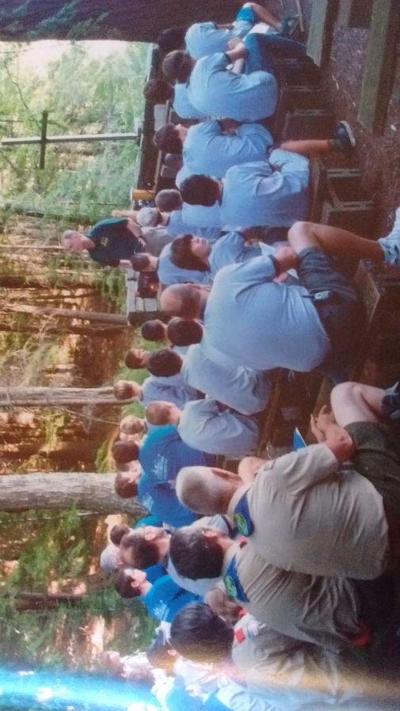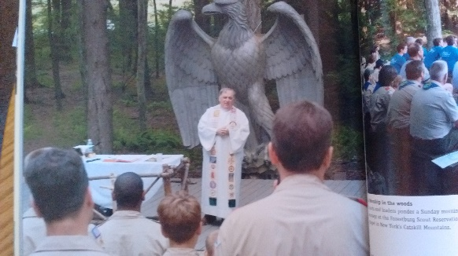Is it possible for Lutheran parent(s) to have a child in the BSA and actively work to correct its work-righteous teachings, interfaith fellowship, and its moralistic deism view of God so that the child’s faith is not weakened in any way?

We let the Boy Scouts speak for themselves to answer the previous questions.

# **Robert Baden-Powell Every Scout Should Have a ReligionsCout Sunday**

**Either the first or second Sunday in February is known as Scout Sunday. This Sunday is set by the BSA for attendance in worship, as part of one’s duty to God is attendance at Scout Sunday**[[7]](#footnote-7)**.**

**These Scout Sundays have a variety of possibilities, according to Mary Ray of the Scouting magazine**[[8]](#footnote-8)**, who encourages the following:**

* **Processional – if the service begins with a processional, join in processional.**
* **Greeters and ushers – have Scouts greet worshipers as they arrive and/or collect offering during the service**
* **Readers – recruit Scouts to handle this task**
* **Religious emblems – if Scouts have earned religious emblems, have the pastor present the badges during the service. This effectively demonstrates the shared values of Scouting and the congregation.**

**A sample bulletin for this service is available. Review this bulletin, asking these questions:**

1. **What perception about fellowship and faith is given to the members of a church when Boy Scouts meet at their church, process forward, share in readings, hand out bulletins, and receive the offering?**
2. **Would we comfortable using this service?**
3. **What differences exist between someone standing up as part of the wedding party or a Lutheran Boy Scout,**

**participating as invited, in a Presbyterian church?**

1. **There are Scout Sabbath Services and Scout Islam services as well. What potential concerns might a Lutheran parent have with their children participating in a Jewish or Islamic worship service?**

# **Chaplains in boy scouts**

“The Boy Scouts of America maintains that no member can grow into the best kind of citizen without recognizing an obligation to God and, therefore, recognizes the religious element in the training off the member”[[9]](#footnote-9)

“To serve as a chaplain or chaplain aide is a unique opportunity for ministry. While serving in these offices, you will have the opportunity to help Scouts as they grow, both physically and spiritually….The Chaplain should…(2) provide a spiritual tone for all unit meetings and camping experiences. (3) provide spiritual counseling when needed or requested (5) encourage Scouts and Venturers to participate in the religious emblems program of their faith”[[10]](#footnote-10)

1. Does the BSA seek to religiously instruct its members?
2. What is the goal of Chaplain?

# **Chaplain’s aide**

“The purposes for this leadership position are to:

* Make the 12th point of the Scout Law more meaningful in life.
* Provide Boy Scouts and Venturers with an opportunity to work with an ordained member of the clergy, thereby gaining insight into the religious professional life

**Duties.** The chaplain’s aide should:

1. Encourage unit members to strengthen their own relationships with God through personal prayer and devotion and participation in religious activities appropriate to their faith.
2. Participate in planning sessions with the troop’s patrol leaders’ council or crew’s officers to ensure that spiritual emphasis is included in unit activities, e.g. vespers, prayers before meals, religious observances,
3. With the unit chaplain, plan appropriate religious services for all members during the weekend campouts.”[[11]](#footnote-11)
4. What are the religious purposes and duties of the Chaplain’s aide?
5. How many religious observances is he/she responsible for?
6. The term chaplain refers to an ordained clergy member. What does the Chaplain’s Aide become for the boys during their weekends away?

“**Unit Worship Opportunities** As a chaplain or chaplain aide, your principal duty is to plan for and/or conduct meaningful worship opportunities.

**Group prayers…** if the group consists of members with mixed beliefs or if the beliefs of the group are unknown, then prayers should be of an interfaith content.

**At Weekend Activities**. Because Scouting units often camp on weekends, youth members and leaders may not be able to attend their regular worship services. Every unit going away for an overnight or a weekend needs to plan to conduct or attend a worship service (either for the individual or for the unit) in keeping with the 12th point of the Scout Law.”[[12]](#footnote-12)

1. What is expected of the Lutheran youth on a weekend retreat in regard to worship and prayer?
2. Why does the Lutheran youth worship, according to the BSA?

**“Interfaith Considerations**. At many Scouting weekend activities (such as unit campouts, Order of the Arrow fellowships, or district camporees), the resources available and the numbers in attendance do not justify planning and offering services for various faith groups. It would seem ideal in these circumstances to plan and conduct a single interfaith religious service…

Here are some basic guidelines for conducting weekend interfaith religious services:

* The word *God* generally is accepted by most faith groups and is the term used in all phases of Scouting. Note that this term represents the creator or divine spirit, as it is used in the Scout Oath and the Venturing Oath. It is not intended to be a limiting term – there are many names that individual religions use to present God.
* Songs (a term more appropriate than “hymns”) should be generic in nature, addressing God alone (not Jesus, Buddha, etc.). This may be a challenge as the list of usable and familiar worship songs is fairly short.”[[13]](#footnote-13)

1. Would our worship services at our congregation fit the consideration of interfaith services? Why or why not?
2. Who does the term “God” describe for BSA? For you?

# **Bringing Youth to Christ through a scouting ministry**

**“Scouting teaches duty to and reverence for God.** Central to the Scout Oath (or Promise) is the pledge to “do my duty to God.” The 12th point of the Scout Law states, “A Scout is Reverent.” These commitments to the prominence of God in one’s life form the cornerstone of the Scouting program.

When properly interpreted by an adult Scouter of strong faith to young people, even the unchurched begin to understand the need for God.”[[14]](#footnote-14)

1. What is Scouting based on – God’s love for me in Christ or my commitment to God? What implications does that have for one’s long-term faith?
2. How can the unchurched be reached for Christ?
3. If it is true that the unchurched might be reached for Christ by a Baptist, what is also true of the Lutheran youth with a Baptist Scoutmaster?
4. In the same pamphlet, the author conservatively estimates that 327 hours of personal guidance per year (including regular meetings, overnight campouts, scouting shows, and summer camp) are invested into each youth in Scouting. What religious implications might that have on the Lutheran boy who at conservative estimate is in worship and Bible study 100 hours a year?

# **Discussion questions**

A/D The Chaplain and his/her Aide assume the role of the Lutheran youth’s clergy on campouts, weekend activities, and other events.

A/D Attendance at an interfaith worship service in the BSA is similar to attending a niece’s baptism at a Catholic church. There is no implication of joint fellowship, beliefs, or motivation among the Boy Scouts.

A/D The Scout is expected to attend and participate in the worship services that are offered. Refusing to attend and participate is breaking the 12th Law.

A/D It is possible for a youth to attend Scouting events and not participate in any of the religious activities.

Loving Truth & Loving Souls

1. Loving Truth and Loving Souls – Lord’s Supper
2. LT-LS – Church Fellowship
3. LT-LS – Prayer and Worship Fellowship - 2nd Half
4. LT-LS – Boy Scouts
5. **LT-LS – Boy Scouts**

# **Boy scouts and the Lutheran Church – Missouri SYnod**

On Tuesday, December 1st, President Matthew Harrison of the Lutheran Church – Missouri Synod (LCMS) issued a letter to all LCMS congregations regarding their relationship with Boy Scouts of America (BSA).

Since 2013, the LCMS and BSA had a Memorandum of Understanding (MOU)[[15]](#footnote-15) which gave spiritual and moral authority over the Scouts to the Pastor and the congregation. This MOU also required that the LCMS respect the membership standard and not deny membership of a boy to Scouting based on sexual orientation alone. The LCMS historically had left up to individual congregations whether or not to be involved in Scouting[[16]](#footnote-16), pressure was mounting on the BSA to include openly LGBT men/women as adult leaders.

On July 27, 2015, the BSA amended their Adult Leadership policy to allow openly LGBT men/women as adult leaders[[17]](#footnote-17). In response, President Matthew Harrison’s letter[[18]](#footnote-18) on December 1st removed the MOU and created a Task Force to determine the path forward. LCMS is in discussions with Trail Life USA (TL) and American Heritage Girls (AHG) to replace BSA and GSA in their congregations and for their members.

1. The BSA has, from its beginning, been a non-sectarian religious movement based on the morals and values present in its partnering churches. How has this foundation in 1909 led to today’s LGBT agenda in 2016?
2. The LCMS quoted concerns of lawsuits as the primary reason to dissolve the MOU. What scriptural and spiritual reasons might they have quoted, as well?
3. The LCMS is considering additional groups like TL or AHG. However, they have concerns about these groups. Comment on a quotation take from their December 2015 letter.

The challenge posed by the BSA is obvious. Its consistently “nonsectarian” stance means it is in perennial danger of encouraging religious syncretism and moral relativism. TL is subject to neither of those tendencies, but an uncritical involvement in TL could be just as problematic for any confessional Lutheran, for he or his congregation could easily be drawn into a theological perspective that is anti-sacramental, Arminian in its view of conversion and legalistic in its understanding of sanctification.

1. Faith Lutheran Church, an LCMS congregation in Appleton, WI, ended its 60 year charter relationship with Boy Scout Troop 73 and Cub Scout Pack 3022[[19]](#footnote-19). What was Pastor Thews reason to end the charter?
   1. “they’ve changed where they now allow open gay scout leaders, troop leaders to influence and shape the minds of boys. And that’s just contrary to our understanding to God’s truth in the Bible.”
   2. “We are afraid of legal action against our congregation that would risk significant legal exposure due to a discrimination lawsuit.”

# **Comparison of boy scouts and biblical teaching**

|  |  |
| --- | --- |
| Bible | Boy Scouts |
| Genesis 6:5b  Every inclination of the thoughts of his heart are only evil all the time  Romans 8:7  The sinful mind is hostile to God. It does not submit to God’s law, nor can it do so. | **1951 Handbook for Boys**  You have it in your power to make the right sort of track in your brain to determine how you will act.  Every boy can say to himself, “I will be what I want to be.” Your actions follow your thoughts. You can control your thoughts. It comes down to a matter of right thinking, and building right habits. |
| Proverbs 3:5  Trust in the LORD with all your heart and lean not on your own understanding; in all your ways acknowledge him, and he will make your paths straight. | **1979 Boy Scout Handbook**  And you owe it to yourself to aim to become a man of strong character… Your life as a Scout will take you along the train that leads to strong, self-reliant manhood. |
| Galatians 1:6-9  6 I am astonished that you are so quickly deserting the one who called you by the grace of Christ and are turning to a different gospel— 7 which is really no gospel at all. Evidently some people are throwing you into confusion and are trying to pervert the gospel of Christ.  8 But even if we or an angel from heaven should preach a gospel other than the one we preached to you, let him be eternally condemned! 9 As we have already said, so now I say again: If anybody is preaching to you a gospel other than what you accepted, let him be eternally condemned! | **1971 Boy Scout Handbook**  The moment you join a patrol or troop you enter a brotherhood that spans the world. The boys in it are of different countries and colors and creeds, but they are brothers’ together, living up to the same Scout Oath and Law that you are following.  **1948 Boy Scout Handbook**  When you step into a church or synagogue, when you stand on a quiet night under a starlight skiy, when you walk thru the woods on an early spring day as the trees are turning green… as you see the wonders about you, your faith in Him is strengthened…  By following the Scout Law, you follow the Law of God also. |

# **Testimony of a former Scout by Paul randolph[[20]](#footnote-20)**

Some might say:

“Ok, Scouting has some incorrect teaching about the Bible, but in my Pack/Troop, those teachings were never taught, or taught all that often. We can sanitize the un-Lutheran teachings out and retain the essence of Scouting, which is really good for our male youth.”

Comment on quotations from Scoutmaster and Veteran Paul Randolph

From my own experience I have come to the conclusion that scouting amounts to a laboratory course for teaching the un-Christian doctrine of work-righteousness – the earning of one’s way to reward, including heaven, by good works… in my boyish way, I used to wonder if I had to be good to have this great scoutmaster and if my efforts were good enough.

These thoughts seemed to cloud over the fact that I do have a Father in Heaven, who does love me and is concerned about me, and who even sent His Son to die for me, whether I have been good or bad. The religious doctrines of scouting not only become the convictions of many scouts, but also the very basis of their outward life. Eventually scouts not only think these theories, but do them. They do good, obey the law, and go through the religious motions to merit praise and to earn their way further up in scouting. I cannot help but feel that such a sly system of spreading un-Christian teachings bears evidence to some tampering by Satan himself.

Loving Truth & Loving Souls

1. LT-LS – Boy Scouts
2. LT-LS – Boy Scouts
3. LT-LS – Boy Scouts w/o religion?
4. **LT-LS – Boy Scouts – Duty to God and Religious Emblems**

# **Duty to God**

Consider these quotations from a 2015 article in *Scouting[[21]](#footnote-21)* about recent changes with Duty To God.

***Doing one’s duty to God****is central to Scouting. The Scout Oath begins with duty to God; the Scout Law ends with reverence. As Scouting founder Robert Baden-Powell said, “There is no religious ‘side’ of the movement. The whole of it is based on religion, that is, on the realization and service of God.”*

***What is changing in Boy Scouting?*** *The Scout Spirit requirement for each rank starting with Tenderfoot is expanding to have the Scout describe how he has done his duty to God*

***How does the new Cub Scout program reflect duty to God?*** *The new program, which begins with the 2015-16 program year, is built around required and elective adventures. Each rank includes a required duty-to-God adventure.*

1. Is Duty to God optional or required for the Boy Scout? At all levels?
2. Can we say that there is a religious aspect to the Boy Scouts?

Boys have indicated that Scouting has encouraged them to feel pride in America, to learn the difference between right and wrong, and strengthen their relationship with God…The National Lutheran Association on Scouting (NLAS), along with the Evangelical Lutheran Church in America (ELCA) and the Lutheran Church-Missouri Synod (LCMS), assists Lutheran congregations using the programs and resources of the Boy Scouts of America and other youth organizations as a means of extending their ministry to children, youth, and families.[[22]](#footnote-22)

“To encourage members to grow stronger in their faith, religious groups have developed religious emblems programs.”[[23]](#footnote-23)

1. What organization administers the Religious Emblems for Lutheran Scouts?
2. What organization is supported through your dollars for patches and emblems?
3. There are different religious emblems for various faiths. However, the Anglicans, Baptists, Christian Scientists, Disciples of Christ, Episcopal, Lutheran, Nazarene, Presbyterians, United Church of Christ, Salvation Army, United Methodist, and United Pentecostal Church International all have the same patches. What message is sent to the Lutheran Scout who has the same patch for religious devotion as these other organizations?
4. There are religious emblems for religions like Zoroastrian, Sikh, Jain, Meher Bab, Baha’I, Buddhist, Hindu, and many others. What message is sent to the Lutheran Scout as he has similar emblems as non-Christian religions?

# **Religious Emblems**

1. 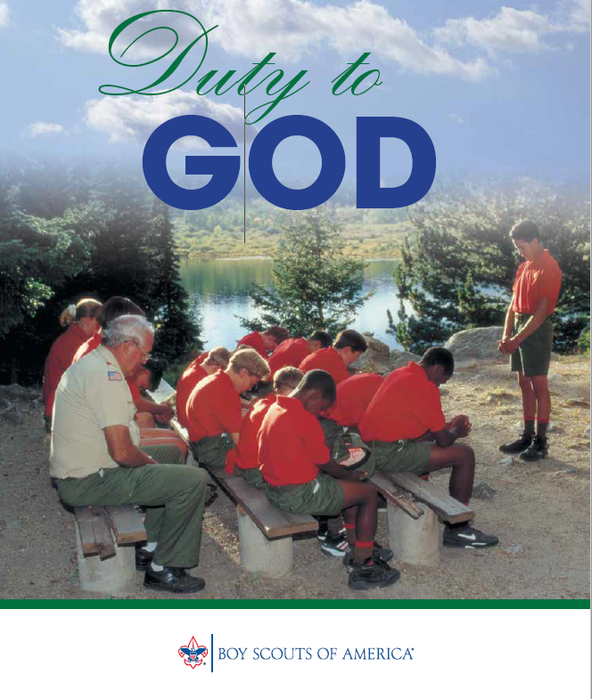What is being taught about Duty to God in this picture?
2. Consider the background, the posture, and the prayer leader.

What is also being taught about the Scout and his relationship with God?

1. 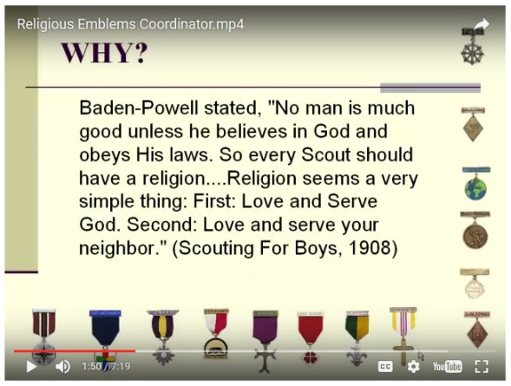Is Duty to God optional or required for the Boy Scout?

**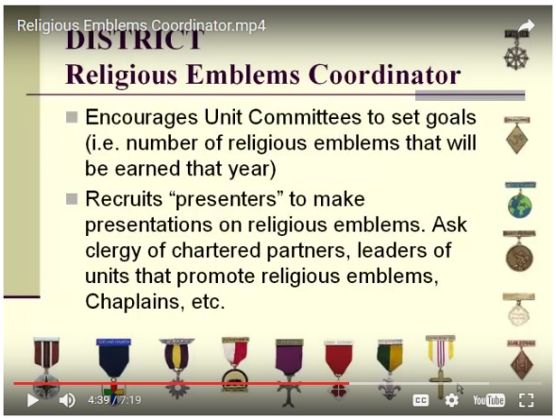**

A recent development in the BSA is the creation of the Religious Emblems Coordinator.

His role, and the coordinators under him, are to encourage, support, and increase participation in the Religious Emblems program.

A promotional video was created on [www.scouting.org](http://www.scouting.org) to describe this new position and its goals.

1. How does this quote (top image) intend to increase participation in the RE program?
2. How does the founder of the Boy Scouts summarize the Christian religion? Would you agree or disagree with his summary?
3. Do you see an irony in a group that encourages growth in faith that sets goals to achieve awards for groups that are already setting goals to achieve awards?
4. Consider this quotation from a 2013 article in *Scouting* magazine[[24]](#footnote-24) about the BSA longtime partnerships with religious faiths. This quotation is taken from the section of LDS.

*To illustrate the synergy of Scouting and spiritual growth, Gibson, the father of five Eagle Scouts, talks about a 50-20 hike—50 miles in 20 hours—that he took with two sons who had failed to complete the arduous trek a year before. After an 18-hour ordeal that “almost killed us,” Gibson says, he and his sons were about to go to sleep. “Dad, I’ll never do that again,” one boy said. Then he paused and added, “Unless my son wants me to.”*

*“That was connecting the dots,” Gibson says. “That’s the reflection I’m talking about, the connection to spiritual things. You recognize he’s going to be a great husband and father, but most of all, he’ll be about what Baden-Powell had as the foundation of the BSA, building the Kingdom of God.”*

Loving Truth & Loving Souls

1. LT-LS – Boy Scouts
2. LT-LS – Boy Scouts
3. LT-LS – Boy Scouts w/o religion?
4. LT-LS – Boy Scouts – Duty to God and Religious Emblems
5. **LT-LS – Boy Scouts – Scout Oath and Scout Law - Summary**

# Image result for Boy Scout Handbook 2016 Back cover**Boy Scout Handbook**

The 2016 edition of the Boy Scout Handbook provides 500 pages of information regarding Boy Scouts.

The back cover of the book lists the two fundamental principles of the Scouting Movement – the Scout Oath and the Scout Law. The Handbook states the Oath and Law “have shown the way for millions of boys and men during the time as Scouts and throughout the rest of their lives.”[[25]](#footnote-25)

You cannot be a Boy Scout or advance in its ranks[[26]](#footnote-26) without belief in and adherence to the Oath and Law. Can a Lutheran Christian boy swear this Oath and believe in a Law that God has not ordained in His Holy Word?

# **Scout Oath**

**James 5:12 Above all, my brothers, do not swear—not by heaven or by earth or by anything else. Let your “Yes” be yes, and your “No,” no, or you will be condemned.**

**Matthew 5:33-37 33 “Again, you have heard that it was said to the people long ago, ‘Do not break your oath, but keep the oaths you have made to the Lord.’**

**34 But I tell you, Do not swear at all: either by heaven, for it is God’s throne; 35 or by the earth, for it is his footstool; or by Jerusalem, for it is the city of the Great King. 36 And do not swear by your head, for you cannot make even one hair white or black. 37 Simply let your ‘Yes’ be ‘Yes,’ and your ‘No,’ ‘No’; anything beyond this comes from the evil one.**

1. Should we swear oaths? Why or why not?
2. Should we swear oaths by our own abilities or might (by your head)? Why or why not?
3. Explain verse 37.
4. What is the difference between swearing an oath and cursing? (cf 2nd Commandment)

**Deuteronomy 6:13 Fear the Lord your God, serve him only and take your oaths in his name.**

**Jeremiah 42:5 Then they said to Jeremiah, “May the Lord be a true and faithful witness against us if we do not act in accordance with everything the Lord your God sends you to tell us.**

1. Jesus forbids frivolous oaths or swearing by objects. What kind of an oath is allowed for a Christian, and why?

**Matthew 26:62-64 62 Then the high priest stood up and said to Jesus, “Are you not going to answer? What is this testimony that these men are bringing against you?” 63 But Jesus remained silent. The high priest said to him, “I charge you under oath by the living God: Tell us if you are the Christ, the Son of God.” 64 “Yes, it is as you say,” Jesus replied. “But I say to all of you: In the future you will see the Son of Man sitting at the right hand of the Mighty One and coming on the clouds of heaven.”**

1. In Matthew 5, Jesus says not to swear at all. Here in Matthew 26, when the high priest charges him under oath, he swears. Why?
2. What circumstances in American society today would a Christian swear an oath that God is his witness?

The Scout Oath: On my honor I will do my best to do my duty to God and my country and to obey the Scout Law; to help other people at all times; to keep myself physically strong, mentally awake, and morally straight.

On my honor… honor is the core of who you are – your honesty, your integrity, your reputation, the ways you treat others, and how you act when no one is looking. By giving your word at the outset of the Scout Oath, you are promising to be guided by its ideals.[[27]](#footnote-27)

1. What does the Scout swear by as his witness? Is this Biblical?
2. What Biblical and practical problem exists for a young boy to swear by his own honor as the basis for his actions?

**Genesis 6:5 Every inclination of the thoughts of his heart was only evil all the time.**

1. Is a young boy sinning by swearing the Scout Oath?

# **Scout Law**

**Deuteronomy 4:2 Do not add to what I command you and do not subtract from it, but keep the commands of the Lord your God that I give you.**

1. Should we add or subtract from God’s Word?
2. Explain the difference between Christian traditions and Christian teachings.

**Galatians 3:10-11 10 All who rely on observing the law are under a curse, for it is written: “Cursed is everyone who does not continue to do everything written in the Book of the Law.” 11 Clearly no one is justified before God by the law, because, “The righteous will live by faith.**

1. Are we saved by grace through faith, or are we saved through observing (keeping) the law?
2. What happens if we point Christians to outward observances of the law as means to grow faith?

**Romans 3:20 Therefore no one will be declared righteous in his sight by observing the law; rather, through the law we become conscious of sin.**

And to obey the Scout Law… in your thoughts, words, and deeds, the 12 points of the Scout Law will lead you toward doing the right thing throughout your life. When you obey the Scout Law, other people will respect you for the way you live, and you will respect yourself.[[28]](#footnote-28)

1. What directs the Lutheran Christian Boy Scout to right living – God’s Law or Scout Law?
2. Does following God’s Law mean that others will respect me and I will respect myself?

**Hebrews 11:36-39 36 Some faced jeers and flogging, while still others were chained and put in prison. 37 They were stoned; they were sawed in two; they were put to death by the sword. They went about in sheepskins and goatskins, destitute, persecuted and mistreated— 38 the world was not worthy of them. They wandered in deserts and mountains, and in caves and holes in the ground. 39 These were all commended for their faith, yet none of them received what had been promised. 40 God had planned something better for us so that only together with us would they be made perfect.**

**Matthew 10:34,38** **“Do not suppose that I have come to bring peace to the earth. I did not come to bring peace, but a sword. 38 and anyone who does not take his cross and follow me is not worthy of me.**

The Scout Law will show you how to live as a boy and as a man.

A Scout is trustworthy … If your judgment fails and you make a mistake, your good character will be what helps you quickly admit it and make good on any damage. Adults and your peers alike will know that they can rely on you to do your best in every situation. Living in this way also means that you can trust yourself. [[29]](#footnote-29)

1. What does the Scout, under the Scout Law, trust in when he fails?
2. What does the Apostle Paul say about trusting himself?

**Romans 7:15-21 15 I do not understand what I do. For what I want to do I do not do, but what I hate I do. 16 And if I do what I do not want to do, I agree that the law is good. 17 As it is, it is no longer I myself who do it, but it is sin living in me. 18 I know that nothing good lives in me, that is, in my sinful nature. For I have the desire to do what is good, but I cannot carry it out. 19 For what I do is not the good I want to do; no, the evil I do not want to do—this I keep on doing. 20 Now if I do what I do not want to do, it is no longer I who do it, but it is sin living in me that does it. 21 So I find this law at work: When I want to do good, evil is right there with me.**

1. If the Apostle Paul, a mature Christian and Pastor with decades of study and ministry experience, has these internal conflicts, struggles, and sins – what about the young Christian boy entering Scouting?

# **Scout Unity**

Your thumb and little finger touch to represent the bond uniting Scouts throughout the world.[[30]](#footnote-30)

One of the great things about Scouting is that it lets you meet with and learn from people of different religious backgrounds. At summer camp or national Scout jamboree, you may encounter Scouts from all sorts of faith groups and even get the chance to participate in worship services with them. The first thing you may notice is how differently they do things, but look for similarities, too, like reverence to God and a commitment to serving people in need.[[31]](#footnote-31)

1. Are members of Scouting in a fraternal unity with other Scouts? Are they in a spiritual unity with other Scouts?
2. How do interfaith worship services help the Scouts? **Galatians 1:9 9 As we have already said, so now I say again: If anybody is preaching to you a gospel other than what you accepted, let him be eternally condemned!**

# **Summary**

**Romans 16:17-18** **17 I urge you, brothers, to watch out for those who cause divisions and put obstacles in your way that are contrary to the teaching you have learned. Keep away from them.**

**18 For such people are not serving our Lord Christ, but their own appetites. By smooth talk and flattery they deceive the minds of naive people.**

**Galatians 1:6-7 6 I am astonished that you are so quickly deserting the one who called you by the grace of Christ and are turning to a different gospel— 7 which is really no gospel at all. Evidently some people are throwing you into confusion and are trying to pervert the gospel of Christ.**

**Titus 3:8-11 8 This is a trustworthy saying. And I want you to stress these things, so that those who have trusted in God may be careful to devote themselves to doing what is good. These things are excellent and profitable for everyone.**

**9 But avoid foolish controversies and genealogies and arguments and quarrels about the law, because these are unprofitable and useless.**

**10 Warn a divisive person once, and then warn him a second time. After that, have nothing to do with him. 11 You may be sure that such a man is warped and sinful; he is self-condemned.**

**2 Timothy 2:16-18 15 Do your best to present yourself to God as one approved, a workman who does not need to be ashamed and who correctly handles the word of truth.**

**16 Avoid godless chatter, because those who indulge in it will become more and more ungodly. 17 Their teaching will spread like gangrene. Among them are Hymenaeus and Philetus, 18 who have wandered away from the truth. They say that the resurrection has already taken place, and they destroy the faith of some.**

**2 John 10-11 If anyone comes to you and does not bring this teaching, do not take him into your house or welcome him. Anyone who welcomes him shares in his wicked work.**

**2 Timothy 4:2-5 2 Preach the Word; be prepared in season and out of season; correct, rebuke and encourage—with great patience and careful instruction.**

**3 For the time will come when men will not put up with sound doctrine. Instead, to suit their own desires, they will gather around them a great number of teachers to say what their itching ears want to hear.**

**4 They will turn their ears away from the truth and turn aside to myths.**

**5 But you, keep your head in all situations, endure hardship, do the work of an evangelist, discharge all the duties of your ministry.**

1. <http://www.theinterfaithobserver.org/journal-articles/2016/7/8/opening-the-door-to-zen-in-church> [↑](#footnote-ref-1)
2. *Prayer and Fellowship in the Detroit Conference*, Bente, essay file at [www.wls.wels.net](http://www.wls.wels.net) [↑](#footnote-ref-2)
3. *Church Fellowship in the First 4 Centuries,* Werner Elert, as quoted in Fellowship Then and Now from the WELS Commission on Doctrinal Matters, [↑](#footnote-ref-3)
4. Apology to the Augsburg Confession, Article XIV, Concerning Church Order [↑](#footnote-ref-4)
5. Boy Scouts of America Today by Robert Birkby [↑](#footnote-ref-5)
6. BSA material recommends the use of the word “message” instead of homily or sermon as to not appear overtly Christian. These, and under recommendations for worship, are found in the Big Book of Scouts Worship, 1999 revision. Available online or the presenter has a copy. [↑](#footnote-ref-6)
7. <http://www.scouting.org/scoutsource/Media/Relationships/ascoutisreverent.aspx> [↑](#footnote-ref-7)
8. <http://scoutingmagazine.org/2012/12/plan-a-scout-sunday-or-scout-sabbath-celebration/> [↑](#footnote-ref-8)
9. Handbook for Chaplains and Chaplain Aides, available at [www.scouting.org](http://www.scouting.org) [↑](#footnote-ref-9)
10. Ibid. [↑](#footnote-ref-10)
11. Ibid [↑](#footnote-ref-11)
12. Ibid [↑](#footnote-ref-12)
13. Ibid [↑](#footnote-ref-13)
14. *Bringing Youth to Christ Through a Scouting Ministry*, Boy Scouts of America, 2012 printing, available at [www.scouting.org](http://www.scouting.org) [↑](#footnote-ref-14)
15. <http://blogs.lcms.org/2013/lcms-releases-statement-on-scouting> [↑](#footnote-ref-15)
16. 1953 LCMS Convention Proceedings, pages 555-556, available at <https://www.lcms.org/Document.fdoc?src=lcm&id=2581> [↑](#footnote-ref-16)
17. <http://scoutingnewsroom.org/blog/boy-scouts-of-america-amends-adult-leadership-policy/> [↑](#footnote-ref-17)
18. <https://blogs.lcms.org/2015/boy-scouts-of-america-update> [↑](#footnote-ref-18)
19. <http://www.postcrescent.com/story/news/local/2016/02/24/appleton-church-cuts-ties-boy-scouts-over-gay-leaders/80847038/> [↑](#footnote-ref-19)
20. [www.wlsessays.net/bitstream/handle/123456789/3951/**RandolphScout**.pdf](http://www.wlsessays.net/bitstream/handle/123456789/3951/RandolphScout.pdf) [↑](#footnote-ref-20)
21. <http://scoutingmagazine.org/2015/02/new-requirements-explore-duty-to-god/> [↑](#footnote-ref-21)
22. Boy Scouts of America promotional flyer, 2009, available at [www.scouting.org](http://www.scouting.org) [↑](#footnote-ref-22)
23. Duty to God Promotional flyer, 2015, available at [www.scouting.org](http://www.scouting.org) [↑](#footnote-ref-23)
24. <http://scoutingmagazine.org/2013/08/explore-the-bsas-longtime-partnerships-with-diverse-religious-faiths/> [↑](#footnote-ref-24)
25. Page 9 of Boy Scout Handbook, 13th Edition, 2016 printing. [↑](#footnote-ref-25)
26. Ibid pg. 10 [↑](#footnote-ref-26)
27. Ibid pg. 11 This section of the book is entitled Boy Scout Basics and it explains each component of the Scout Oath. Additional explanations from the Handbook are available. Of special interest to us is the explanation of duty to God. [↑](#footnote-ref-27)
28. Ibid pg. 12 [↑](#footnote-ref-28)
29. Ibid pg. 13. [↑](#footnote-ref-29)
30. Ibid pg. 18 [↑](#footnote-ref-30)
31. Ibid pg. 23 [↑](#footnote-ref-31)