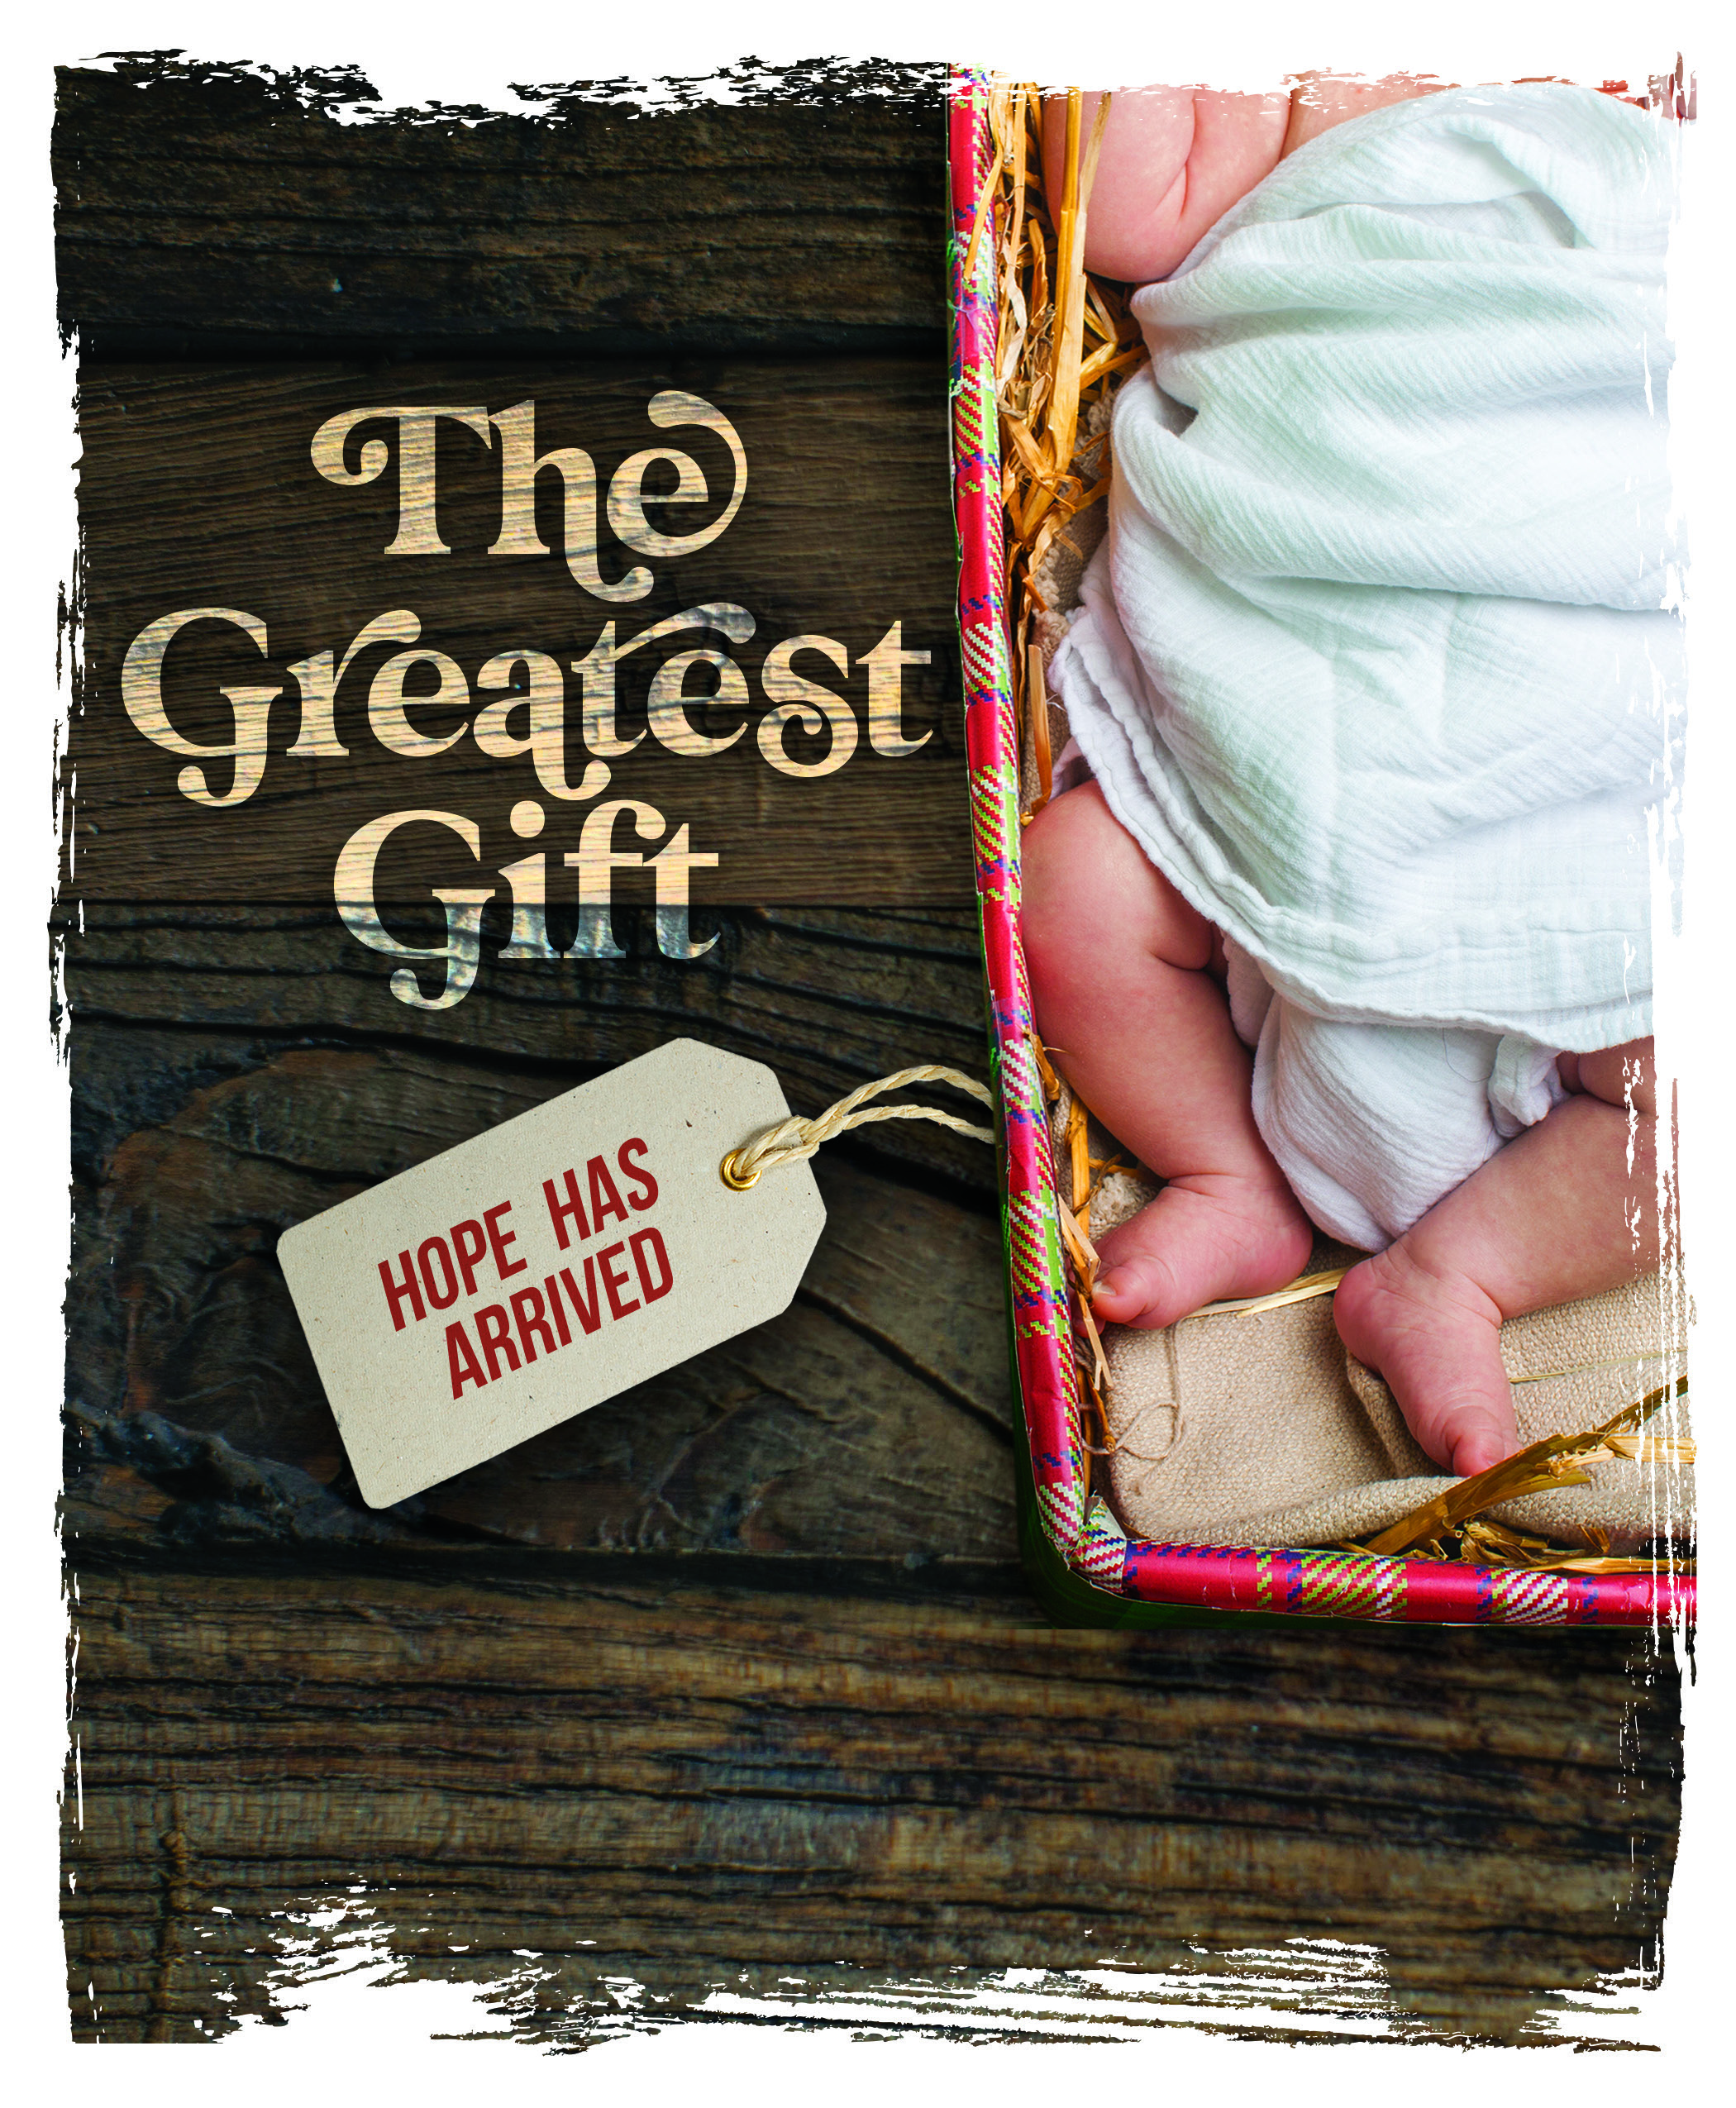

Church Name
CHURCH
LOGO
HERE
EVANGELICAL LUTHERAN CHURCH
Church tagline, i.e. a very brief summary of your mission statement

Welcome! We are glad that you have joined us to celebrate the birth of the Christ child. Our service is printed for you in its entirety in this worship folder.
- Restrooms are located in the hallway directly opposite the entrance to the sanctuary.
 Infants Room If you have a young child or nursing infant and are in need of a cry-room, you will find it to the right as soon as you exit the sanctuary. A speaker there allows you to hear the service.
 Staffed nursery We offer a staffed nursery for children ages 2 to 6. As you exit the sanctuary, it is located in the back left of the entry foyer, near the kitchen window.
 Connection cards are found inside each worship folder. We ask that before worship or during the offering you fill those out, front and back. You can return the card in the offering plate or hand it to an usher at your convenience.
 Gift bags for children will be distributed after worship. Please be sure to pick one up on your way out of the building.
 Prayer before worship Father, open my heart to hear and believe your word, so that through faith your Son may take his rightful place not just in the manger, but also within my heart. In his name I pray. Amen.
These are examples of the type of information that is helpful to guests. Substitute your usual content, or edit to fit your congregation. Then delete these lines.

December 24, 2020 at 7:00PM
CHRISTMAS EVE

Service of Lessons and Carols
Our worship this evening is an adaptation of the Lessons and Carols service traditionally held at King's College, Cambridge, England, on December 24th every year. Lessons and Carols was first held on Christmas Eve, 1918. It was planned by Eric Milner-White, who at the age of thirty-four had just been appointed Dean of King’s College after experience as an army chaplain.
Worship Theme
Welcome to worship this Christmas Eve. We trust that God will bless you in this service of lessons and carols/hymns. Our focus, “The Greatest Gift,” is found in every lesson and song. The progression of lessons and songs gradually reveals more and more about this greatest gift. Imagine yourself as someone who over centuries is trying to figure out the nature of God’s gift. Or, if the readings are not familiar to you, let the meaning of God’s gift become clearer and clearer to you as you hear each lesson and sing each song.
Tonight we see God’s gift, in the words of the first hymn, “in that poor, lowly stable, with the oxen standing by.” By trusting what God’s gift means for us, we look forward to seeing that gift in heaven where God’s “praise will sound” for all eternity!

Lectors
Those reading the lessons tonight are:
• John Frederick, congregational president
• George Brandenburg, elder
• Phil Hesse, student preparing for pastoral ministry
• Wolf Anhalt, trustee
- Frank Luneburg, Sunday school teacher
- Christian Beyer, pastor
- Chris von Stadion, choir member

A SERVICE OF LESSONS AND CAROLS

HYMN Once in Royal David’s City (CW 50)

Stand
EXHORTATION AND PRAYER
M: Beloved in Christ: In this Christmas season it is our duty and delight to hear again the message of the angels and, in heart and mind, to go even unto Bethlehem and see this thing which has come to pass, which the Lord has made known to us, the Christ-child, lying in a manger.
Let us read and learn in Holy Scripture the story of the loving purposes of God from the first days after our fall, and into the birth and glorious redemption brought to us by this Holy Child. Let us hear how peace was lost, and how peace is restored.
But first, let us pray, for this is good and right.
Heavenly Father, we pray for ourselves and all people who worship you and your Son this holy night. By your holy Word, lead us to say with the angels,
C: Glory to God in the highest!
M: We pray for your blessing upon the people of our city, our state, our nation, and our world.
C: Glory to God in the highest!
M: We pray for the poor and helpless, the cold and hungry, the sick and sad, that you would give them the joy of your salvation and the comfort of your presence.
C: Glory to God in the highest!
M: We pray for unbelievers and enemies of the Church, that through your Law and Gospel you would lead them to recognize your Son as their only hope for eternal life.
C: Glory to God in the highest!
M: Finally, we remember before you all those who rejoice with us in heaven, who live in greater light and beauty than we, that multitude which no one can number, who died in faith, and now praise you in your heavenly temple. We confess that we are united with them and with one another.
C: Glory to God in the highest!
M: We humbly offer up these prayers and praises in the words that Christ himself taught us.
C: Our Father in heaven, hallowed be your name, your kingdom come, your will be done on earth as in heaven. Give us today our daily bread. Forgive us our sins, as we forgive those who sin against us. Lead us not into temptation, but deliver us from evil. For the kingdom, the power, and the glory are yours now and forever. Amen.

Be seated
A sermon may be inserted here or near the end. See C20-Worship Planning
GOD PROMISES A NEEDED GIFT
FIRST LESSON Genesis 3:8-15
Humanity’s separation from God dates to the beginning of time, to the fall into sin by the first humans, Adam and Eve. As tragic as this was, the account ends with God’s promise of a stunning gift—that the woman’s offspring, Christ, would ultimately defeat Satan and restore us to God.
⁸ Then the man and his wife heard the sound of the Lord God as he was walking in the garden in the cool of the day, and they hid from the Lord God among the trees of the garden. ⁹ But the Lord God called to the man, “Where are you?”
¹⁰ He answered, “I heard you in the garden, and I was afraid because I was naked; so I hid.”
¹¹ And he said, “Who told you that you were naked? Have you eaten from the tree that I commanded you not to eat from?”
¹² The man said, “The woman you put here with me—she gave me some fruit from the tree, and I ate it.”
¹³ Then the Lord God said to the woman, “What is this you have done?”
The woman said, “The serpent deceived me, and I ate.”
¹⁴ So the Lord God said to the serpent, “Because you have done this, “Cursed are you above all livestock and all wild animals! You will crawl on your belly and you will eat dust all the days of your life.
¹⁵ And I will put enmity between you and the woman, and between your offspring and hers; he will crush your head, and you will strike his heel.”

HYMN Now Sing We, Now Rejoice (CW 34 alt.)
Stanza 3 speaks of the need for God’s gift and the ultimate “opening” of that gift: “Death was reigning o’er us…till he opened for us a bright eternity.”

GOD’S GIFT IS DESCRIBED

SECOND LESSON Isaiah 11:1-9
Striking symbolic language describes the gift more than 700 years before it was given.

A shoot will come up from the stump of Jesse; from his roots a Branch will bear fruit. ² The Spirit of the Lord will rest on him—
the Spirit of wisdom and of
understanding,
the Spirit of counsel and of might,
the Spirit of the knowledge and fear of
the Lord—
³ and he will delight in the fear of the Lord.
He will not judge by what he sees with his eyes, or decide by what he hears with his ears; ⁴ but with righteousness he will judge the needy, with justice he will give decisions for the poor of the earth. He will strike the earth with the rod of his mouth; with the breath of his lips he will slay the wicked.
⁵ Righteousness will be his belt and
faithfulness the sash around his waist.
⁶ The wolf will live with the lamb,
the leopard will lie down with the goat,
the calf and the lion and the yearling together;
and a little child will lead them.
⁷ The cow will feed with the bear,
their young will lie down together,
and the lion will eat straw like the ox.
⁸ The infant will play near the cobra’s den,
and the young child will put its hand into the
viper’s nest.
⁹ They will neither harm nor destroy
on all my holy mountain,
for the earth will be filled with the knowledge
of the Lord as the waters cover the sea.

HYMN Joy to the World (CW 62)
This familiar hymn echoes thoughts from the lesson as we jubilantly sing about God’s gift.
1 Joy to the world, the Lord is come! 3 No more let sins and sorrows grow
Let earth receive her King; Nor thorns infest the ground;
Let ev’ry heart prepare him room He comes to make his blessings flow
And heav’n and nature sing, Far as the curse is found,
And heav’n and nature sing, Far as the curse is found,
And heav’n, and heav’n and nature sing. Far as, far as the curse is found.

2 Joy to the earth, the Savior reigns! 4 He rules the world with truth and grace
Let all their songs employ, And makes the nations prove
While fields and floods, rocks, hills, and plains The glories of his righteousness
Repeat the sounding joy, And wonders of his love,
Repeat the sounding joy, And wonders of his love,
Repeat, repeat the sounding joy. And wonders, wonders of his love.

GOD REVEALS WHERE HIS GIFT WILL APPEAR

THIRD LESSON Micah 5:2-4
God wants there to be no doubt about his gift. Through prophecy he reveals the exact tiny village where Jesus would be born. The wonder of fulfilled prophecy continues to convince people about the validity of God’s gift even today.
² “But you, Bethlehem Ephrathah,
though you are small among the clans of Judah,
out of you will come for me
one who will be ruler over Israel,
whose origins are from of old,
from ancient times.”
³ Therefore Israel will be abandoned
until the time when she who is in labor bears a son,
and the rest of his brothers return
to join the Israelites.
⁴ He will stand and shepherd his flock
in the strength of the Lord,
in the majesty of the name of the Lord his God.
And they will live securely, for then his greatness
will reach to the ends of the earth.

CAROL O Little Town of Bethlehem (CW 65)
Not to a palace in a city does God send his gift, but to an obscure village. “How silently the wondrous gift is given” (stanza 2).
O little town of Bethlehem, how still we see thee lie!
Above thy deep and dreamless sleep the silent stars go by.
Yet in thy dark streets shineth the everlasting light.
The hopes and fears of all the years are met in thee tonight.
How silently, how silently the wondrous gift is giv’n!
So God imparts to human hearts the blessings of his heav’n.
No ear may hear his coming, but in this world of sin
Where meek souls will receive him still, the dear Christ enters in.
O holy Child of Bethlehem, descend to us, we pray;
Cast out our sin and enter in; be born in us today.
We hear the Christmas angels the great glad tidings tell;
Oh, come to us, abide with us, our Lord Immanuel!

GOD’S GIFT COMES THROUGH A MIRACLE

FOURTH LESSON Luke 1:26-38
So many of God’s ways of intervening in our world are beyond our understanding. We are blessed to receive God’s gift when, like Mary, we humbly accept God’s plan and marvel at it.
²⁶ In the sixth month of Elizabeth’s pregnancy, God sent the angel Gabriel to Nazareth, a town in Galilee, ²⁷ to a virgin pledged to be married to a man named Joseph, a descendant of David. The virgin’s name was Mary. ²⁸ The angel went to her and said, “Greetings, you who are highly favored! The Lord is with you.”
²⁹ Mary was greatly troubled at his words and wondered what kind of greeting this might be. ³⁰ But the angel said to her, “Do not be afraid, Mary; you have found favor with God. ³¹ You will conceive and give birth to a son, and you are to call him Jesus. ³² He will be great and will be called the Son of the Most High. The Lord God will give him the throne of his father David, ³³ and he will reign over Jacob’s descendants forever; his kingdom will never end.”
³⁴ “How will this be,” Mary asked the angel, “since I am a virgin?” ³⁵ The angel answered, “The Holy Spirit will come on you, and the power of the Most High will overshadow you. So the holy one to be born will be called the Son of God. ³⁶ Even Elizabeth your relative is going to have a child in her old age, and she who was said to be unable to conceive is in her sixth month. ³⁷ For no word from God will ever fail.”
³⁸ “I am the Lord’s servant,” Mary answered. “May your word to me be fulfilled.” Then the angel left her.

HYMN Of the Father’s Love Begotten (CW 35)
God’s gift is born of the virgin Mary but begotten by the Father from eternity. Note how this hymn comments both on Mary (stanza 2) and the many prophecies from earlier centuries (stanza 3).

THE GIFT IS “GOD WITH US”

FIFTH LESSON Matthew 1:18-25
The first lesson described the human race’s separation from God. God’s gift to end this separation is his Son, Immanuel—“God with us.”
¹⁸ This is how the birth of Jesus the Messiah came about: His mother Mary was pledged to be married to Joseph, but before they came together, she was found to be pregnant through the Holy Spirit.¹⁹ Because Joseph her husband was faithful to the law, and yet did not want to expose her to public disgrace, he had in mind to divorce her quietly. ²⁰ But after he had considered this, an angel of the Lord appeared to him in a dream and said, “Joseph son of David, do not be afraid to take Mary home as your wife, because what is conceived in her is from the Holy Spirit. ²¹ She will give birth to a son, and you are to give him the name Jesus, because he will save his people from their sins.” ²² All this took place to fulfill what the Lord had said through the prophet: ²³ “The virgin will conceive and give birth to a son, and they will call him Immanuel” (which means “God with us”). ²⁴ When Joseph woke up, he did what the angel of the Lord had commanded him and took Mary home as his wife. ²⁵ But he did not consummate their marriage until she gave birth to a son. And he gave him the name Jesus.

HYMN Oh, Come, Oh, Come, Emmanuel (CW 23)
As God’s people in ancient times longed for his gift to come, we long for the ultimate fulfillment of that gift. Through the gift of a restored relationship with God, the way to our heavenly home is wide open, and the path that leads from this life’s misery to that home is safe and certain (stanza 4).

GOD’S GIFT ARRIVES
SIXTH LESSON Luke 2:1-7
In a fulfillment of the prophecy in tonight’s third lesson, God uses the mighty powers of this world to accomplish his will and to deliver his gift to an otherwise doomed world.
In those days Caesar Augustus issued a decree that a census should be taken of the entire Roman world. ² (This was the first census that took place while Quirinius was governor of Syria.) ³ And everyone went to their own town to register.
⁴ So Joseph also went up from the town of Nazareth in Galilee to Judea, to Bethlehem the town of David, because he belonged to the house and line of David. ⁵ He went there to register with Mary, who was pledged to be married to him and was expecting a child. ⁶ While they were there, the time came for the baby to be born, ⁷ and she gave birth to her firstborn, a son. She wrapped him in cloths and placed him in a manger, because there was no guest room available for them.

SONG Away in a Manger (CW 63)
This simple children’s song, from late 19th century Philadelphia and Louisville, expresses the confidence that God’s gift gives us: “And take us to heaven to live with you there.”

GOD’S GIFT IS CELEBRATED

SEVENTH LESSON Luke 2:8-20
The angels can’t help but celebrate God’s gift. The shepherds eagerly spread the word of this gift as announced by the angels. We join them, glorifying and praising God for all that we have come to know about God’s great gift.
⁸ And there were shepherds living out in the fields nearby, keeping watch over their flocks at night. ⁹ An angel of the Lord appeared to them, and the glory of the Lord shone around them, and they were terrified. ¹⁰ But the angel said to them, “Do not be afraid. I bring you good news that will cause great joy for all the people. ¹¹ Today in the town of David a Savior has been born to you; he is the Messiah, the Lord. ¹² This will be a sign to you: You will find a baby wrapped in cloths and lying in a manger.”
¹³ Suddenly a great company of the heavenly host appeared with the angel, praising God and saying,
¹⁴ “Glory to God in the highest heaven,
and on earth peace to those on whom his favor rests.”
¹⁵ When the angels had left them and gone into heaven, the shepherds said to one another, “Let’s go to Bethlehem and see this thing that has happened, which the Lord has told us about.”
¹⁶ So they hurried off and found Mary and Joseph, and the baby, who was lying in the manger. ¹⁷ When they had seen him, they spread the word concerning what had been told them about this child, ¹⁸ and all who heard it were amazed at what the shepherds said to them. ¹⁹ But Mary treasured up all these things and pondered them in her heart. ²⁰ The shepherds returned, glorifying and praising God for all the things they had heard and seen, which were just as they had been told.

CAROL Hark! The Herald Angels Sing (CW 61)
We celebrate the gift of Christ Jesus to rescue this world from sin and death, to bring ultimate meaning into our lives. The well-known hymn emphasizes our rescue with these words: peace, reconciled, righteousness, life, healing, second birth.

Hark! The herald angels sing, Christ, by highest heav’n adored,
“Glory to the newborn King; Christ, the everlasting Lord,
Peace on earth and mercy mild, Late in time behold him come,
God and sinners reconciled!” Offspring of a virgin’s womb.
Joyful, all you nations rise, Veiled in flesh the Godhead see,
Join the triumph of the skies; Hail th’ incarnate Deity!
With th’ angelic host proclaim, Pleased as man with us to dwell,
“Christ is born in Bethlehem!” Jesus, our Immanuel!
Hark! The herald angels sing, Hark! The herald angels sing,
“Glory to the newborn King!” “Glory to the newborn King!”

Hail, the heav’nly Prince of Peace!
Hail, the Sun of Righteousness!
Light and life to all he brings,
Ris’n with healing in his wings.
Mild he lays his glory by,
Born that we no more may die,
Born to raise us from the earth,
Born to give us second birth.
Hark! The herald angels sing,
“Glory to the newborn King!”
A sermon may be inserted here or at the beginning. See C20-Worship Planning
OFFERING
During the offering, acolytes will come to your pew and light the candle nearest the center aisle. Please then light the candle next to you until all the candles are lit in the pew. When all the candles are lit, the lights will be dimmed. Remember to tip the unlit candle and leave the lit candle vertical.
The members of this congregation have joined together to do the Lord's work in this community and around the world. Visitors need not feel obligated to participate in this offering which supports our ministry.

Stand
PRAYER
M: O God, who makes us glad with the yearly remembrance of the birth of your only Son, Jesus Christ; grant that, as we joyfully receive him as our Redeemer, so may we also behold him with sure confidence when he shall come to be our judge; who lives and reigns with you and the Holy Spirit, one God, now and forever.
C: Amen.
BLESSING
M: May he who by his incarnation gathered things earthly and heavenly into one,
fill us with such joy that comes with the knowledge
of the forgiveness of sins and the hope of eternal life.
And the blessing of God Almighty—the Father, the  Son, and the Holy Spirit—
be upon you and remain with you always.
C: Amen.
CAROL Silent Night (CW 60)

Silent night! Holy night! Silent night! Holy night!
All is calm, all is bright, Shepherds quake at the sight.
Round yon virgin mother and child. Glories stream from heaven afar;
Holy Infant, so tender and mild, Heav’nly hosts sing, Alleluia;
Sleep in heavenly peace, Christ, the Savior, is born!
Sleep in heavenly peace. Christ, the Savior, is born!

Silent night! Holy night!
Son of God, love’s pure light
Radiant beams from thy holy face
With the dawn of redeeming grace,
Jesus, Lord, at thy birth,
Jesus, Lord, at thy birth.

Acknowledgments
Organist / pianist:
Instruments:
Cantor:
The hymn texts and tunes are in the public domain.
Change the following acknowledgments if substitutes are used.
The following are reprinted under OneLicense.net A-##### or CCLI #######.

Opportunities for Christmas Worship
“The Twelve Days of Christmas” run from tonight through the festival of Epiphany. Here are our additional Christmas worship opportunities. Please, join us!
• Wednesday, December 25 at 10:30AM — THE FESTIVAL OF THE NATIVITY
• Sunday, December 27 at 8:00AM and 10:30AM — SAVED BY A CHILD
• Sunday, January 3 at 8:00AM and 10:30AM — WISDOM AND FOOLISHNESS

Announcements
CHURCH NAME
City, State, Zipcode
555.555.5555
CHURCH
LOGO
HERE

