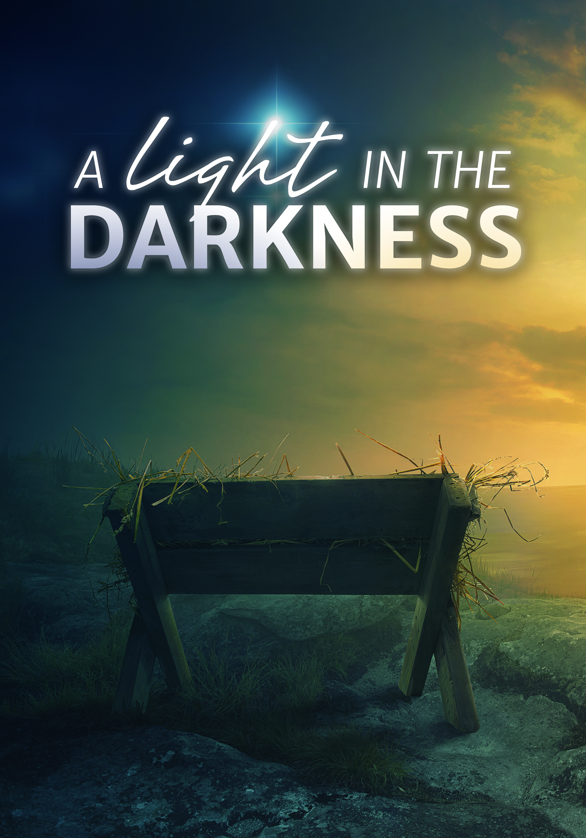

Church Name
CHURCH
LOGO
HERE
EVANGELICAL LUTHERAN CHURCH
Church tagline, i.e. a very brief summary of your mission statement

Welcome! We are glad that you have joined us to celebrate the birth of the Christ child. Our service is printed for you in its entirety in this worship folder.
- Restrooms are located in the hallway directly opposite the entrance to the sanctuary.
- Infants Room If you have a young child or nursing infant and are in need of a cry-room, you will find it to the right as soon as you exit the sanctuary. A speaker there allows you to hear the service.
- Staffed nursery We offer a staffed nursery for children ages 2 to 6. As you exit the sanctuary, it is located in the back left of the entry foyer, near the kitchen window.
- Connection cards are found inside each worship folder. We ask that before worship or during the offering you fill those out, front and back. You can return the card in the offering plate or hand it to an usher at your convenience.
- Gift bags for children will be distributed after worship. Please be sure to pick one up on your way out of the building.
- Prayer before worship Father, open my heart to hear and believe your word, so that through faith your Son may take his rightful place not just in the manger, but also within my heart. In his name I pray. Amen.

These are meant to serve as examples of the type of information that is helpful to guests. Edit to fit your congregation. Then delete this text box.
CHRISTMAS EVE
December 24, 2018 at 7:00PM

Our Theme for This Night
A Light in the Darkness. Light and darkness are polar opposites. Where one advances, the other must retreat. Thus, they parallel the ultimate of polar opposites—good and evil, holiness and sin. Ever since mankind fell into sin, God promised to send a great Light to pierce the darkness of sin and death.
Opportunities for Worship This Christmas
“The Twelve Days of Christmas” run from tonight through the festival of Epiphany. Here are our additional Christmas worship opportunities. Please, join us!
- Tuesday, December 25 at 10:30AM — THE FESTIVAL OF THE NATIVITY
- Sunday, December 30 at 8:00AM and 10:30AM — SAVED BY A CHILD
- Sunday, January 7 at 8:00AM and 10:30AM — WISDOM AND FOOLISHNESS

+ ORDER OF SERVICE +

HYMN Oh, Come, All Ye Faithful

STAND

CALL TO WORSHIP
M(inister): In the name of the Father, and of the  Son, and of the Holy Spirit.
C(ongregation): Amen.
M: The people walking in darkness have seen a great light.
C: The light shines in the darkness,
but the darkness has not understood it.
M: Those who dwelt in the land of deep darkness,
on them light has shined.
C: We have seen the glory of the Christ,
the glory of the only Son of the Father,
full of grace and truth.
M: To us a child is born.
To us a Son is given.
C: In him was life,
and that life was the light of men.
M: O loving God,
you once caused this holy night to shine with the brightness of the true Light.
Turn our thoughts toward Bethlehem and the Christ child.
May the words of Scripture we hear tonight remind us again that the old story is ever so new.
May the carols we sing tonight reveal to us again the mystery of his birth.
May the candles we see tonight symbolize for us your Son as the Light of the world.
May all who have known that Light on earth come to the full measure of its joys in heaven.
C: Help us, O Lord, in our worship this night. Amen.

HYMN Angels We Have Heard on High

PRAYER OF THE DAY
M: Let us pray.
Almighty God,
You made this holy night shine with the brightness of the true light.
Grant that as we have known on earth the wonder of this light,
we may also behold him in all glory in the life to come;
through your only Son, Jesus Christ our Lord,
who lives and reigns with you and the Holy Spirit,
one God, now and forever.
C: Amen.

BE SEATED
FIRST LESSON Isaiah 9:2-7
Isaiah foretells that the darkness of sin and death will be
scattered by a great light, the promised Savior.
²The people walking in darkness have seen a great light;
on those living in the land of deep darkness a light has dawned.
³ You have enlarged the nation and increased their joy;
they rejoice before you as people rejoice at the harvest,
as warriors rejoice when dividing the plunder.
⁴ For as in the day of Midian’s defeat,
you have shattered the yoke that burdens them,
the bar across their shoulders, the rod of their oppressor.
⁵ Every warrior’s boot used in battle
and every garment rolled in blood
will be destined for burning, will be fuel for the fire.
⁶ For to us a child is born,
to us a son is given,
and the government will be on his shoulders.
And he will be called
Wonderful Counselor, Mighty God,
Everlasting Father, Prince of Peace.
⁷ Of the greatness of his government and peace there will be no end.
He will reign on David’s throne and over his kingdom,
establishing and upholding it with justice and righteousness
from that time on and forever.
The zeal of the Lord Almighty will accomplish this.

RESPONSE The People that in Darkness Sat

ALL:
ALL:
Men:
Women:
ALL:

SECOND LESSON 1 John 1:1-9

St John proclaims what he has “seen and heard.” Jesus came to bring the light of
salvation. Christ has created fellowship with God and one another.

¹ That which was from the beginning, which we have heard, which we have seen with our eyes, which we have looked at and our hands have touched—this we proclaim concerning the Word of life. ² The life appeared; we have seen it and testify to it, and we proclaim to you the eternal life, which was with the Father and has appeared to us. ³ We proclaim to you what we have seen and heard, so that you also may have fellowship with us. And our fellowship is with the Father and with his Son, Jesus Christ. ⁴ We write this to make our joy complete.
⁵ This is the message we have heard from him and declare to you: God is light; in him there is no darkness at all. ⁶ If we claim to have fellowship with him and yet walk in the darkness, we lie and do not live out the truth. ⁷ But if we walk in the light, as he is in the light, we have fellowship with one another, and the blood of Jesus, his Son, purifies us from all sin.
⁸ If we claim to be without sin, we deceive ourselves and the truth is not in us. ⁹ If we confess our sins, he is faithful and just and will forgive us our sins and purify us from all unrighteousness.

HYMN Come, Your Hearts and Voices Raising

STAND

GOSPEL Luke 2:1-20
St. Luke records the birth of our Savior.

¹ In those days Caesar Augustus issued a decree that a census should be taken of the entire Roman world. ² (This was the first census that took place while Quirinius was governor of Syria.) ³ And everyone went to their own town to register.
⁴ So Joseph also went up from the town of Nazareth in Galilee to Judea, to Bethlehem the town of David, because he belonged to the house and line of David. ⁵ He went there to register with Mary, who was pledged to be married to him and was expecting a child. ⁶ While they were there, the time came for the baby to be born, ⁷ and she gave birth to her firstborn, a son. She wrapped him in cloths and placed him in a manger, because there was no guest room available for them.
⁸ And there were shepherds living out in the fields nearby, keeping watch over their flocks at night. ⁹ An angel of the Lord appeared to them, and the glory of the Lord shone around them, and they were terrified. ¹⁰ But the angel said to them, “Do not be afraid. I bring you good news that will cause great joy for all the people. ¹¹ Today in the town of David a Savior has been born to you; he is the Messiah, the Lord. ¹² This will be a sign to you: You will find a baby wrapped in cloths and lying in a manger.”
¹³ Suddenly a great company of the heavenly host appeared with the angel, praising God and saying,
¹⁴ “Glory to God in the highest heaven,
and on earth peace to those on whom his favor rests.”
¹⁵ When the angels had left them and gone into heaven, the shepherds said to one another, “Let’s go to Bethlehem and see this thing that has happened, which the Lord has told us about.”
¹⁶ So they hurried off and found Mary and Joseph, and the baby, who was lying in the manger. ¹⁷ When they had seen him, they spread the word concerning what had been told them about this child, ¹⁸ and all who heard it were amazed at what the shepherds said to them. ¹⁹ But Mary treasured up all these things and pondered them in her heart. ²⁰ The shepherds returned, glorifying and praising God for all the things they had heard and seen, which were just as they had been told.

BE SEATED

HYMN Hark! The Herald Angels Sing

SERMON

Sermon Theme

THANK OFFERING

During the offering, acolytes will come to your pew and light the candle nearest the center aisle. Please then light the candle next to you until all the candles are lit in the pew. When all the candles are lit, the lights will be dimmed. Remember to tip the unlit candle and leave the lit candle vertical.

STAND

PRAYER OF THE CHURCH
Throughout the prayer when the minister says, “praising God and saying,” the congregation responds with:
C: Glory to God in the highest!
LORD’S PRAYER
M: Lord, we pray in your name and as you taught.
C: Our Father in heaven, hallowed be your name, your kingdom come, your will be done on earth as in heaven. Give us today our daily bread. Forgive us our sins, as we forgive those who sin against us. Lead us not into temptation, but deliver us from evil. For the kingdom, the power, and the glory are yours now and forever. Amen.

BLESSING
M: May he who by his incarnation
gathered things earthly and heavenly into one,
fill us with such joy that comes with the knowledge
of the forgiveness of sins and the hope of eternal life.
And the blessing of God Almighty
— the Father, the  Son, and the Holy Spirit —
be upon you and remain with you always.
C: Amen.

HYMN Silent Night

ACKNOWLEDGMENTS
Organist / pianist:
Instruments:
Cantor:
The hymns are in the public domain.
Change the following acknowledgments if substitutes are used.
The following are reprinted by special permission for WELS Advent services in 2018. All music is either public domain or reprinted under OneLicense.net A-##### or CCLI #######.

ANNOUNCEMENTS

CHURCH
LOGO
HERE
CHURCH NAME
City, State, Zipcode
555.555.5555
www.yourchurchwebsite.com

