Third Sunday in Advent
December 16, 2018

Church Name
CHURCH
LOGO
HERE
EVANGELICAL LUTHERAN CHURCH

Church tagline, i.e. a very brief summary of your mission statement

elcome! Thank you for joining us for worship this morning. In our service we gather before our almighty God to offer him our worship and praise. We also gather to strengthen ourselves through the study of God’s holy and powerful Word.
W
 Restrooms are located in the hallway directly opposite the entrance to the sanctuary.
 Staffed nursery. We offer a staffed nursery for ages 2 to 6 and special needs children. It is located to the left of the entry foyer near the kitchen.
 Connection Cards are inside the worship folder. We ask that before worship or during the offering, you fill those out, front and back. Then place them in the offering plate after the sermon.
 Additional info: church contact info, etc.
WORSHIP NOTES
Our Worship Series: Our Lord Jesus is coming, bearing real gifts, profoundly important gifts. He came that first Christmas to win forgiveness and give all the gifts that come with it: hope, peace, joy, love. He is coming again at the end of this world to give the gift of resurrection to eternal life. In the season of Advent, we connect Christ’s first coming with his second coming. We rejoice in all the unconditional gifts he gives. Each Sunday during the gathering rite Advent candles are lighted. Music occurs throughout this rite to accompany singing and as background music to communicate themes of longing and repentance.
Theme of the Day: The ancient church had Latin titles for all their Sundays. They called the third Sunday in Advent “Gaudete Sunday.” The Latin word gaudete means rejoice. On some Advent wreaths, the third candle is a pinkish rose color, symbolizing joy.
An encouragement to rejoice might sound odd in light of this Advent season’s themes, especially Christ’s second coming to this world. We have seen that when Jesus comes again he is going to judge all mankind and destroy the universe. Even the gospel reading for today warns about “the coming wrath” which will include “unquenchable fire.” If that is what Christ will bring at his second coming, how can we possibly live joyfully?
Answer: because of Christ’s first coming. When Jesus came that first Christmas, it wasn’t to bring judgment, but to bear judgment. Jesus was born, not to punish sin, but to be punished for sin. All those with faith in Christ know that when he comes for the second time, it will be to deliver us, not destroy us. He will not increase our pain but take every pain away. Then, and not a moment before, our lives will finally be perfect! And so, we live joyfully and thankfully, looking forward to Christ’s return.
Order of Service for
THE SEASON OF ADVENT

STAND
INVOCATION
M: In the name of the Father and of the Son and of the Holy Spirit.
C: Amen.
Confession of Sins and advent candle Lighting
M: When God created the world, he made the crown of his creation—the human race—in his image. Perfect people lived in a perfect world in a perfect relationship with God.
C: But mankind rebelled against God, bringing sin into the world and death to all. God declared the wages of sin to be death. We too are guilty, and we confess our sinful thoughts, words, and actions.
M: However, God—who is Love—did not want to be separated from his children forever. He promised a Savior who would bear the punishment for sin, defeat the devil, and break the bonds of death. Genesis 1:26; Romans 6:23

ALL:

M: When the time had fully come, God sent his Son. Jesus, our Savior, has paid the ransom for your debt; your sins are forgiven. In view of God’s mercy, today we light the joy candle. Though we have not seen Jesus, we love him; and even though we do not see him now, we believe in him.
C: And we are filled with an inexpressible and glorious joy, for we are receiving the end result of our faith, the salvation of our souls. Galatians 4:4,5; 1 Peter 1:8,9

ALL:

M: In the joy of God we go to the world—to our friends, relatives, acquaintances and neighbors. We regard no one from a worldly point of view. If anyone is in Christ, the new creation has come. All this is from God, who reconciled us to himself through Christ and gave us the ministry of reconciliation.
C: God has committed to us the ministry of reconciliation. We are therefore Christ’s ambassadors, as though God were making his appeal through us. Jesus, who had no sin, became sin for us; in him we have become the righteousness of God. 2 Corinthians 5:19-21

ALL:

 The Word 

PRAYER OF THE DAY
M: Hear our prayers, Lord Jesus Christ, and come with the good news of your mighty deliverance. Drive the darkness from our hearts and fill us with your light; for you live and reign with the Father and the Holy Spirit, one God, now and forever.
C: Amen.

BE SEATED

FIRST LESSON Zephaniah 3:14-17
The LORD has taken away the punishment for our sins. Therefore, the
prophet tells us that when we see Christ, our joy will be complete…
and also that the LORD will find joy in us.

¹⁴ Sing, O Daughter of Zion;
shout aloud, O Israel!
Be glad and rejoice with all your heart,
O Daughter of Jerusalem!
¹⁵ The LORD has taken away your punishment,
he has turned back your enemy.
The LORD, the King of Israel, is with you;
never again will you fear any harm.
¹⁶ On that day they will say to Jerusalem,
"Do not fear, O Zion;
do not let your hands hang limp.
¹⁷ The LORD your God is with you,
he is mighty to save.
He will take great delight in you,
he will quiet you with his love,
he will rejoice over you with singing."

PSALM OF THE DAY Psalm 130

Out of the depths I cry to you, O LORD;*
This psalm is a placeholder. Psalms for each Advent Sunday, from those under consideration by the new WELS hymnal project, were emailed to pastors in early November. Due to copyright restrictions, they are not posted with other C18 worship resources.

Insert a rubric to indicate how the psalm is sung, or announce this.
O Lord, hear my voice.
Let your ears be attentive*
to my cry for mercy.
If you, O LORD, kept a record of sins,*
O Lord, who could stand?
But with you there is forgiveness;*
therefore you are feared.
Refrain
I wait for the LORD and in his Word I put my hope.*
My soul waits for the Lord more than
watchmen wait for the morning.
O Israel, put your hope in the LORD,*
for with the LORD is unfailing love
and with him is full redemption.
Glory be to the Father and to the Son*
and to the Holy Spirit,
as it was in the beginning,*
is now, and will be forever. Amen.
Refrain

SECOND LESSON Philippians 4:4-7

Because our sins have been forgiven, Christ is always near us. We have
the peace of knowing we will live forever with him. Therefore, we can live
joyfully instead of anxiously, no matter our earthly circumstances

⁴ Rejoice in the Lord always. I will say it again: Rejoice! ⁵ Let your gentleness be evident to all. The Lord is near. ⁶ Do not be anxious about anything, but in everything, by prayer and petition, with thanksgiving, present your requests to God. ⁷ And the peace of God, which transcends all understanding, will guard your hearts and your minds in Christ Jesus.

STAND

VERSE OF THE DAY Matthew 12:18,21

ALL: Refrain (after a brief introduction)

Cantor: Sing and shout aloud, O Israel; rejoice with all your heart.
God removed your punishment. Alleluia.
ALL: Refrain (without introduction)

Change “Cantor” to choir, soloist, or M: as desired.

GOSPEL Luke 3:7-18

Repentance is actually a joyful activity. While we are contrite about sin, we rejoice that we have a
Savior whose life, death, and resurrection mean that we will escape sin’s punishment.
We joyfully turn to him in faith. And in gratitude, we joyfully produce fruits of repentance.

⁷ John said to the crowds coming out to be baptized by him, "You brood of vipers! Who warned you to flee from the coming wrath? ⁸ Produce fruit in keeping with repentance. And do not begin to say to yourselves, 'We have Abraham as our father.' For I tell you that out of these stones God can raise up children for Abraham. ⁹ The axe is already at the root of the trees, and every tree that does not produce good fruit will be cut down and thrown into the fire."
¹⁰ "What should we do then?" the crowd asked.
¹¹ John answered, "The man with two tunics should share with him who has none, and the one who has food should do the same."
¹² Tax collectors also came to be baptized. "Teacher," they asked, "what should we do?"
¹³ "Don't collect any more than you are required to," he told them.
¹⁴ Then some soldiers asked him, "And what should we do?"
He replied, "Don't extort money and don't accuse people falsely—be content with your pay."
¹⁵ The people were waiting expectantly and were all wondering in their hearts if John might possibly be the Christ. ¹⁶ John answered them all, "I baptize you with water. But one more powerful than I will come, the thongs of whose sandals I am not worthy to untie. He will baptize you with the Holy Spirit and with fire. ¹⁷ His winnowing fork is in his hand to clear his threshing floor and to gather the wheat into his barn, but he will burn up the chaff with unquenchable fire." ¹⁸ And with many other words John exhorted the people and preached the good news to them.

M: This is the Gospel of our Lord.
C: Praise be to you, O Christ!

BE SEATED

HYMN OF THE DAY — 7 Rejoice, Rejoice, Believers
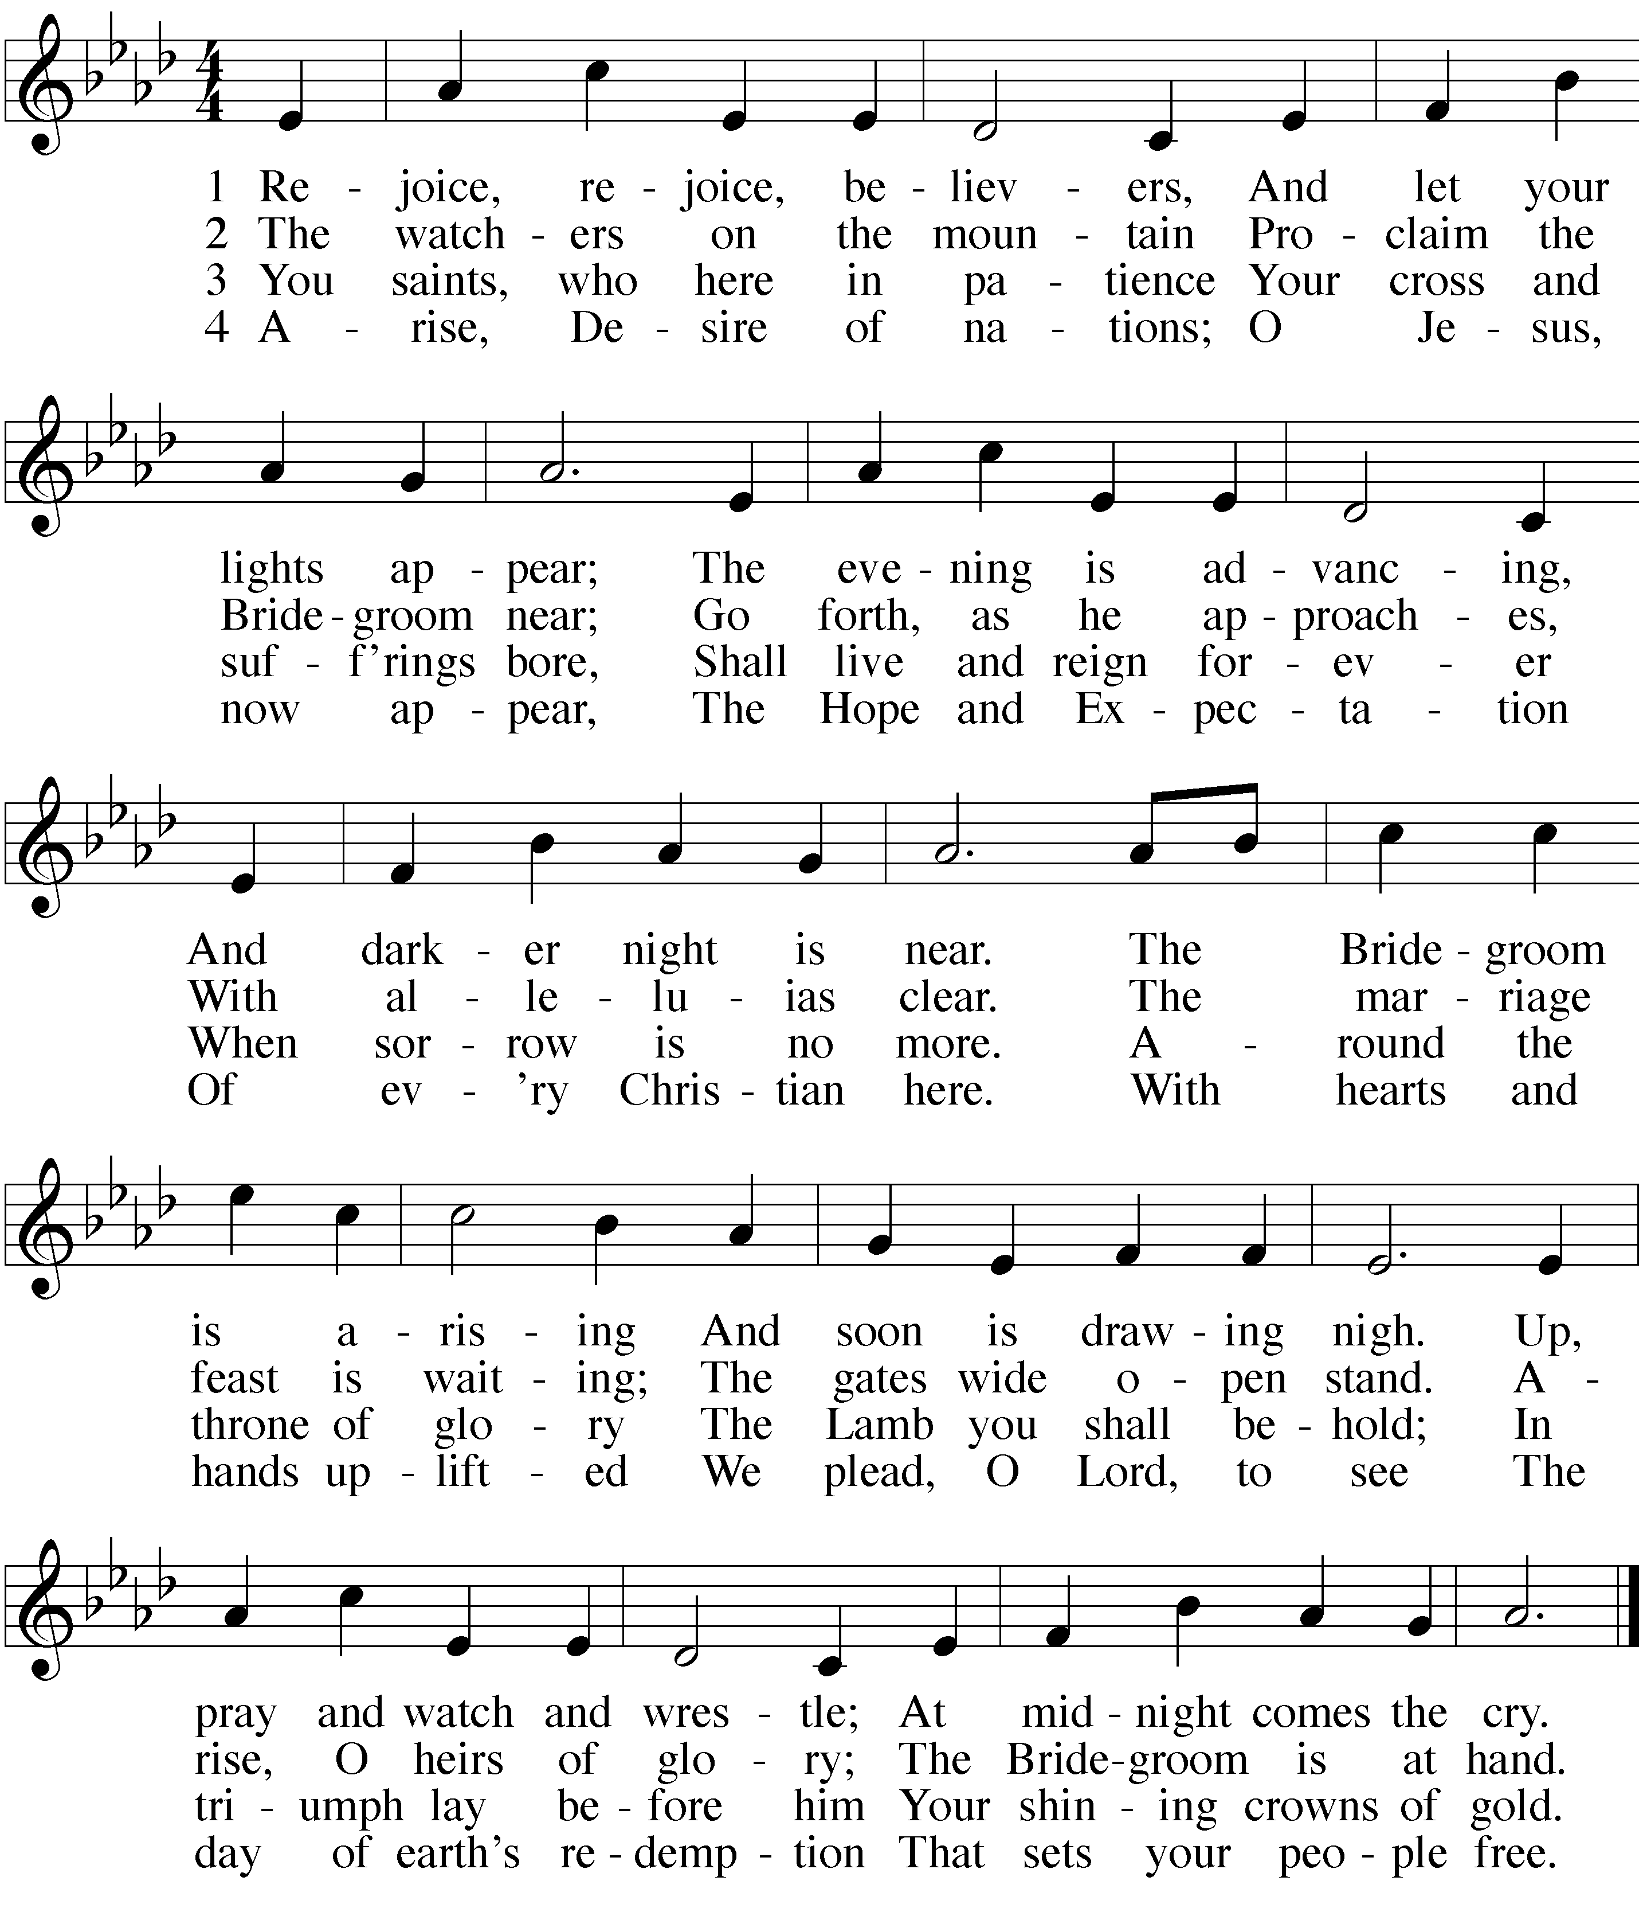

SERMON Sermon Theme

STAND

APOSTLES’ CREED
I believe in God, the Father almighty, maker of heaven and earth.
I believe in Jesus Christ, his only Son, our Lord,
who was conceived by the Holy Spirit,
born of the virgin Mary, suffered under Pontius Pilate,
was crucified, died, and was buried.
He descended into hell. The third day he rose again from the dead. He ascended into heaven and is seated at the right hand of God the Father almighty. From there he will come to judge the living and the dead.
I believe in the Holy Spirit,
the holy Christian Church, the communion of saints, the forgiveness of sins,
the resurrection of the body, and the life everlasting. Amen.
BE SEATED

OFFERING

STAND
PRAYER OF THE CHURCH
Prayers and petitions are offered on behalf of the Church, nation, and world.
M: Hear us, Lord, as we bring you our private petitions.
Silent prayer

LORD’S PRAYER
M: We pray in your name, Lord, and as you taught:

C: Our Father in heaven, hallowed be your name, your kingdom come, your will be done on earth as in heaven. Give us today our daily bread. Forgive us our sins, as we forgive those who sin against us. Lead us not into temptation, but deliver us from evil. For the kingdom, the power, and the glory are yours now and forever. Amen.
BE SEATED
HYMN — 5 As Angels Joyed with One Accord
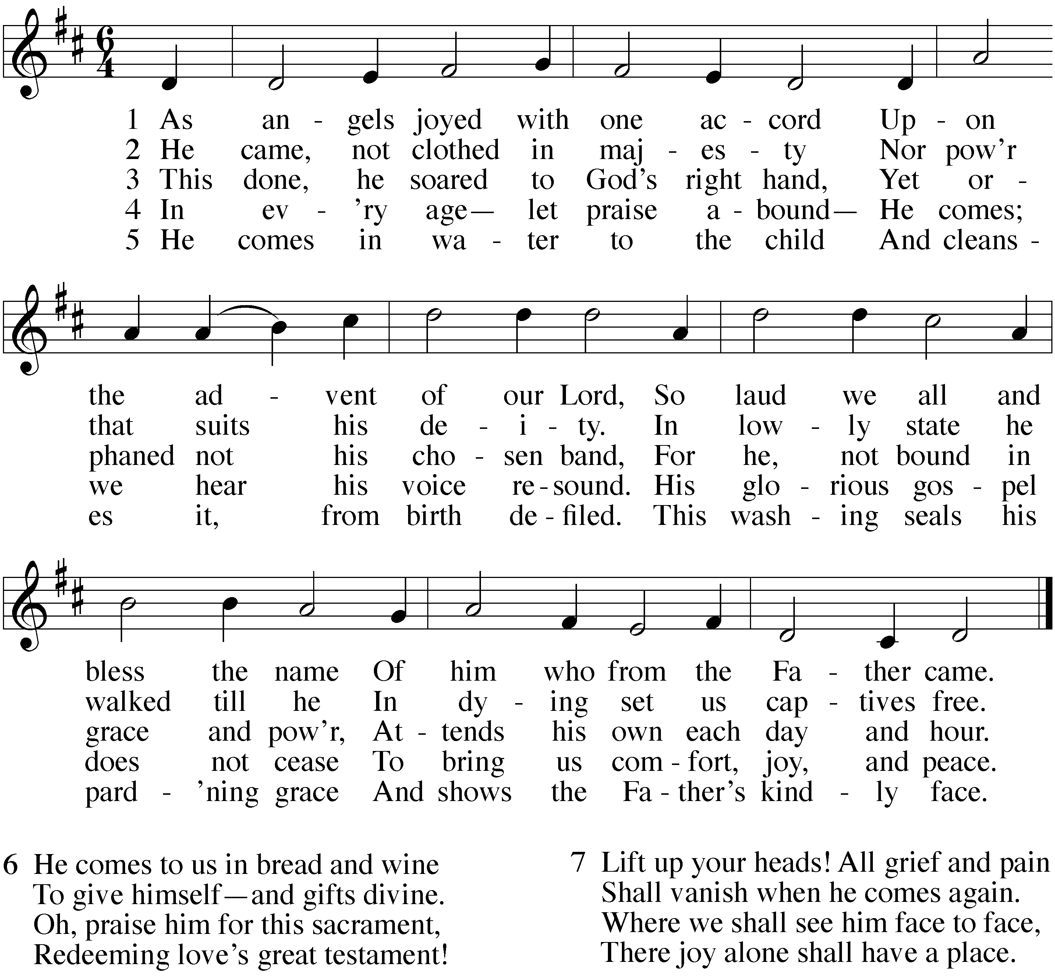

Yes, this worship folder is longer than 12 pages. We haven’t tried to solve this by making it fit to 12 because:
- Most churches sing hymns from the hymnal, so deleting hymns gains pages.
- Adding announcements probably raises page count to at least 16.
- Some churches will modify the service to include communion.

One slight edit for fit: the closing prayer does not have the usual title.

STAND
M: Blessed Lord, you have given us your Holy Scriptures for our learning. May we so hear them, read, learn, and take them to heart, that being strengthened and comforted by your Holy Word, we may cling to the blessed hope of everlasting life, through Jesus Christ, our Lord, who lives and reigns with you and the Holy Spirit, one God, now and forever.
C: Amen.

BLESSING
M: Brothers and sisters, go in peace. Live in harmony with one another.
Serve the Lord with gladness.
The Lord bless you and keep you. The Lord make his face shine on you and be gracious to you. The Lord look on you with favor and give  you peace.

C: Amen.
HYMN — 540 Rejoice, O Pilgrim Throng
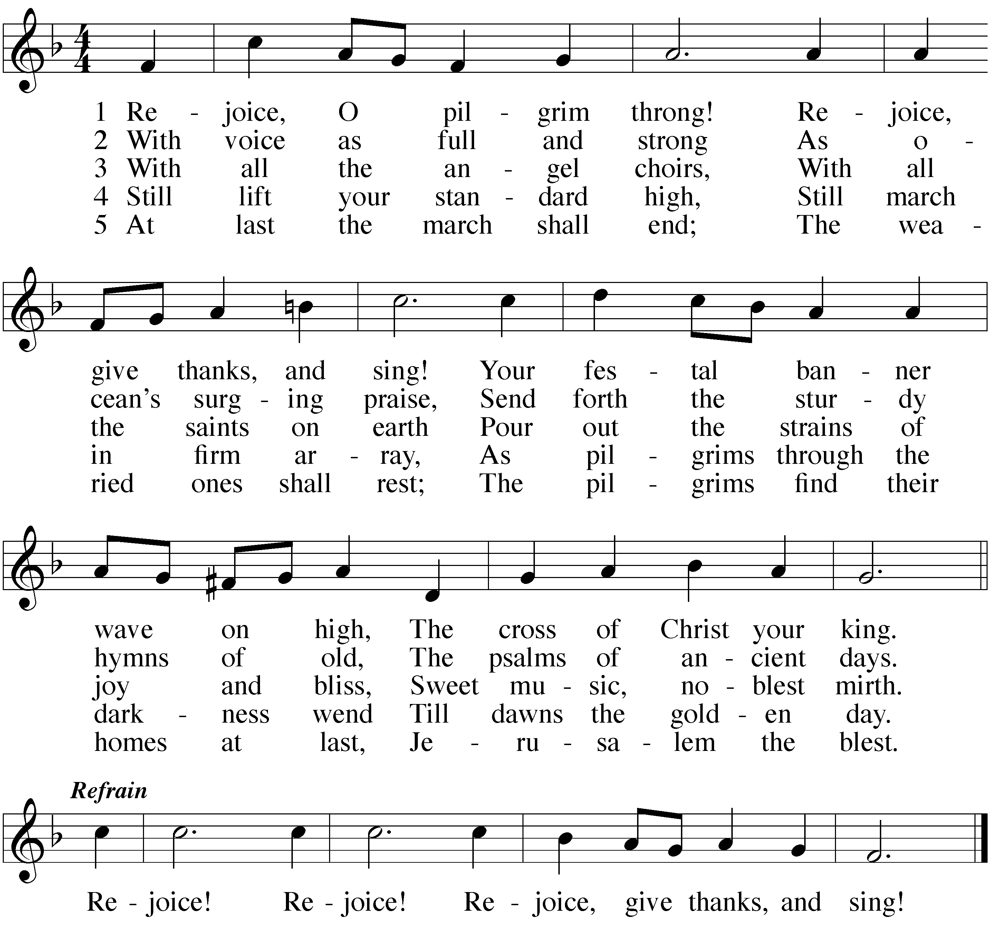

ACKNOWLEDGMENTS
Organist / pianist:
Change the following acknowledgments if substitutes are used. Delete one of the psalm credits.
The following are reprinted by special permission for WELS Advent services in 2018. All music is either public domain or reprinted under OneLicense.net A-##### or CCLI #######.
Gathering Rite new texts and music: © 2018 Jeremy S. Bakken. All rights reserved. Used with permission.
Psalm 130. Refrain Tune: Michael Joncas. © 1986 GIA Publications, Inc., Chicago, IL, www.giamusic.com. All rights reserved. Used by permission.
Psalm 130A: Music (refrain): Kevin J. Sadowski © 1992 Concordia Publishing House; (tone): Paul Bunjes © 1982 Concordia Publishing House.
Verse of the Day new texts and music: © 2018 Jeremy S. Bakken. All rights reserved. Used with permission.

