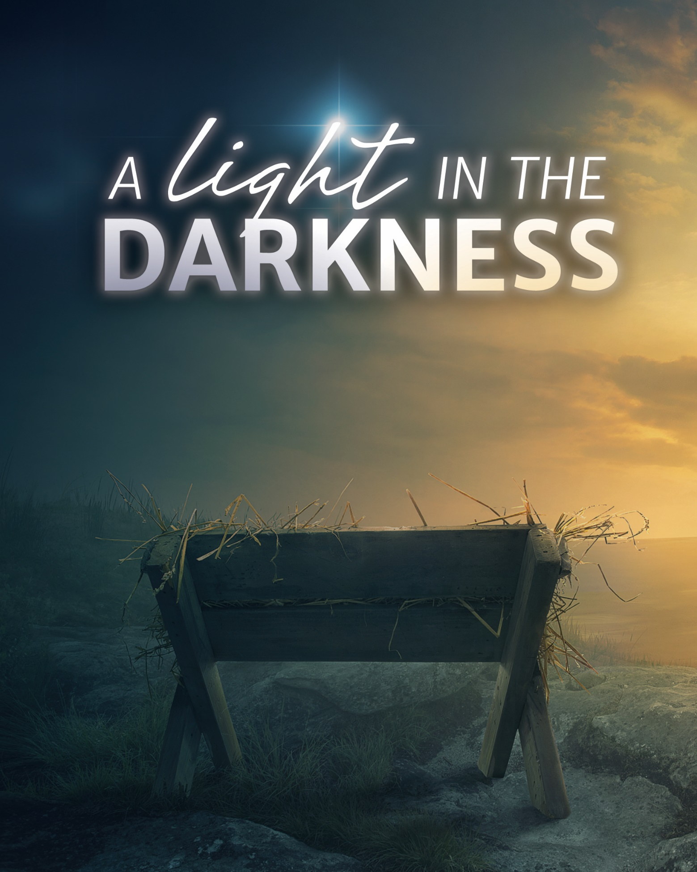

Church Name
CHURCH
LOGO
HERE
EVANGELICAL LUTHERAN CHURCH
Church tagline, i.e. a very brief summary of your mission statement
Welcome! We are glad that you have joined us to celebrate the birth of the Christ child. Our service is printed for you in its entirety in this worship folder.
- Restrooms are located in the hallway directly opposite the entrance to the sanctuary.
 Infants Room If you have a young child or nursing infant and are in need of a cry-room, you will find it to the right as soon as you exit the sanctuary. A speaker there allows you to hear the service.
 Staffed nursery We offer a staffed nursery for children ages 2 to 6. As you exit the sanctuary, it is located in the back left of the entry foyer, near the kitchen window.
 Connection cards are found inside each worship folder. We ask that before worship or during the offering you fill those out, front and back. You can return the card in the offering plate or hand it to an usher at your convenience.
 Gift bags for children will be distributed after worship. Please be sure to pick one up on your way out of the building.
 Prayer before worship Father, open my heart to hear and believe your word, so that through faith your Son may take his rightful place not just in the manger, but also within my heart. In his name I pray. Amen.

These are meant to serve as examples of the type of information that is helpful to guests. Edit to fit your congregation. Then delete this text box.
CHRISTMAS EVE
December 24, 2018 at 7:00PM

Service of Lessons and Carols
Our worship this evening is an adaptation of the Lessons and Carols service traditionally held at King's College, Cambridge, England, on December 24th every year. Lessons and Carols was first held on Christmas Eve, 1918. It was planned by Eric Milner-White, who at the age of thirty-four had just been appointed Dean of King’s College after experience as an army chaplain.
Our Theme for This Night
A Light in the Darkness. Light and darkness are polar opposites. Where one advances, the other must retreat. Thus, they parallel the ultimate of polar opposites—good and evil, holiness and sin. Ever since mankind fell into sin, God promised to send a great Light to pierce the darkness of sin and death. Through a series of seven lessons, we explore that theme of light in the darkness.
Opportunities for Worship This Christmas
“The Twelve Days of Christmas” run from tonight through the festival of Epiphany. Here are our additional Christmas worship opportunities. Please, join us!
• Tuesday, December 25 at 10:30AM — THE FESTIVAL OF THE NATIVITY
• Sunday, December 30 at 8:00AM and 10:30AM — SAVED BY A CHILD
• Sunday, January 7 at 8:00AM and 10:30AM — WISDOM AND FOOLISHNESS
Our Lectors This Evening
Thank you to all who served this evening. Our lectors tonight were:
• John Frederick, congregational president
• George Brandenberg, elder
• Phil Hesse, student preparing for pastoral ministry
• Wolf Anhalt, trustee
- Frank Luneburg, Sunday school teacher
- Christian Beyer, pastor
- Chris von Stadion, choir member
+ ORDER OF SERVICE +

Stand
EXHORTATION AND PRAYER
M: Beloved in Christ: In this Christmas season it is our duty and delight to hear again the message of the angels and, in heart and mind, to go even unto Bethlehem and see this thing which has come to pass, which the Lord has made known to us, the Christ-child, lying in a manger.
Let us read and learn in Holy Scripture the story of the loving purposes of God from the first days after our fall, and into the birth and glorious redemption brought to us by this Holy Child. Let us hear how peace was lost, and how peace is restored.
But first, let us pray, for this is good and right.
Heavenly Father, we pray for ourselves and all people who worship you and your Son this holy night. By your holy Word, lead us to say with the angels,
C: Glory to God in the highest!
M: We pray for your blessing upon the people of our city, our state, our nation, and our world.
C: Glory to God in the highest!
M: We pray for the the poor and helpless, the cold and hungry, the sick and sad, that you would give them the joy of your salvation and the comfort of your presence.
C: Glory to God in the highest!
M: We pray for unbelievers and enemies of the Church, that through your Law and Gospel you would lead them to recognize your Son as their only hope for eternal life.
C: Glory to God in the highest!
M: Finally, we remember before you all those who rejoice with us in heaven, who live in greater light and beauty than we, that multitude which no one can number, who died in faith, and now praise you in your heavenly temple. We confess that we are united with them and with one another.
C: Glory to God in the highest!

M: We humbly offer up these prayers and praises in the words that Christ himself taught us.
C: Our Father in heaven, hallowed be your name, your kingdom come, your will be done on earth as in heaven. Give us today our daily bread. Forgive us our sins, as we forgive those who sin against us. Lead us not into temptation, but deliver us from evil. For the kingdom, the power, and the glory are yours now and forever. Amen.

CAROL Oh, Come, All Ye Faithful
Oh, come, all ye faithful, Joyful and triumphant,
Oh, come ye, oh, come ye to Bethlehem;
Come and behold him, Born the King of angels.
Oh, come, let us adore him, Oh, come, let us adore him,
Oh, come, let us adore him, Christ the Lord.

God from true God, and Light from Light eternal,
Born of a virgin, to earth he comes,
Only begotten Son of God the Father.
Oh, come, let us adore him, Oh, come, let us adore him,
Oh, come, let us adore him, Christ the Lord.

Be seated

LET THERE BE LIGHT

FIRST LESSON Genesis 1 & 3
CAROL O Little Town of Bethlehem
O little town of Bethlehem, How still we see thee lie!
Above thy deep And dreamless sleep The silent stars go by.
Yet in thy dark streets shineth The everlasting light.
The hopes and fears Of all the years Are met in thee tonight.
How silently, how silently The wondrous gift is giv’n!
So God imparts To human hearts The blessings of his heav’n.
No ear may hear his coming, But in this world of sin
Where meek souls will Receive him still, The dear Christ enters in.
O holy Child of Bethlehem, Descend to us, we pray;
Cast out our sin And enter in; Be born in us today.
We hear the Christmas angels The great glad tidings tell;
Oh, come to us, Abide with us, Our Lord Immanuel!

LIGHT HAS COME

SECOND LESSON John 3
CAROL What Child Is This

What child is this who, laid to rest,
On Mary’s lap is sleeping?
Whom angels greet With anthems sweet
While shepherds watch are keeping?
This, this is Christ the King,
Whom shepherds guard and angels sing.
Haste, haste to bring him laud,
The babe, the Son of Mary!
Why lies he in such mean estate
Where oxen now are feeding?
Good Christians, fear; For sinners here
The silent Word is pleading.
Nails, spear shall pierce him through;
The cross he’ll bear for me, for you.
Hail, hail the Word made flesh,
The babe, the Son of Mary!

A DAY OF DARKNESS

THIRD LESSON Joel 2
CAROL Of the Father’s Love Begotten
Verse 1 — soloist
Of the Father’s love begotten
Ere the worlds began to be,
He is Alpha and Omega,
He the source, the ending he,
Of the things that are, that have been,
And that future years shall see
Evermore and evermore.
Verse 2 — choir
Oh, that birth forever blessed
When the virgin, full of grace,
By the Holy Ghost conceiving,
Bore the Savior of our race,
And the babe, the world’s Redeemer,
First revealed his sacred face
Evermore and evermore.
Verse 3 — All
This is he whom heav’n-taught singers
Sang of old with one accord;
Whom the Scriptures of the prophets
Promised in their faithful word.
Now he shines, the long-expected;
Let creation praise its Lord
Evermore and evermore.

Walk in the Light

FOURTH LESSON First John 1
CAROL Angels We Have Heard on High
Angels we have heard on high,
Sweetly singing o’er the plains,
And the mountains in reply,
Echoing their joyous strains.
Gloria in excelsis Deo;
Gloria in excelsis Deo.
Shepherds, why this jubilee?
Why your joyous strains prolong?
What the gladsome tidings be
Which inspire your heav’nly song?
Gloria in excelsis Deo;
Gloria in excelsis Deo.
Come to Bethlehem and see
Him whose birth the angels sing;
Come, adore on bended knee
Christ the Lord, the newborn King.
Gloria in excelsis Deo;
Gloria in excelsis Deo.

The LORD Is My Light

Stand
FIFTH LESSON Psalm 27
M: The LORD is my light and my salvation —
whom shall I fear?
C: The LORD is the stronghold of my life —
of whom shall I be afraid?

M: Though an army besiege me, my heart will not fear;
C: though war break out against me,
even then will I be confident.
M: One thing I ask of the LORD, this is what I seek:
C: that I may dwell in the house of the LORD all the days of my life,
M: to gaze upon the beauty of the LORD
C: and to seek him in his temple.
M: For in the day of trouble he will keep me safe in his dwelling;
C: he will hide me in the shelter of his tabernacle
and set me high upon a rock.
M: Hear my voice when I call, O LORD;
C: be merciful to me and answer me.
M: Do not hide your face from me,
do not turn your servant away in anger;
you have been my helper.
C: Do not reject me or forsake me, O God my Savior.
M: Though my father and mother forsake me,
the LORD will receive me.
C: I am still confident of this:
I will see the goodness of the LORD in the land of the living.
M: Wait for the LORD;
C: be strong and take heart and wait for the LORD.

Be seated

CAROL The People That in Darkness Sat
Verse 1 — All
The people that in darkness sat A glorious light have seen;
The light has shone on them who long
In shades of death have been, In shades of death have been.
Verse 2 — Women
To us a child of hope is born, To us a son is giv’n,
And on his shoulders ever rests
All pow’r in earth and heav’n, All pow’r in earth and heav’n.
Verse 3 — Men
His name shall be the Prince of Peace, The Everlasting Lord,
The Wonderful, the Counselor,
The God by all adored, The God by all adored.
Verse 4 — All
His righteous government and pow’r Shall over all extend;
On judgment and on justice based,
His reign shall have no end, His reign shall have no end.
Verse 5 — All
Lord Jesus, reign in us, we pray, And make us yours alone,
For you are with the Father and
The Spirit ever one, The Spirit ever one.

A LIGHT HAS DAWNED

SIXTH LESSON Isaiah 9
¹Nevertheless, there will be no more gloom for those who were in distress. In the past he humbled the land of Zebulun and the land of Naphtali, but in the future he will honor Galilee of the nations, by the Way of the Sea, beyond the Jordan —
² The people walking in darkness have seen a great light;
on those living in the land of deep darkness a light has dawned.
³ You have enlarged the nation and increased their joy;
they rejoice before you as people rejoice at the harvest,
as warriors rejoice when dividing the plunder.
⁴ For as in the day of Midian’s defeat,
you have shattered The yoke that burdens them,
the bar across their shoulders, the rod of their oppressor.
⁵ Every warrior’s boot used in battle
and every garment rolled in blood
will be destined for burning, will be fuel for the fire.
⁶ For to us a child is born, to us a son is given,
and the government will be on his shoulders.
And he will be called
Wonderful Counselor,
Mighty God,
Everlasting Father,
Prince of Peace.
⁷ Of the greatness of his government and peace
there will be no end.
He will reign on David’s throne and over his kingdom,
establishing and upholding it with justice and righteousness
from that time on and forever.
The zeal of the Lord Almighty will accomplish this.

CAROL Hark! The Herald Angels Sing

Hark! The herald angels sing,
“Glory to the newborn King;
Peace on earth and mercy mild,
God and sinners reconciled!”
Joyful, all you nations rise,
Join the triumph of the skies;
With th’ angelic host proclaim,
“Christ is born in Bethlehem!”
Hark! The herald angels sing,
“Glory to the newborn King!”

Christ, by highest heav’n adored,
Christ, the everlasting Lord,
Late in time behold him come,
Offspring of a virgin’s womb.
Veiled in flesh the Godhead see,
Hail th’ incarnate Deity!
Pleased as man with us to dwell,
Jesus, our Immanuel!
Hark! The herald angels sing,
“Glory to the newborn King!”

Hail, the heav’nly Prince of Peace!
Hail, the Sun of Righteousness!
Light and life to all he brings,
Ris’n with healing in his wings.
Mild he lays his glory by,
Born that we no more may die,
Born to raise us from the earth,
Born to give us second birth.
Hark! The herald angels sing,
“Glory to the newborn King!”
THANK OFFERING
During the offering, acolytes will come to your pew and light the candle nearest the center aisle. Please then light the candle next to you until all the candles are lit in the pew. When all the candles are lit, the lights will be dimmed. Remember to tip the unlit candle and leave the lit candle vertical.
Stand
CLOSING PRAYER
M: O God,
who makes us glad with the yearly remembrance
of the birth of your only Son, Jesus Christ;
grant that, as we joyfully receive him as our Redeemer,
so may we also behold him with sure confidence
when he shall come to be our judge;
who lives and reigns with you and the Holy Spirit,
one God, now and forever.
C: Amen.
BLESSING
M: May he who by his incarnation
gathered things earthly and heavenly into one,
fill us with such joy that comes with the knowledge
of the forgiveness of sins and the hope of eternal life.
And the blessing of God Almighty
— the Father, the  Son, and the Holy Spirit —
be upon you and remain with you always.
C: Amen.

THE BIRTH OF CHRIST

FINAL LESSON Luke 2:1-20
HYMN Silent Night

Silent night! Holy night!
All is calm, all is bright,
Round yon virgin mother and child.
Holy Infant, so tender and mild,
Sleep in heavenly peace,
Sleep in heavenly peace.

Silent night! Holy night!
Shepherds quake at the sight.
Glories stream from heaven afar;
Heav’nly hosts sing, Alleluia;
Christ, the Savior, is born!
Christ, the Savior, is born!

Silent night! Holy night!
Son of God, love’s pure light
Radiant beams from thy holy face
With the dawn of redeeming grace,
Jesus, Lord, at thy birth,
Jesus, Lord, at thy birth.

ACKNOWLEDGMENTS
Organist / pianist:
Instruments:
Cantor:
The hymns are in the public domain.
Change the following acknowledgments if substitutes are used.
The following are reprinted by special permission for WELS Advent services in 2018. All music is either public domain or reprinted under OneLicense.net A-##### or CCLI #######.

ANNOUNCEMENTS

www.yourchurchwebsite.com
CHURCH NAME
City, State, Zipcode
555.555.5555
CHURCH
LOGO
HERE

