Fourth Sunday in Advent
December 23, 2018
Week Two
OPEN MINDS
Proportionate Giving

WELCOME TO WORSHIP!
This weekend is the second of a three-week stewardship emphasis titled Ten for Ten. In this worship series, we are looking at the daily struggle we all face when two paths are set before us, one by God and the other by this world. Shall we live for this life or the life that is to come? One very obvious way that struggle manifests itself is when we plan our finances.
Americans are generally shy when it comes to talking about money. The Lord isn’t. He speaks to us about worldly wealth and possessions over 2,300 times in his Word. Last week we heard that the Lord asks, without apology, to be first in our hearts. The Lord’s position in our hearts is to be reflected in our firstfruits giving. Firstfruits giving calls for us to open up our hearts and offer up to God our first and our very best.
This weekend, the Lord will open our minds to consider the magnitude of his blessings. Each of us has been blessed in different ways and at various levels. What should our thoughtful, prayerful response be to these blessings? That’s where the Bible’s teaching about proportionate giving is such a help. For some families with fewer resources, the practice of giving 10% of their income might be a significant leap of faith. For other families with more resources, the practice of giving 10% may be a starting point for faith-filled giving.
St. Paul wrote to the Christians in Corinth, “On the first day of every week, each one of you should set aside a sum of money in keeping with your income, saving it up, so that when I come no collections will have to be made” (1 Corinthians 16:2). Christians are blessed as they put God’s principles of proportional giving into practice!
Our worth is taking us on this path:
Week One: OPEN HEARTS (Firstfruits Giving)
Week Two: OPEN MINDS (Proportionate Giving)
Week Three: OPEN HANDS (Sacrificial Giving)
PRAYER OF PREPARATION
Dear Father, you have given me so much more than I can ever return to you. Give me the wisdom I need to respond to your love thoughtfully. Strengthen my will to dedicate all that I am and have to your glory thankfully. I ask this in the name of the One who lived and died for me, Jesus Christ, your Son, my Lord. Amen.
ORDER OF SERVICE

OPENING HYMN We Give Thee but Thine Own | CW485

INVOCATION
M: In the name of the Father and of the  Son and of the Holy Spirit.
C: Amen.

DIALOGUE
M: “Everything under heaven belongs to me,” declares Lord.
C: Every good and perfect gift is from above, coming down from the Father.
M: You may say to yourself, “My power and the strength of my hands have produced this wealth for me.”
C: But remember the Lord your God, for it is he who gives you the ability to produce wealth.
M: The earth is the Lord’s, and everything in it, the world, and all who live in it.
C: Give thanks to the Lord, for he is good; his love endures forever.
Job 41:11; James 1:17; Psalm 24:1; Deuteronomy 8:17,18; 1 Chronicles 16:34
The rite of Holy Baptism may take place here.

CONFESSION & ABSOLUTION
M: Lord God, heavenly Father, we humbly come before you today knowing that we have failed to speak lovingly, think purely, or act rightly. We have sinned against you and against others…
…in wasting the precious time you give us.
C: ...in our slowness and hesitancy to spread your Gospel.
M: ...in the faithful care of our relationships.
C: ...in our restless and relentless preoccupation with worldly wealth.
M: ...in caring for the bodies and minds you have given us.
C: ...in our refusal to make you our first priority.

Silence for personal reflection

M: Hear our confession, for we have sinned and are in need of your mercy and forgiveness.
C: Holy and merciful Father, I confess that I am by nature sinful and that I have disobeyed you in my thoughts, words, and actions. I have done what is evil and failed to do what is good. For this I deserve your punishment both now and in eternity. But I am truly sorry for my sins, and trusting in my Savior Jesus Christ, I pray: Lord, have mercy on me, a sinner.
M: God, our heavenly Father, has been merciful to us and has given his only Son to be the atoning sacrifice for our sins. Therefore, as a called servant of Christ and by his authority, I forgive you all your sins in the name of the Father and of the  Son and of the Holy Spirit.
C: Amen.
M: In the peace of forgiveness, let us praise the Lord!
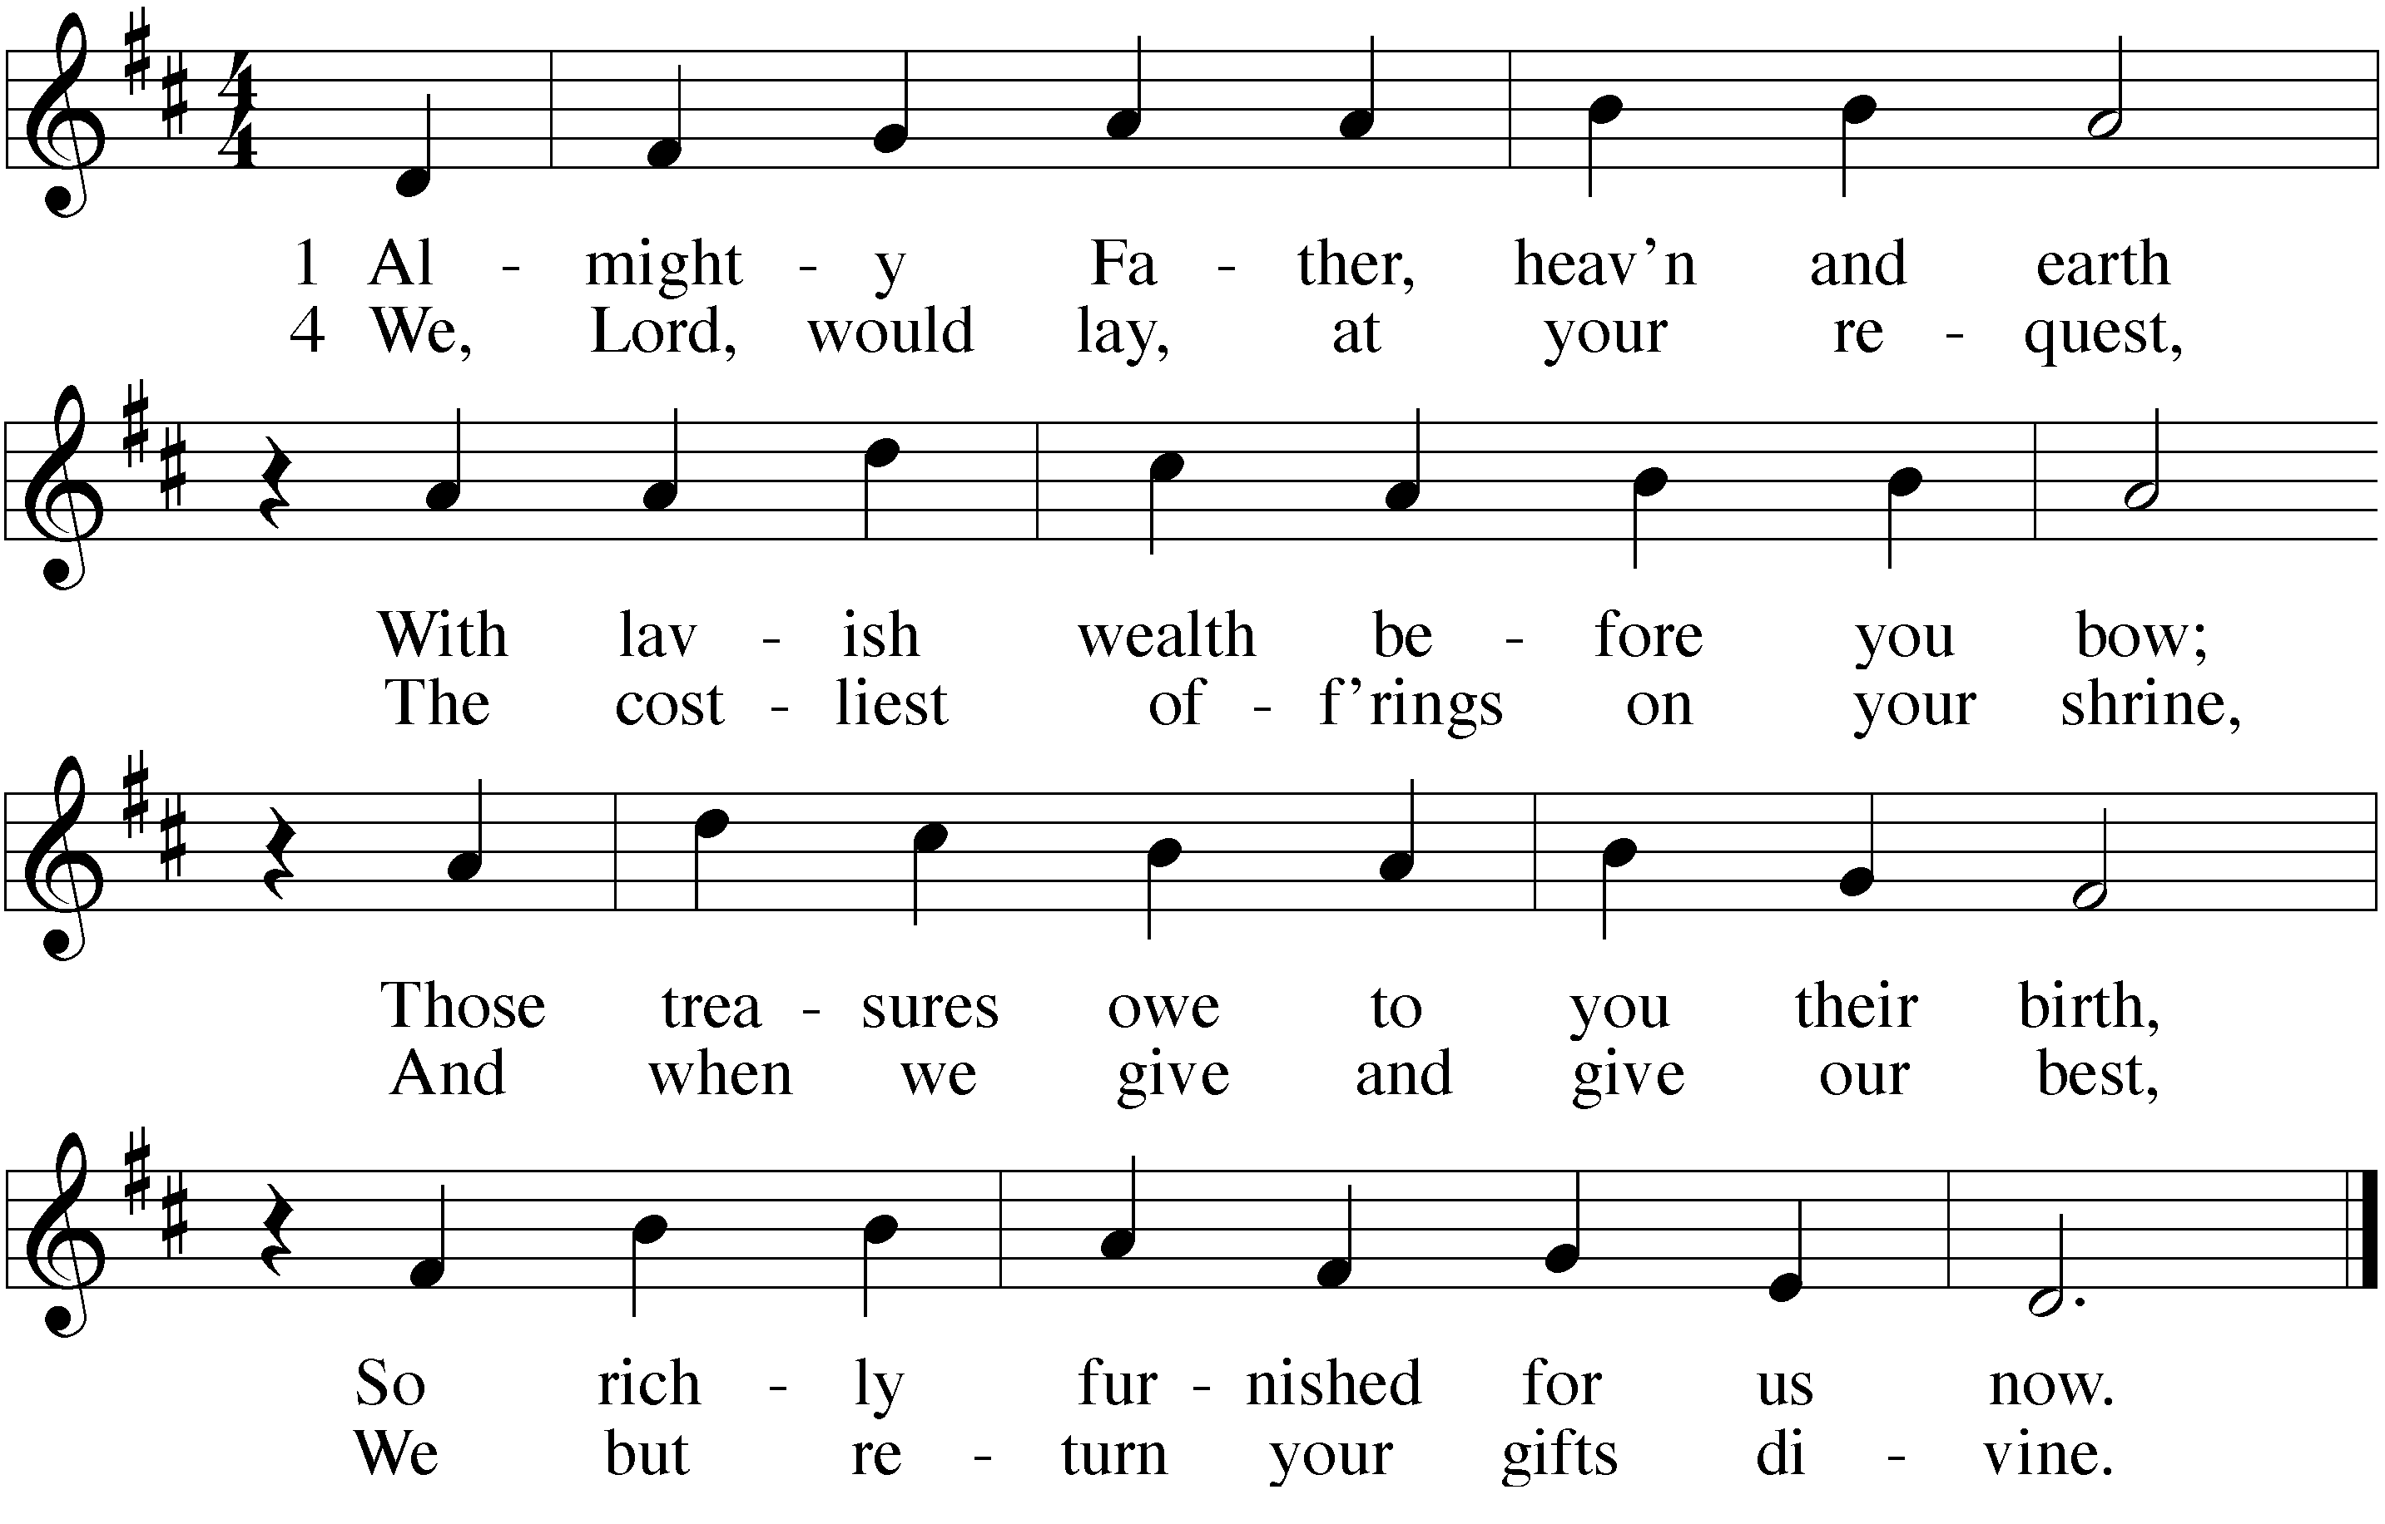

PRAYER OF THE DAY
M: O merciful Creator, your hand is open wide to satisfy the needs of every living creature. Make us always thankful for your loving care; and grant that we, remembering the richness of your grace, may be faithful stewards of all your good gifts; through your Son, Jesus Christ our Lord.
C: Amen.

LESSON 1 Corinthians 16:1-4

Scripture calls for offerings that “in keeping with your income,” that is, proportionate. These offerings are given so that God’s people might be a blessing to others, meeting physical and eternal needs.

¹Now about the collection for the Lord’s people: Do what I told the Galatian churches to do. ² On the first day of every week, each one of you should set aside a sum of money in keeping with your income, saving it up, so that when I come no collections will have to be made.³ Then, when I arrive, I will give letters of introduction to the men you approve and send them with your gift to Jerusalem. ⁴ If it seems advisable for me to go also, they will accompany me.

PSALM OF THE DAY Psalm 100
Page 104 in Christian Worship

GOSPEL Luke 12:13-21

Jesus teaches it is the height of folly to live for this temporal
life, forgetting of the eternal life that is to come.

¹⁴ “Again, it will be like a man going on a journey, who called his servants and entrusted his wealth to them. ¹⁵ To one he gave five bags of gold, to another two bags, and to another one bag, each according to his ability. Then he went on his journey. ¹⁶ The man who had received five bags of gold went at once and put his money to work and gained five bags more. ¹⁷ So also, the one with two bags of gold gained two more. ¹⁸ But the man who had received one bag went off, dug a hole in the ground and hid his master’s money.
¹⁹ “After a long time the master of those servants returned and settled accounts with them. ²⁰ The man who had received five bags of gold brought the other five. ‘Master,’ he said, ‘you entrusted me with five bags of gold. See, I have gained five more.’
²¹ “His master replied, ‘Well done, good and faithful servant! You have been faithful with a few things; I will put you in charge of many things. Come and share your master’s happiness!’
²² “The man with two bags of gold also came. ‘Master,’ he said, ‘you entrusted me with two bags of gold; see, I have gained two more.’
²³ “His master replied, ‘Well done, good and faithful servant! You have been faithful with a few things; I will put you in charge of many things. Come and share

continued on the next page

your master’s happiness!’
²⁴ “Then the man who had received one bag of gold came. ‘Master,’ he said, ‘I knew that you are a hard man, harvesting where you have not sown and gathering where you have not scattered seed. ²⁵ So I was afraid and went out and hid your gold in the ground. See, here is what belongs to you.’
²⁶ “His master replied, ‘You wicked, lazy servant! So you knew that I harvest where I have not sown and gather where I have not scattered seed? ²⁷ Well then, you should have put my money on deposit with the bankers, so that when I returned I would have received it back with interest.
²⁸ “‘So take the bag of gold from him and give it to the one who has ten bags. ²⁹ For whoever has will be given more, and they will have an abundance. Whoever does not have, even what they have will be taken from them. ³⁰ And throw that worthless servant outside, into the darkness, where there will be weeping and gnashing of teeth.

M: This is the Gospel of our Lord.
C: Praise be to you, O Christ!

CONFESSION OF FAITH Nicene Creed

We believe in one God, the Father, the Almighty, maker of heaven and earth, of all that is, seen and unseen.
We believe in one Lord Jesus Christ, the only Son of God, eternally begotten of his Father, God from God, Light from Light, true God from true God, begotten, not made, of one being with the Father. Through him all things were made. For us and for our salvation, he came down from heaven, was incarnate of the Holy Spirit and the virgin Mary, and became fully human. For our sake he was crucified under Pontius Pilate. He suffered death and was buried. On the third day he rose again in accordance with the Scriptures. He ascended into heaven and is seated at the right hand of the Father. He shall come again in glory to judge the living and the dead, and his kingdom will have no end.
We believe in the Holy Spirit, the Lord, and giver of Life, who proceeds from the Father and the Son, who in unity with the Father and the Son is worshipped and glorified, who has spoken through the prophets. We believe in one holy Christian and apostolic Church. We acknowledge one baptism for the forgiveness of sins. We look for the resurrection of the body and the life of the world to come. Amen.

HYMN OF THE DAY Jesus, Priceless Treasure | CW349:1,4,5

SERMON What Really Matters Is Knowing the Master

OFFERING

OFFERING PRAYER Lord of All Good | CW483:2

PRAYER OF THE CHURCH
M: Lord of heaven and earth, you made all things beautiful. You have provided green forests and refreshing streams. You have arranged the orderly procession of day and night for our work and rest.
C: Thank you for the mountains and the prairies, the roaring sea, and the gentle breeze.
M: Thank you for roofs that shelter us, for clothing that protects us, and for food and drink. Thank you for our work and the income it provides.
C: Thank you for our cities and our countrysides, for farms and factories, for streets and highways, and for all of life that flows so swiftly before us.
M: We know that it is from your hand that we have received all we have and are and will be. We understand that you call us to be the stewards of your abundance, the caretakers of
all you have entrusted to us.
C: Help us always to use your gifts wisely and teach us to share them generously. May our faithful stewardship bear witness to the love of Christ in our lives.
Special prayers and petitions may be offered here.
M: Help us, Lord, to be wise and fruitful stewards of the opportunities that you give us to use our gifts.
C: Amen.

Lord’s Prayer
C: Our Father in heaven, hallowed be your name, your kingdom come, your will be done on earth as in heaven. Give us today our daily bread. Forgive us our sins, as we forgive those who sin against us. Lead us not into temptation, but deliver us from evil. For the kingdom, the power, and the glory are yours now and forever. Amen.
Holy Communion may be celebrated here. If so, the presiding minister will direct the congregation to the appropriate pages of Christian Worship or Christian Worship Supplement.
BIBLE STUDY: Proportionate Giving

I. INTRODUCTION
? Which of these diagrams do you think most accurately reflects the Bible’s teaching on money, possessions, and our use of them?
97.5% belongs to me
2.5% belongs to God
90% belongs to me
10% belongs to God
nothing belongs to me
100% belongs to God

Proportionate giving beings by recognizing
who really is the _____________.

II. GOD OWNS EVERYTHING
Genesis 1:1
In the beginning God created the heavens and the earth.
John 1:3
Through him all things were made; without him nothing was made that has been made.
Job 33:4
The Spirit of God has made me; the breath of the Almighty gives me life.
Job 41:11
The Lord said, “Who has a claim against me that I must pay? Everything under heaven belongs to me.”
Exodus 19:6
The Lord said, “...the whole earth is mine.”

God ___________ everything
and therefore __________ everything
III. WE, BY NATURE, RESENT GOD’S OWNERSHIP
Think of the way we talk about wealth and possessions. At every step we are forgetful of the fact that God owns everything.
• There are two children who want the same toy. “Mine!”
- There is the man talking about his salary. “Last year I made $52,000.”
- There is the admiration for the “self-made millionaire.”
We need to constantly guard our hearts and minds, remembering God created all things, and therefore owns all things. Anything we have—our life, our intellect, our time, our possessions—we have because he generously gave them to us.
James 1:17
Every good and perfect gift is from above, coming down from the Father.
Point / Counter-Point
Below are things we tell ourselves. In your own words, explain how God answers.
Man says: “I put in my time.”
God says: “Now listen, you who say, "Today or tomorrow we will go to this or that city, spend a year there, carry on business and make money." Why, you do not even know what will happen tomorrow. What is your life? You are a mist that appears for a little while and then vanishes” (James 4:13-14).
Man says: “It’s my brain and talent that are responsible for my success.”
God says: “I have filled him (Bezalel) with the Spirit of God, with skill, ability and knowledge in all kinds of crafts—to make artistic designs for work in gold, silver and bronze, to cut and set stones, to work in wood” (Exodus 31:3-5).
Man says: “I’ve worked hard for what I’ve got!”
God says: “You may say to yourself, "My power and the strength of my hands have produced this wealth for me." But remember the Lord your God, for it is he who gives you the ability to produce wealth” (Deuteronomy 8:17-18).

The Takeaway
a) If I don’t recognize God’s complete ownership, I need to ______________ of my idolatry.
b) If I do recognize God’s complete ownership, as his forgiven child I give to him _______________.
c) If my life’s focus is on earthly possessions, every day I live is a day I come closer to losing __________________.
d) If my life’s focus is on heaven, then every day I live is a day I come closer to __________________ everything.
IV. QUESTIONS, QUESTIONS, QUESTIONS…
So, our New Man wants to honor Christ through percentage giving. That New Man now wrestles with the following questions.
“What percentage should I give?” Turn the table on legalism!
- Abraham gladly gave ______%, a “tithe” (Genesis 14:20)
- Old Testament law ____________ people to give multiple tithes (Numbers 18:21-23; Deuteronomy 14:22-29)
- Zacchaeus freely gave ______% (Luke 19:1-10)
- The widow of Zarephath and the widow at the temple gave ______% (1 Kings 17:7-16; Luke 21:1-4)
The point? Let the percentage of your gifts flow from the Spirit’s work in your heart. “Each man should give what he has decided in his heart to give, not reluctantly or under compulsion, for God loves a cheerful giver” (2 Corinthians 9:7).
“How much of God’s money do I need to live on?” Turn the table on greed!
? Consider these two examples. There is a single mom with two children who made $30,000 last year. She gave $2,500 in offerings. There is a two-income family with two children who made $110,000 last year and gave $11,000. Who gave more?

The point? God is so generous, he often gives us so much income that we can not only meet our needs but also purchase some things we want, but don’t really need. However, if we better distinguish between wants and needs… if we focus on earthly needs and heavenly wants... it frees us up to be exceedingly generous with our offerings.
“What will my investments be earning 50,000 years from now?” Turn the table on materialism!
Matthew 6:21
Jesus said, “For where your treasure is, there your heart will be also.”
Martin Luther
I have held many things in my hands and I have lost them all. But whatever I have placed in God’s hands, that I still possess.
? You gave $10,000 to support our congregation. Your gift was used to fund efforts to reach the lost. It funded the teaching of God’s Word to young and old. A portion of it was sent to WELS to support world-wide mission efforts. How might you enjoy that investment 50,000 years from now?

The point? Even Jesus had a treasurer. Ministry requires funding. An earthly investment can bring joy only in this life. But investing in gospel ministry can reap blessings that we will enjoy for all eternity.
“Do I fully comprehend Jesus’ sacrifice for me?” Turn the table on self-centeredness!
2 Corinthians 8:9
For you know the grace of our Lord Jesus Christ, that though he was rich, yet for your sake he became poor, so that you through his poverty might become rich.
? Part of “the American Dream” is upward mobility. Americans typically aspire to move up in their socioeconomic status. There is also the possibility of downward mobility. People who were rich can end up dirt poor. There is no greater example of downward mobility than Jesus. Describe a) how big a step down he took and b) why he was willing to take that step.

The point? Giving generously will never be achieved by focusing only on the Scripture passages which talk about generous giving! The gospel—the good news of Christ’s sacrifice, resurrection and the glorious eternity that is waiting for us—is what the Spirit uses to empower joyful, generous giving.

V. NEWS AND NOTES
• This week is the time to study the information in your 10 for 10 commitment packet. Please read the letter, use the planning tools included, and prayerful consider what your response will be.
- Two weeks from today is when commitment cards will be gathered. Important note: your commitment cards will not be opened. They will be placed near the altar for ten weeks and then returned to you unopened for your prayerful reflection.
- Please do not place offerings in your 10 for 10 commitment envelopes. The only thing that goes in that envelope is your giving plan.
- Additional devotional material has been/will be shared. Read. Ponder. Pray.

BLESSING
M: Brothers and sisters, go in peace.
Live in harmony with one another.
Serve the Lord with gladness.
The Lord bless you and keep you.
The Lord make his face shine on you and be gracious to you.
The Lord look on you with favor and give  you peace.
C: Amen.

CLOSING HYMN Lord of Glory, You Have Bought Us | CW486:1-2

WELS Congregational Services
COPYRIGHT PERMISSIONS
Bible questions from New International Version, unless otherwise noted
Almighty Father, Heaven and Earth: Text by Edward Dayman; Tune by Nikolaus Herman; public domain

