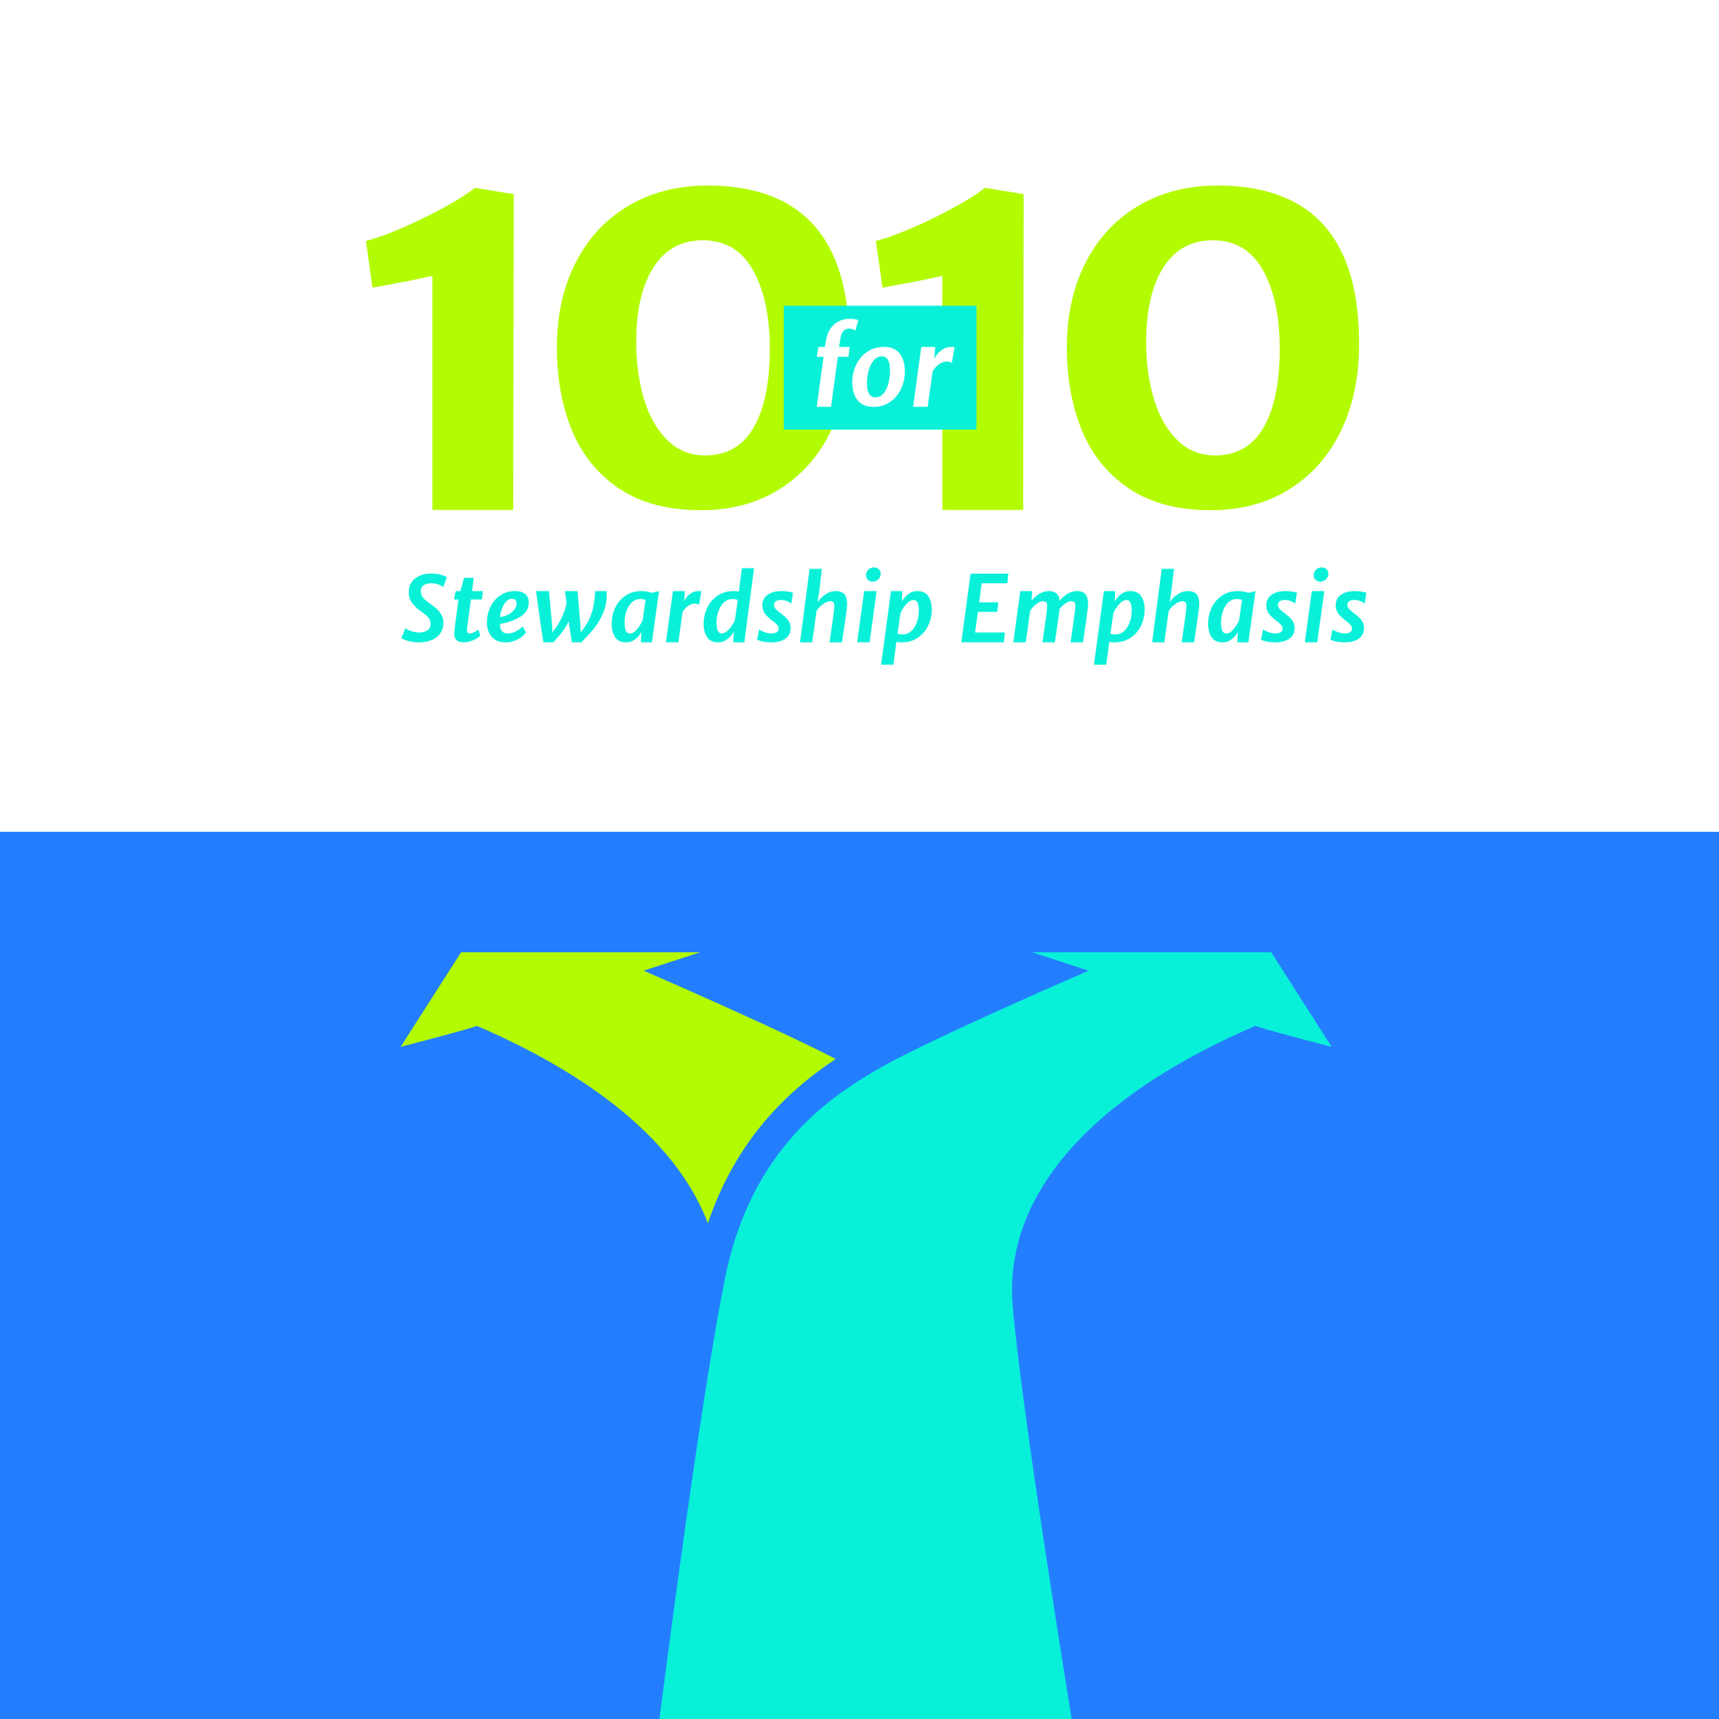

**My Personal TEN FOR TEN Giving Plan**

*Enhanced Weekly Offerings for Ten Weeks ([month_day] to [month_day])*

**Please check the one that applies:**

* I/We are not in the habit of regular, proportional giving. I/We will begin the biblical practice of firstfruits and proportional giving to glorify God and thank the Savior.
* I/We give less than 10% (a tithe) of income and desire to increase giving to _____ % for the ten weeks of TEN for TEN.
* I/We already give 10% (a tithe) of income and will continue to do so.
* I/We already give 10% and will increase giving to _____ % for the ten weeks of TEN for TEN.

**Name(s): ________________________________________________________ Envelope #: ____________**