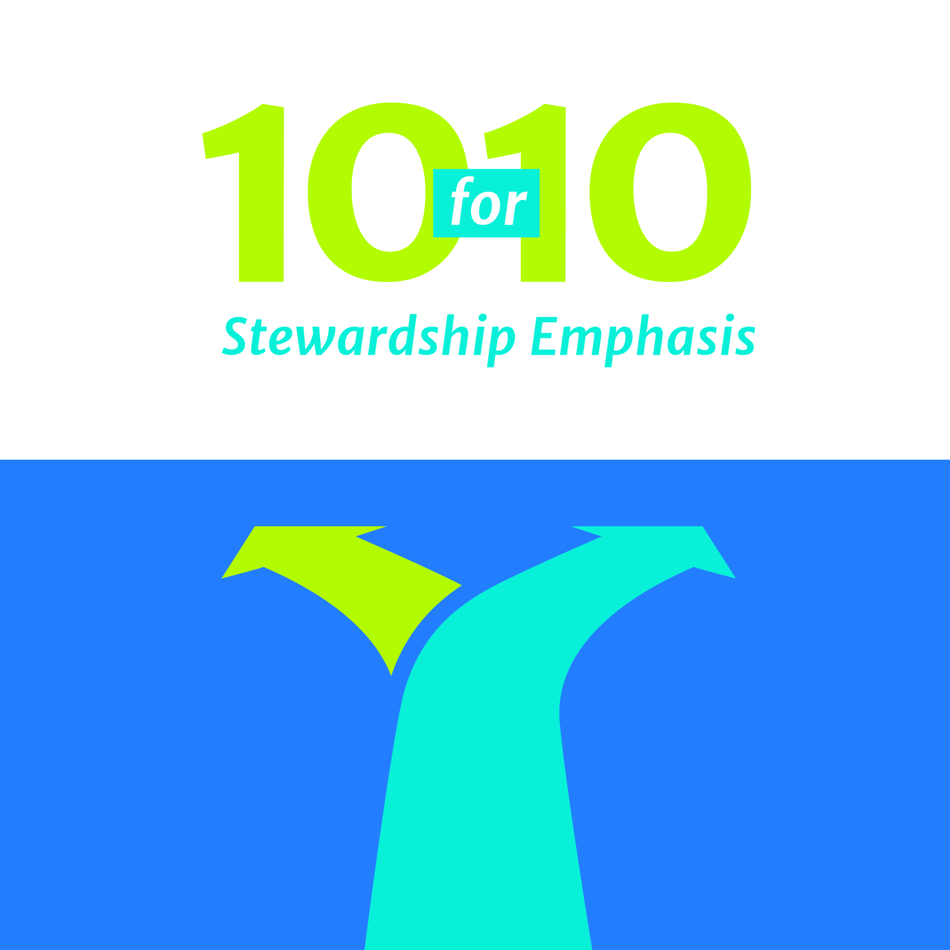

**My Personal TEN FOR TEN Giving Plan**

*Place in offering plate the weekend of [month_day,_ year]*

**Name: _______________________________________________ Envelope #: ____________**

* Please place your TEN FOR TEN planning card in this envelope. Place this envelope into the offering plate the weekend of [month_day].
* Giving plans will be kept at the Lord’s altar for the ten weeks of TEN FOR TEN. Prayers for God’s blessing will be regularly offered during TEN FOR TEN.
* Your giving plans will be returned to you (unopened) the first weekend of [month].
* DO NOT place any offerings in this envelope. Use your regular weekly envelopes for your offerings during the ten weeks of TEN FOR TEN.